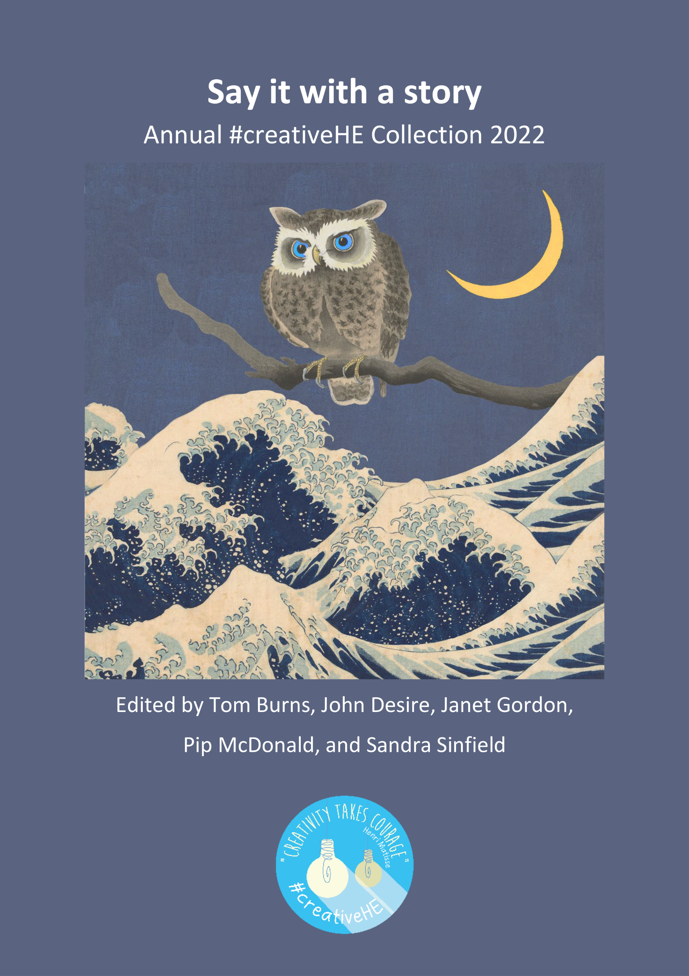

Annual #creativeHE collection 2022
Series editors
Chrissi Nerantzi University of Leeds
Nathalie Tasler University of Glasgow

Editors 2022
Tom Burns London Metropolitan University
John Desire London Metropolitan University
Janet Gordon London Metropolitan University
Pip McDonald Royal Agricultural University
Sandra Sinfield London Metropolitan University

Cover design by Odysseas Frank, Current first year undergraduate student at Norwich University of the Arts studying towards a BA (Hons) Digital Game Art and Design, portfolio at https://www.artstation.com/odydigitalart email: ody.digital.art@gmail.com
Original openly licensed artwork used to create cover image:
1 Under the wave off Kanagawa, 1829-1833 by Katsushika Hokusai, Rijksmuseum, Netherlands
2 Ransuil op kale boomtak, by Ohara Koson, 1900-1930, Rijksmuseum, Netherlands

Being creative in the face of adversity. The #creativeHE Annual 2022 has been made available under a CC BY NC licence by the Creativity for Learning in HE community. Check the conditions before use and attribute appropriately when re-purposing and re-mixing.

Reference
Burns, T., Desire, J., Gordon, J., McDonald, P. and Sinfield, S. (eds.) (2022) Say it with a story. The #creativeHE Annual 2022. Creativity for Learning in Higher Education Community, #creativeHE, DOI: TO ADD HERE
Contents
Editorial 5
Story 1: How can I engage and help all students in the unit I lead? 7
Story 2: Learning to sit comfortably with sadness 9
Story 3: Compassion – an essential part of teaching and learning communities 11
Story 4: #QuietCreativeHE Event: Chat June 08, 2022 13
Story 5: Freedom Emergence, Unfiltered Joy 15
Story 6: Connecting through nature in a HyFlex classroom 18
Story 7: Maybe tomorrow 20
Story 8: University 23
Story 9: Returning to my Marching Cubes Project 24
Story 10: Wait, am I in the wrong class? 26
Story 11: Owl to Elephant: reflecting on my role 29
Story 12: Exploring Micro Stories with Techno-Haiku 31
Story 13: A creative interpretation of 99 Online Education Buzz Words 37
Story 14: Look Out 39
Story 15: The Art of Collaboration: moving beyond your comfort zone 41
Story 16: Drawing on experience 44
Story 17: Re-humanising Education, through Art 46
Story 18: Riding the great wave: sink or swim? 48
Story 19: The Great Confluence 50
Story 20: Waves of Change: Decolonising a Reading List 52
Story 21: Two Sides of One Coin – Hybrid Learning Edition 54
Story 22: I tried this Menti in class 57
Story 23: Connect online and everything will be okay 59
Story 24: Joyful Connections 62
Story 25 Pedagogy of Hope 64
Story 26: Branches of Life 66
Story 27: Come on feel the noise 68
Story 28: I Tried: Resistance and Recovery 70
Story 29: Better than you might think 72
Story 30: Zoom Wars: Teaching and Learning Strikes Back 74
Story 31: Into the Woods… A Tale of a Team 76
Story 32: From engagement to empowerment - how a ‘souped-up” active learning can take student success further 79
Story 33: Eyes on the : Writing about the 2022 World Cup in Qatar 82
Story 34: Cradling Post pandemic Architecture Education 85
Story 35: Once upon a musical journey to Drill 88
Story 36: A Leap of Faith 90
Story 37: The Kids Are Alright 92
Story 38: Once upon a time 94
Story 39: Drawing the Dialogic Growth: Mapping the Supervisory Relationship 98
Story 40: Building bridges; primary masters 101
Story 41: Tree trunks and grass roots 103
Story 42: The Not-Dead Tree: Tales of creativity in dark times 105

Editorial

The annual was an opportunity to dive into forty two short storyworlds. In our capacity as the Editorial team, it was a real privilege to read these stories and use the annual as a platform to bring the contributions to life. Editing an annual tells a story in itself. What did we discover over the past year? What changed for us? What inspired us? We hope that you enjoy it. Say it with a story. Say it with #creativeHE.

What ‘story’ means to us
For Tom Burns, storytelling can take us into other worlds, other experiences, other lives, it can also show us our worlds, our lives, differently - and enhance our experiences. There is always an opportunity to learn from telling the story - or listening to it. That was my editing experience, an opportunity to learn.
For John Desire (JD), the importance of sharing stories is well established in all cultures. Storytelling is not about just the story, but the way it’s written, the way it’s delivered and presented to the audience. My editing experience has been focused to ensure these elements were highlighted in each story.
For Janet Gordon, storytelling is a way of making sense of things, but also allows us to escape and explore parallel possibilities. The editing experience has been refreshing, inspiring and joyful.
For Pip McDonald, storytelling is a creative opportunity to explore what really matters to us in a safe space. The editing experience has been a way to collaborate in a meaningful way to share diverse stories.
For Sandra Sinfield, storytelling can have a shape and a goal, with genres and structures, formats and patterns to help you get there. There is also storytelling that flows like speech, a little journey of the mind to see where you go. That was our story - and that was my editing experience.

Tom, JD, Janet, Pip and Sandra
December 2022

About the Editors:
Pip is a Senior Learning Technology Project Officer at the Royal Agricultural University (RAU).
Tom Burns, John Desire, Janet Gordon and Sandra Sinfield are Senior Lecturers within the Centre for Professional and Educational Development (CPED) at London Metropolitan University.

About #creativeHE
The open and international cross-institutional Creativity for Learning in Higher Education (HE) community (#creativeHE), was born in 2015. Since then, #creativeHE has become a distributed community of practice, a space for emergent professional development, practice sharing, peer support and experimentation with creative learning and teaching approaches and curriculum design for educators, students and the wider public. Access our website and join the #creativeHE community on Twitter or in Facebook. Check out our planned activities for 2022/23.

About this collection
In the 2022 annual, #creativeHE invited both teachers and students to write stories to explore and reflect on teaching and learning experiences that took place in 2021 and 2022. As part of this, we asked submissions to include a visual to enhance the story.

Story 1: How can I engage and help all students in the unit I lead?

Dr Aspasia Eleni Paltoglou
A.Paltoglou@mmu.ac.uk

Bio: Aspa is a Senior Lecturer in Psychology at Manchester Metropolitan University, and a Chartered Psychologist. She is interested in the interaction between creativity and education.

How can I engage and help all students in the unit I lead?

Image: Screenshot of the ‘Engagement tracker’ from Moodle, which shows how many students are engaging with the unit.

I lead a second-year undergraduate unit where around 400 students study. When I think of this large cohort of students, I think of all the potential of diversity. I worry that this diversity might mean that some students might find the course too basic, or uninteresting. So I include additional optional workshops, such as public engagement writing, and a variety of activities and optional sessions to make sure ‘there is something for everyone’. I also did not follow the Moodle template religiously, as I thought each colleague had different ways of organising their material.

However, in a staff meeting I was made aware that differences between units can have negative effects on students, especially those that struggle with the material or are neurodiverse. Having similar layouts really helps with access, especially for students that find studying a struggle.

It dawned on me that I was not thinking of the BSc in its entirety, and I was only focusing on my unit and on the students that might not find the topic engaging, while not thinking much about students that might have accessibility issues. It also dawned on me that seemingly simple administrative issues can potentially make a huge difference for students. Although innovations are important in education, it is also important to remember the basics, and provide clarity and some uniformity across units within a course. It can be a difficult balance to strike.

Story 2: Learning to sit comfortably with sadness

Dr Aspasia Eleni Paltoglou
A.Paltoglou@mmu.ac.uk

Bio: Aspa is a Senior Lecturer in Psychology at Manchester Metropolitan University, and a Chartered Psychologist. She is interested in the interaction between creativity and education.

Learning to sit comfortably with sadness
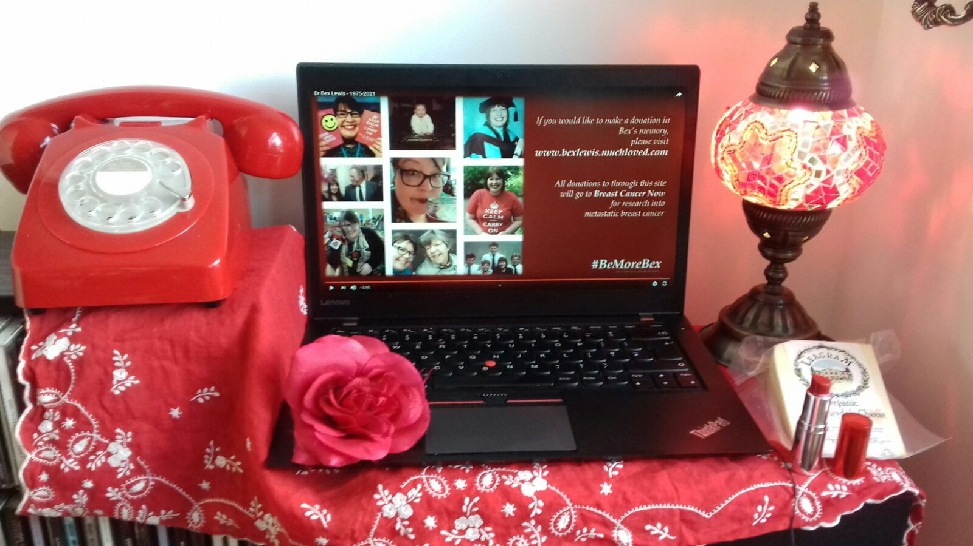
Image: A laptop with images of Dr Bex Lewis from her funeral

David Mitchell, novelist, shares the soundtrack of his life with Lauren Laverne on Desert Island Discs.
One of the things I enjoyed during lockdown was listening to Desert Island Discs (DID) on a Sunday morning while drinking tea. In this long-lived BBC radio 4 programme, the interviewer discusses the life and work of a guest/castaway in relation to eight pieces of music that the guest would take to a desert island. Something that really moved me was a piano Sonata by Domenico Scarlatti that novelist David Mitchel chose to include.
Apparently, Domenico is a bit of a mystery; a royal harpsichord tutor, he suddenly started writing music five years before he died and has bequeathed us with around 555 sonatas. What led to this sudden burst of creativity, and why was he able to capture sadness so beautifully in this sonata? David hopes to piece it all together in a future novel (if he manages to escape the desert island, that is).
Domenico’s sonata made me reflect on how I deal with sadness. I tend to try to avoid sadness and instead I do one of the following: try to look on the bright side, make fun of things, or get angry – occasionally even all at once. Perhaps because I like to think of myself as a strong person that does not wallow in sorrow. Hiding sadness under other emotions can be helpful, but it doesn’t always work. Certainly not when a full-of-beans-and-plans friend and colleague dies painfully at the age of 45 from secondary breast cancer and Covid-19. Dr Bex Lewis had a positive outlook but didn’t try to ignore difficult emotions. She wrote books (including one on the poster ‘Keep calm and carry on’), academic articles, blogs, and used social media to connect with others and help them become their best selves. She inspired me and encouraged me to write. Bex wrote about her cancer in social media and blogs, and I think writing about it helped her deal with the difficulties that she faced.
Reflecting on Bex, Domenico’s Sonata, David Mitchell’s and other DID castaways’ ponderings on creativity, made me think that it is important to learn to sit comfortably with sadness. Creativity could potentially help us accept sadness without being overwhelmed by it, and connect with others in this acceptance. I think that writing about Bex and learning to sit comfortably with the sadness of her death while listening to Domenico’s sonata is the best way to honour this bright, bubbly, generous, honest Manchester bee.
Do go to Bex’s page for raising funds for research on secondary breast cancer.

Story 3: Compassion – an essential part of teaching and learning communities

Mr Dee Vyas
d.vyas@mmu.ac.uk

Bio: I have worked at the Manchester Metropolitan University for 33 years. I am employed as a Technology Enhanced Learning Advisor, working with academic and professional services staff to build communities of practice, share knowledge, to develop digital skills, and engage in my continued professional development.

Compassion – an essential part of teaching and learning communities

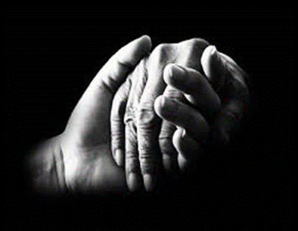

Image: A close-up of two hands holding each other

The image highlights the need for support and compassion through a difficult time for education - the pandemic, remote working, limited social interaction, a return to campus, face-to-face teaching, working from home, and possibly a hybrid approach to teaching. Throughout all these challenges, a need to be supportive, and compassionate is important.
From the start of my 33-year academic career in 1989, as an Information Technology (IT) Advisor at Manchester Metropolitan University, I have been fascinated and passionate about the science and art of teaching and learning. After eight years of primarily IT support, my interests shifted to the emerging role of technology in HE and I actively changed the direction of my career towards academic staff development and training. I am now a Technology Enhanced Learning Advisor (TELA).
Changes to the delivery of teaching, digital skills and student interaction have become a major focus, with the move to flexible active learning a key driver. It is essential as part of this that the skills of academic staff are supported and nurtured to deliver an enhanced student experience.
As a TELA I am aware of the impact the new model of teaching will have on academic skills requirements. Support is provided over several different channels to ensure staff can have access to quick and precise help. Working incredibly hard to create a sense of community has not been underestimated and developing relationships has been central to this.
The need to update my digital skills rose exponentially during the pandemic and this has continued as the return to campus-based teaching has resumed. MS Teams, Teaching and Learning Apps, interactive teaching, student engagement are now keywords as part of the digital and pedagogical landscape.
The photo highlights two hands holding each other, and providing the guidance and support to develop, be confident, and deliver an enhanced student experience remain important. The feedback obtained from academics since that initial move to online teaching has been positive, from the initial sense of bewilderment, of how to deliver online predominantly, to now having the confidence to incorporate interactive teaching. It is important to acknowledge that returning to a pre-pandemic world, without reflection or change, is not realistic. We need a commitment ‘to learning from this period and embracing change where it has the potential to enhance quality and the student experience’ (Snelling, 2022).

References
Snelling, C. (2022) Lessons from the pandemic: making the most of technologies in teaching. [online] Universities UK. Available at: https://www.universitiesuk.ac.uk/what-we-do/policy-and-research/publications/lessons-pandemic-making-most.

Story 4: #QuietCreativeHE Event: Chat June 08, 2022

Sandra Abegglen, University of Calgary
https://sandra-abegglen.com/

Bio: Sandra Abegglen is a Researcher in the School of Architecture, Planning and Landscape at the University of Calgary where she explores online education, and learning and teaching in the design studio. Sandra has a MSc in Social Research and a MA in Learning and Teaching in Higher Education. She has extensive experience both as a social researcher and lecturer/programme leader. She has published widely on emancipatory learning and teaching practice, creative and playful pedagogy, and remote education. Do look for her personal website.

#QuietCreativeHE Event: Chat June 08, 2022

On June 8th 2022, together with Alex Spiers and Nathalie Tasler, I delivered the 4th Annual #creativeHE Jam, a quiet end-of-academic-year reflection. The event was free and open access, promoted through the #creativeHE network and social media channels. The aim of the event was to take a ‘time out’ from busy academic life to reflect on the last couple of months. The first 30 minutes of the event were reserved for ‘getting to know each other’ before getting creative – calmly and quietly. The activities undertaken included a ‘minute of silence’, the creation of a ‘sound cloud’ and gentle, creative prompts to reflect on participants' experience of the past year (check out the outcomes here).

During the event, a lively discussion evolved in the chat which was open during the whole session. As with most online meetings, where participants are allowed to use the chat, this is where the interesting ‘stuff’ happened. Hence, it appeared worth not only to 'save’ the chat but to actively utilise it. But how? Chats are complex in that discussions overlap; several different things are discussed simultaneously. Plus, there are often extra comments that go ‘off piste’ or flag up technical difficulties (“We can’t hear you, you are muted”). So, publishing the chat ‘as is’ does not really make sense, especially when the chat recording spans several pages. Yet, this chat was in parts so poetic that I felt compelled to do something with it. The choice of action was to extract the elements that spoke to a particular theme and curate them so they loosely follow the order of the discussion held. What emerged is a poem in situ on quietness and creativity.

What brings people joy, right now?

my handcream that smells lovely

garden and flowers in my garden

I can see a lovely pink rose in the garden, and the breeze is blowing through the leaves of the buddleia.

The small perfectness of my caravan bedroom (where I am working right now).

My neighbour's enormous rose bush that I can see out of the window, a candle flame on the fireplace, and the children (in between arguments) :))

Trees blowing out the window.

Our sleeping dog, curled up on his bed, who has been very ill - touch and go - but is now well on the way to recovery.

My lunch :) also a stone shaped by a glacier a friend brought for me from New Zealand.

Sat listening with three colleagues - the comfort of companionship and discussion! The smell of cake, the little houseplant, and our creative activity!

I can see strawberries growing in the garden.

looking at the sky, garden, tree, garden sculpture, flowers, cat, to rest my eyes away from the screen :-)

a shell i found in the outer hebrides

The tree in front of the window, which currently blooms pink.

And now, in the silence, a robin singing away outside in the garden.

Some paintings of the new mexico desert that help me remember the smell of sun-baked cactus, dry sand, and the relief of a breeze to convert sweat into a balm.

Feeling warm as the view is not great (quite a bare office space), I can't see any greenery from where I sit and the light is too strong for my eyes. :)

the communal silence now.

Acknowledgement
A huge thank you to Sandra Sinfield for her ever so wonderful support, and spontaneous enthusiasm to ‘read through’ and comment on the initial draft. A big thank you also to Natalie Tasler and Alex Spiers who co-led the 4th Annual #creativeHE Jam with me, and obviously #creativeHE that made the event possible.

Story 5: Freedom Emergence, Unfiltered Joy

Hannah Seat, Hannah Wilson, Elizabeth Collins
h.h.seat@leedsbeckett.ac.uk

Bios: Hannah Seat is the Course Leader for the BA (Hons) Primary Education (Accelerated Degree) within the Carnegie School of Education at Leeds Beckett University. Hannah Curstaidh Wilson and Elizabeth Collins have recently graduated from Primary Education (Accelerated Degree) and are currently studying towards a Primary Education PGCE at Leeds Beckett. Hannah, Hannah and Lizzie all share an interest in storytelling, poetry and creative arts-based teaching methods.

Freedom Emergence, Unfiltered Joy

Once upon a time, in a galaxy not too far
away, journeys end as new adventures
are only just beginning…
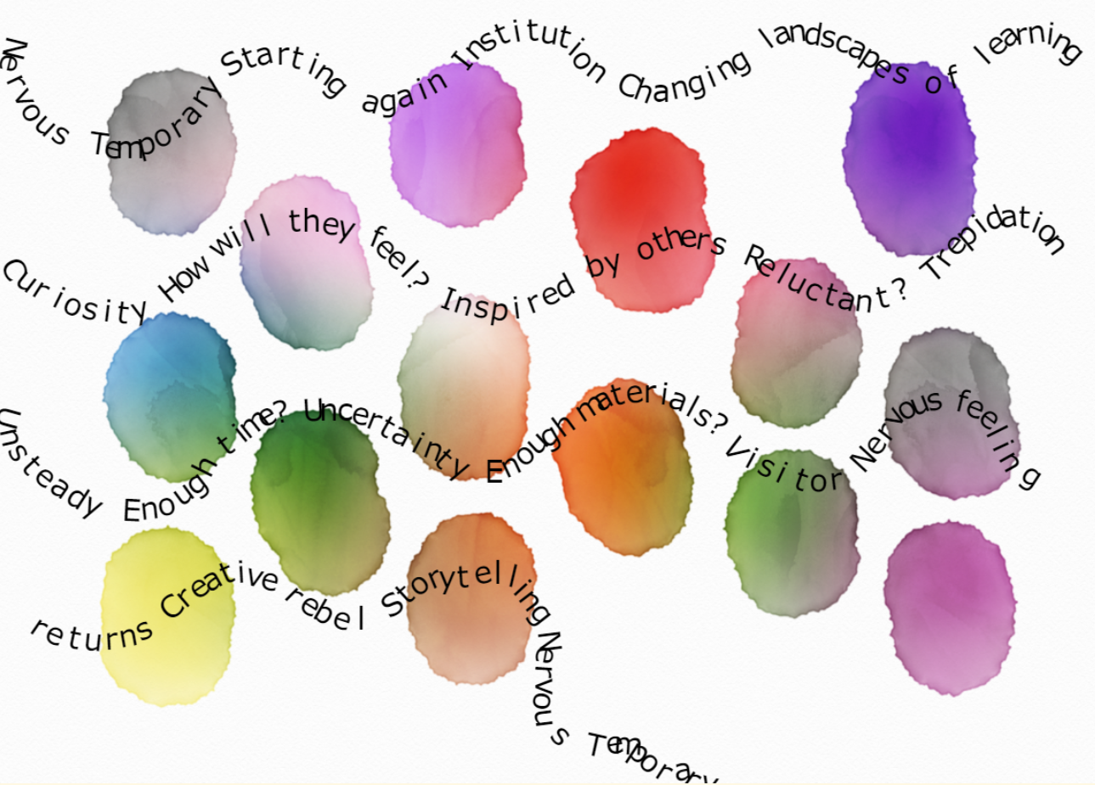
y
Breaking the norm
Excited
Go for it
Inspired by poets
In the room
“Go with me on this”
“Yes!!”
Inspiring habitat found
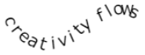
Alleviated worries
Engaged
Found poetry
Mo
ve
me
nt
Child-like vigour
Orbiting the outdoors

Escaping
Bl… st..
lu.. ery
Performances
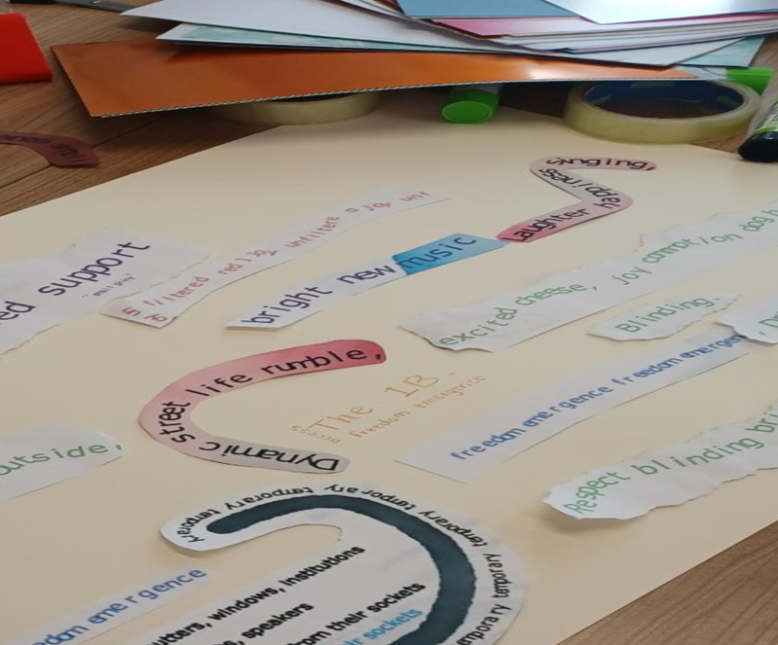
Evolving
Laughter
New perspectives
Materials
Textures
Art
Making
Energy

Collaborating

Endless possibilities

Evolving boundaries
Creativity reignited
Silent habitat left behind
Freedom emergence
Unfiltered joy

Story 6: Connecting through nature in a HyFlex classroom

Nayiri Keshishi
n.keshishi@surrey.ac.uk

Bio: Nayiri Keshishi is a Lecturer in Learning Development, with over eight years’ experience in the design, development and delivery of engaging learning programmes, focusing on academic and professional skills development. She has an MSc in Occupational & Business Psychology and is also a Fellow of The Higher Education Academy.

Image 1: Picture of Nayiri Keshishi

Connecting through nature in a HyFlex classroom

Teaching in 2021-22 has been about balance; the balance of student/ staff safety with maintaining as much face-to-face contact as possible. Sometimes, this meant delivering in a HyFlex classroom, with some students present in the physical classroom and some participating virtually. So how do we ensure all students are engaged and able to actively participate in class? It definitely required experimentation, particularly when it came to the use of technology and designing activities which provided equivalent learning outcomes…

Though we do not know if HyFlex classrooms will feature at our institutions in the future, it is always worth considering how we can leverage technology and adjust our teaching to be more inclusive, engaging and playful.

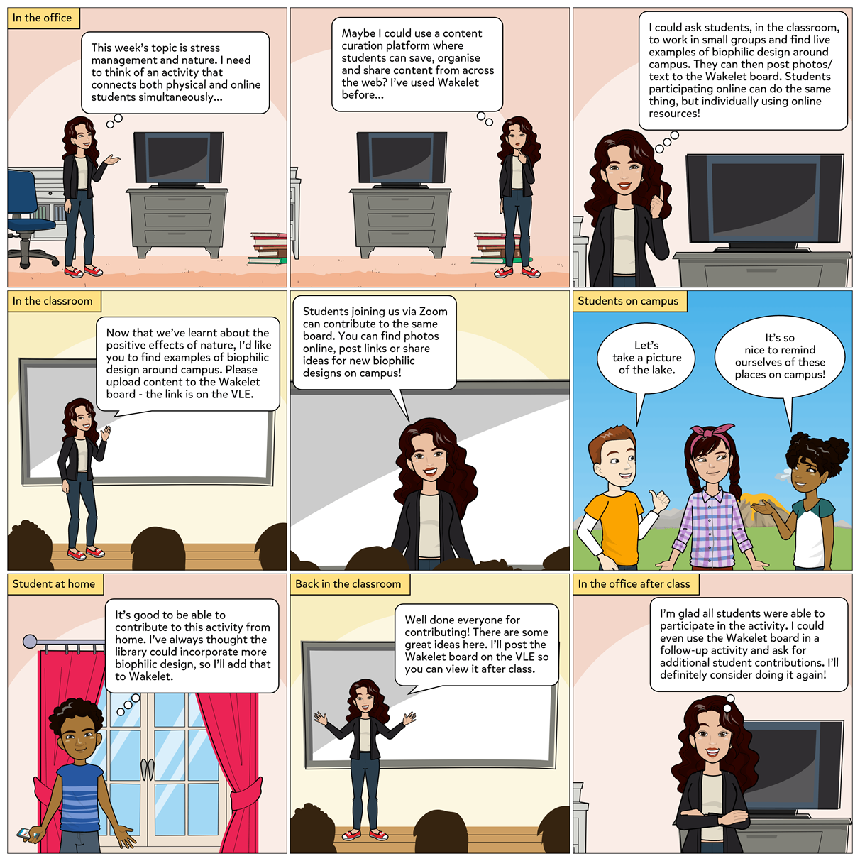
Image 2 Comic strip illustrating the process of designing and delivering an activity, using a content curation platform, to engage students in a HyFlex classroom. (Created on Pixton)

Story 7: Maybe tomorrow

Dr Chrissi Nerantzi
c.nerantzi@leeds.ac.uk

Bio: Chrissi is an Associate Professor in Education in the School of Education at the University of Leeds. Her interests lie within creativity, openness and collaboration in learning and teaching and professional development. She is the founder of #creativeHE and has co-founded a series of further successful open cross-institutional professional development initiatives including TLC, FDOL, BYOD4L, #LTHEchat and FOS. Chrissi has been a National Teaching Fellow since 2015, won the ALT Learning Technologist of the Year Award in 2017, the Open Innovation Award in 2021 and a CATE in 2022.

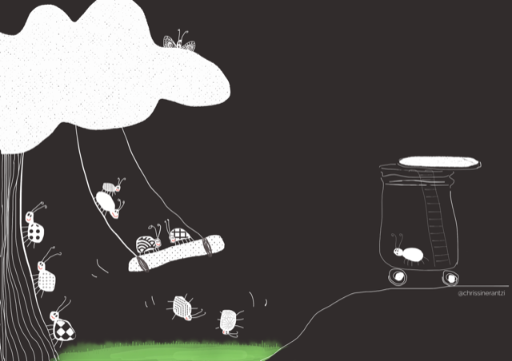

Image: Bug in his glass home - by Chrissi.

Maybe tomorrow

I wish I was out there…
... maybe tomorrow
Maybe

All day long Bug keeps himself busy. Every day.
Dark, finally, he says.
His belly is rumbling.

Everybody has gone to sleep.
Even the flowers.

Perfect time to go to the kitchen, he says to himself.

His heart is racing.
He grabs his basket
And climbs out.
Quickly and quietly.

What a feast... if only I had somebody to share it with...
But who would want to eat with me?

Bug puts his meal in the basket
It smells SO SO good.
His nose was tickling.

He goes back home.
Quickly and quietly.

Bug sits on the little platform at the top of his ladder
A picnic under the night sky.
Wow, he says. How many stars are out there?
They are all dancing together in the sky.

Bug closes his eyes and dances with them.

For a moment he forgets what he finds scary
And is
Freeeeeeeeeeeeeeeeeeeeeeeeeeeeeeeeee.

I did it, I did it, he says all joy.

The night dance with the stars gives Bug new strength.
He makes plans.

Today is the day, he says to himself
The other bugs and butterflies are playing in the sun.
He decides to join them for the first time ever.
He tries to arrange his words in his mouth
and goes up the ladder
His heart is racing.
He hears their laughter and then suddenly...

...he freezes...
and turns around.

Maybe tomorrow.
Maybe

I wish I was out there.
Bug has been wishing for this to happen for a long long time.

Bug is looking outside again when he hears a BIG Bang.
Oh no, what is that?
In no time he climbs up the ladder and sees a butterfly
She injured her head on his house.
I am so sorry, she says.

Don’t move, says Bug.
He makes bandages from soft leaves.
You will be fine, he says
The butterfly doesn’t say anything.

I am Bug. Who are you? Bug surprised himself.
He actually asked a complete stranger a question.
The butterfly opens one of her eyes and says, you can call me Butter. I was flying away from them when I crashed into your house.
Oh, them, over there, said Bug.
Normally I am only out when everybody sleeps, says Butter.
Me too, said Bug.

Bug and Butter sit there together and tell each other how they have wished every day to be out here and make friends but they didn’t dare.

Tomorrow.
Yes tomorrow, we will do it together, they say leaning on each other..
Maybe?
We will.

WE did it! WE did it! WE did it!

Story 8: University

Odysseas Frank
odysseas.frank@student.nua.ac.uk

Bio: Ody is a first year undergraduate student studying towards the BA (Hons.) in Game Art Design at the Norwich University of the Arts. He is interested in video games, the art that goes into them and how they are made (this being evidenced in his chosen path of education).

University

Image: Disappearing into online learning (3D scene created by Ody Frank)

A time to make new friends and face new experiences,
A place for learning and developing not only education but life as a whole,
A stepping stone to the real world from the safety of early youth,
A place to face tough times and the greatest of times, all at the same time,
A chance to express who you truly are and what you can be,
A place for creativity and freedom of ideas,
A thriving centre of collaboration,
A community to call your own,
The excitement for it all to start:
Unimaginable

Story 9: Returning to my Marching Cubes Project

Thanassis Frank
tf366@cam.ac.uk

Bio Thanassis is a 3rd year undergraduate student reading Electrical Engineering at Trinity Hall at the University of Cambridge. He has always had a love for programming and enjoys experimenting through software projects. Electronics is another interest and he is a member of the Cambridge University drone and spaceflight societies.

Returning to my Marching Cubes Project
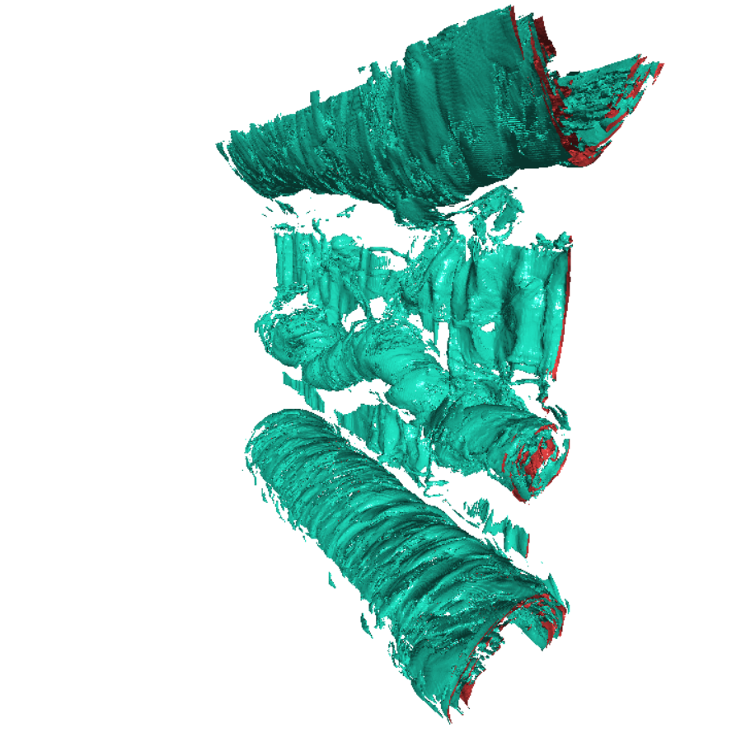

Image: An example mesh generated by the program for a turbulent magnetic dataset
In the summer of 2022, I took part in an internship project with a Professor and a PhD student, based in the Whittle Lab of the University of Cambridge. This was the continuation of work from last summer on a web based implementation of the marching cubes data visualisation algorithm (Frank, 2021). It is a technique for displaying information about a volumetric dataset by creating a mesh of points that have the same data value, cell by cell to build a full representation. I had laid the groundwork already, getting to grips with the algorithm and implementing it in Javascript, WebAssembly, as well as a parallel version running on the Graphical Processing Unit (GPU) with higher performance.

Unlike last year where I worked remotely due to the pandemic, the first week was spent in Cambridge. I carried out work in the Whittle Lab as well as the University Library which both offered a welcome change of scenery from home working and helped me to fully concentrate on my tasks, being surrounded by others doing the same.

Individually learning about and experimenting with new algorithms and programming techniques was engaging and rewarding as there were always challenges to overcome. I find the involved process of planning and designing new systems and classes, utilising entity relationship diagrams and required feature lists, an equally rewarding challenge.

Communication was important with this project as with any to make sure that the focus of work was being placed in the right areas and to properly convey changes made and algorithms implemented. This naturally led to a collaborative approach to the planning of work and order of tasks to complete.

I will take the experience of this project with me into the future. Specifically, working individually to complete the tasks set as fully as possible, managing their priorities as and when needed will be critical throughout my life. The experience I’ve gained with new algorithms and programming tools will undoubtedly transfer readily to any similar data visualisation projects in the future but also more broadly to other software projects.

Additionally, this year, my work is to be incorporated into the project of the PhD student that I collaborated with. This gives me the satisfaction that the program will be used in a real application but also apprehension as this means it should be as bug free and fully functional as possible.

References
Frank, T. (2021) UROP, Cambridge, IA Feedback, Industrial Placements, University of Cambridge, Available at: https://www.placements.eng.cam.ac.uk/Search/Feedback/Feedback/urop-cambridge-ia-feedback

Story 10: Wait, am I in the wrong class?

Shelini Surendran and Maggi Li
s.surendran@surrey.ac.uk

Bios:
Shelini Surendran is a Lecturer in Bioscience, University of Surrey, in the Biosciences Foundation year. She is interested in playful learning and flipped learning. She has taught in primary schools, colleges, and Universities globally. She has a PhD in Nutrigenetics and a PGCE, she is also a Fellow of the Higher Education Academy.

Maggi Li is a first year Biomedical Sciences student, who recently completed her foundation year studies. She is currently studying at the University of Surrey. She is interested in anatomy and the diagnosis of unexpected diseases.

Wait, am I in the wrong class?

Keeping students engaged has always been challenging; balancing students’ expectations, their drives and adding fun is often required. Sometimes, this means delivering classes with a twist and giving students tasks that are not stereotypical to their subject of interest. Whilst some students have certain perceptions of how a class should be, how do we convince students that it is okay to enjoy learning and feel as if you were a kid again - when learning was fun!

The success of a class can be measured in trying out new activities as shown in Image 1. Sometimes classes which have activities used from childhood, can be nostalgic and memorable to students.

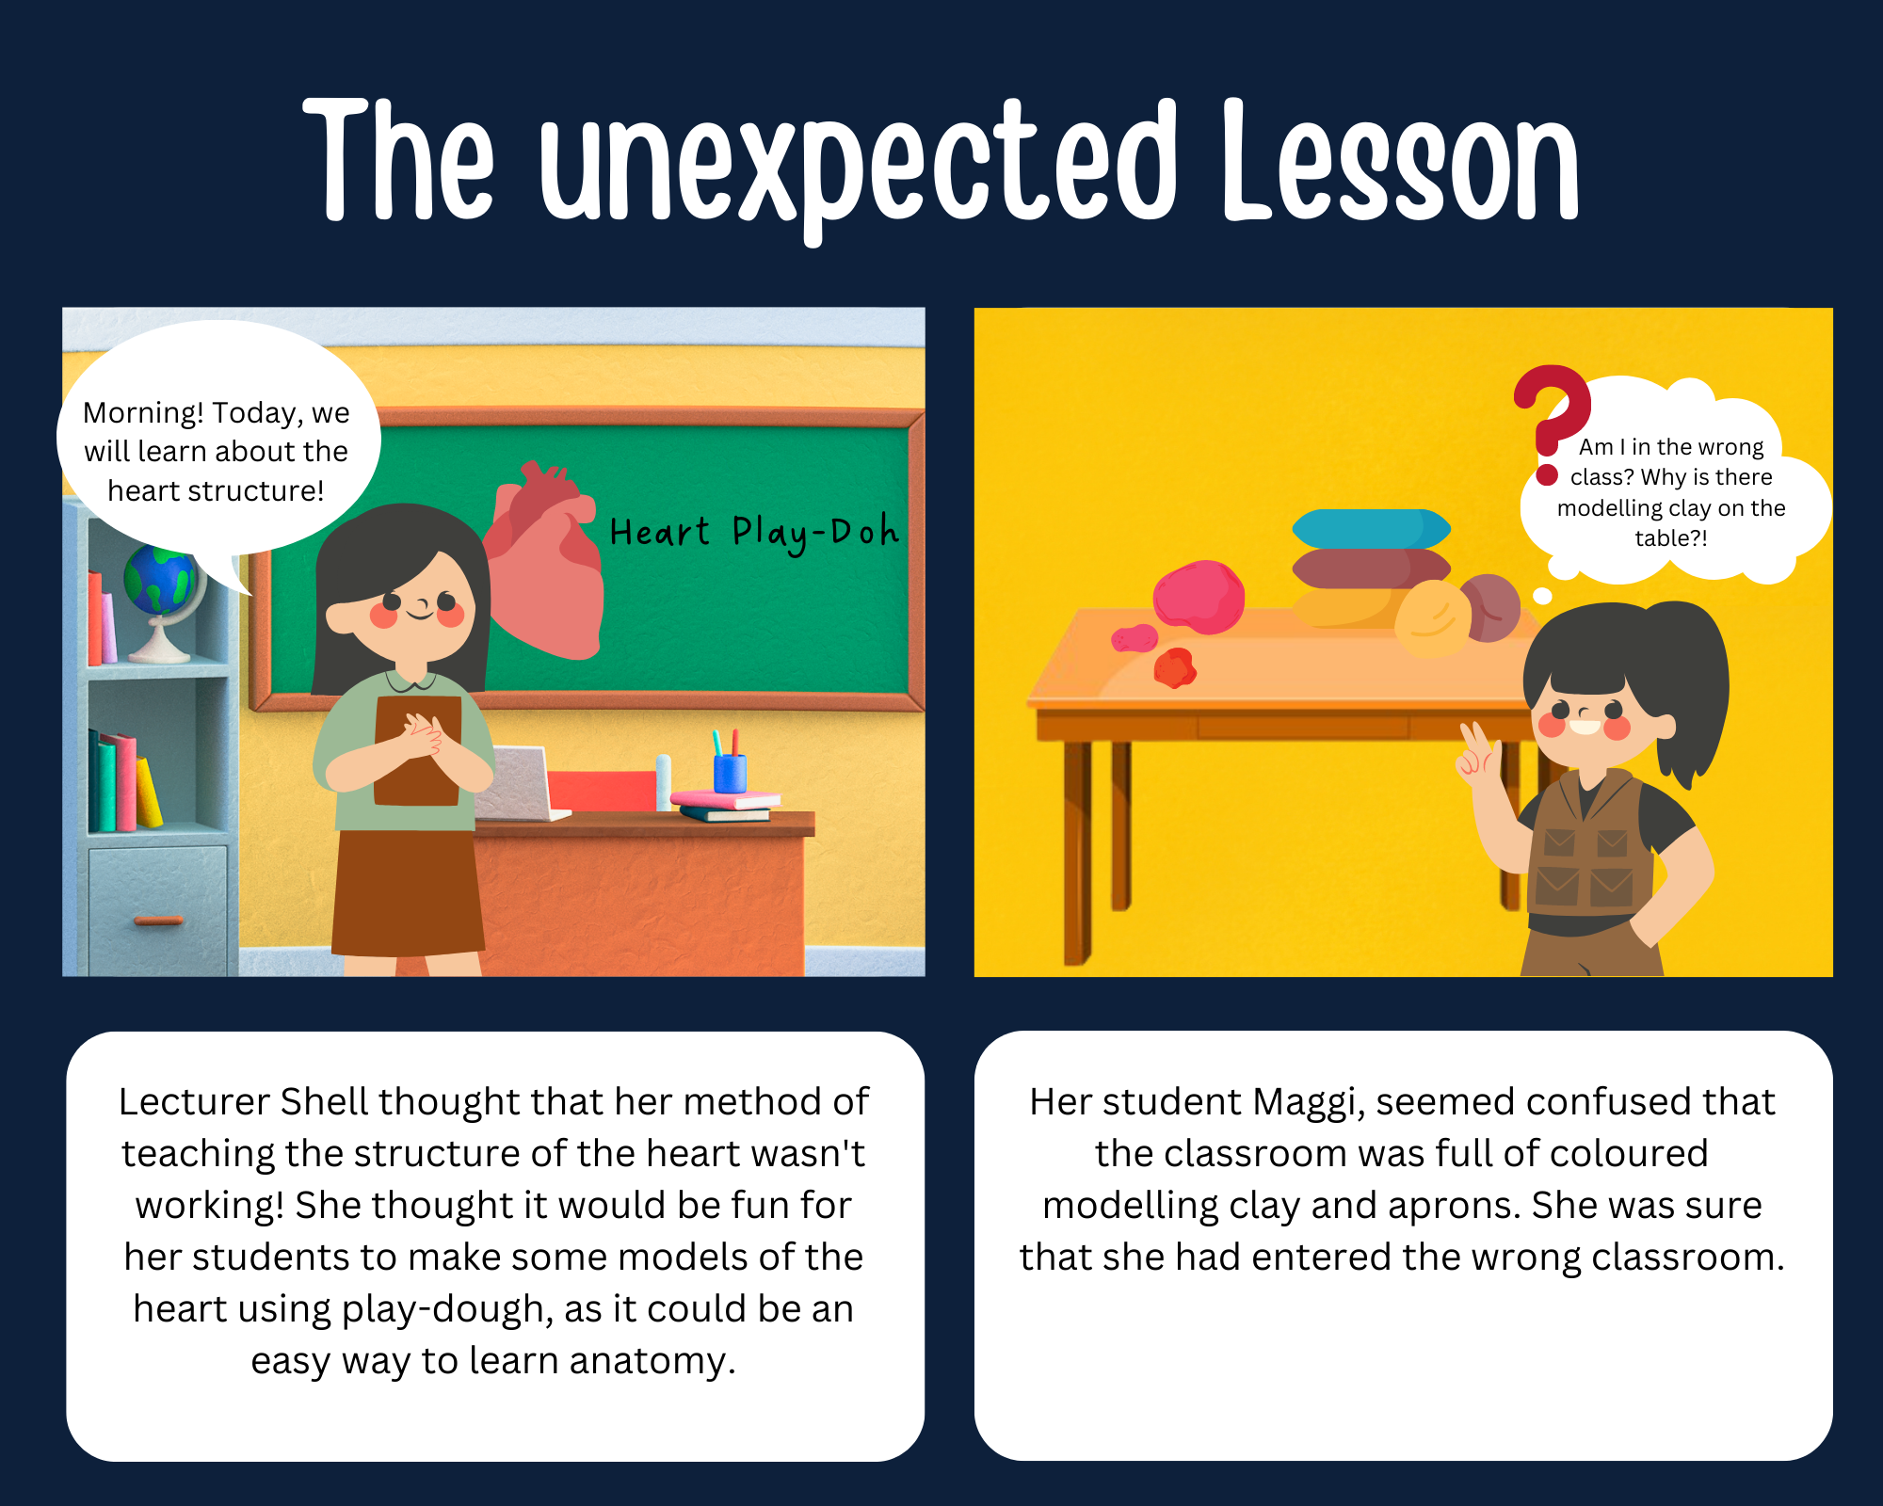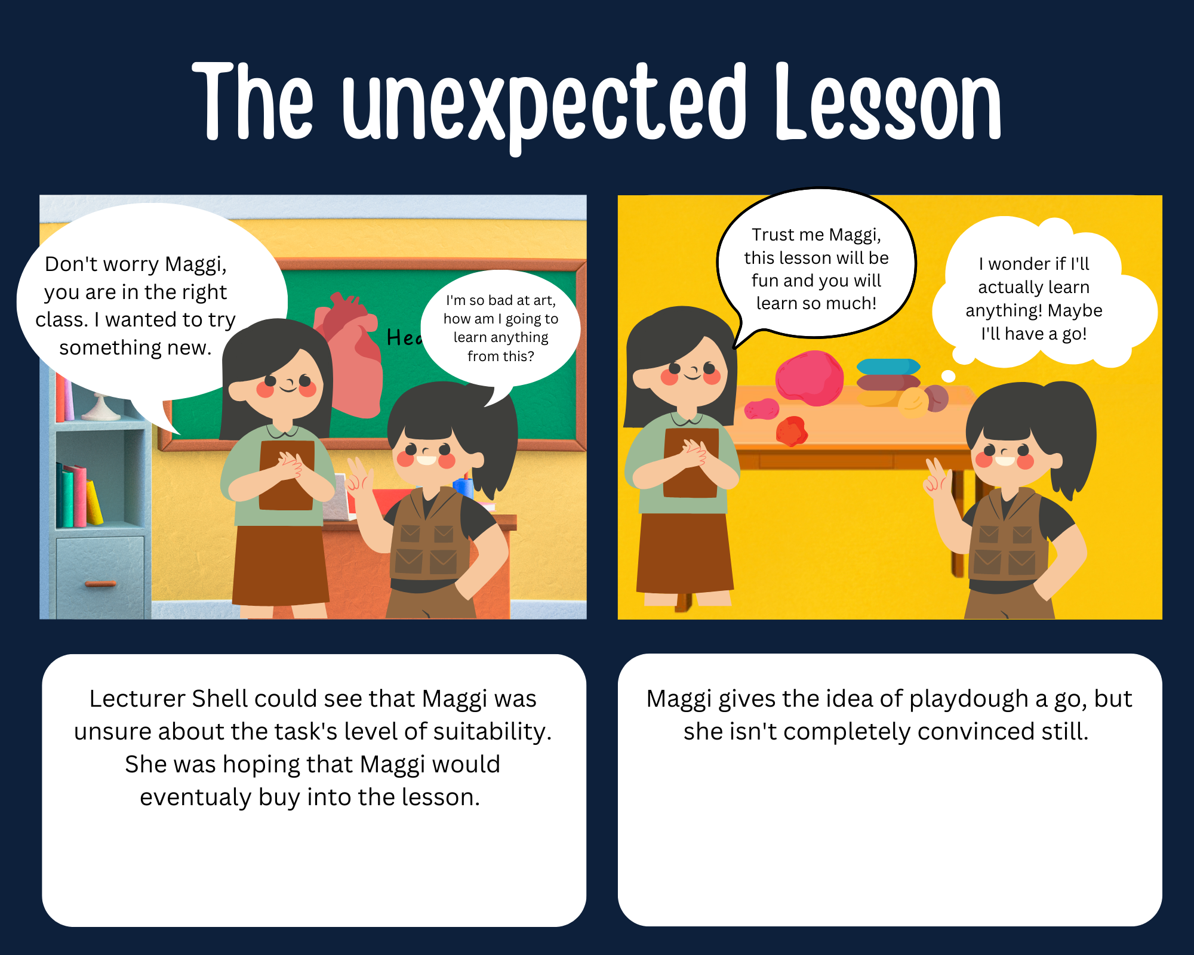
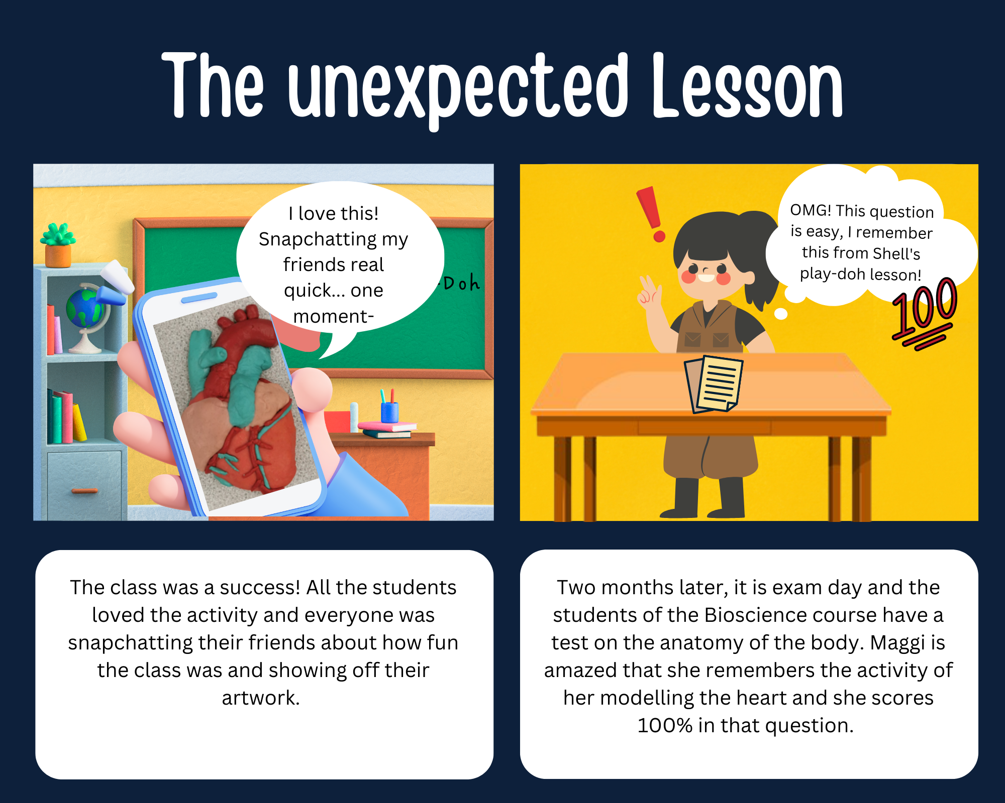

Image: Comic strip illustrating the impact of using playdough in a Bioscience classroom to teach heart anatomy.

Story 11: Owl to Elephant: reflecting on my role

Dr Sarah Hack
sarah.hack@surrey.ac.uk

Bio: Dr Sarah Hack is the Programme Lead for the Foundation Year (FY) in Psychology at the University of Surrey. In her current role, she is able to draw on 15 years’ experience of teaching Psychology within the FE sector. She has a PhD in Psychology and is a Fellow of the Higher Education Academy.

Owl to Elephant: reflecting on my role

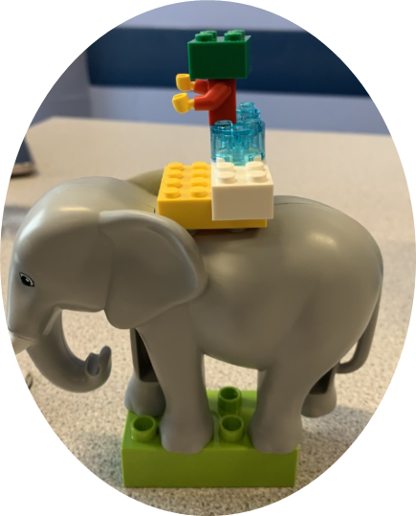
Image: LEGO(R) model of an elephant carrying a person.

The image of the elephant was made by one of my students, it chimed with my perceptions of teaching Psychology foundation year students over the 2021-22 academic year. More than any other year, I felt a greater distance, and a sense I was more the wise owl ‘sage on the stage’, than my intended ‘meddler in the middle’ (McWilliam, 2008). There seemed to be less warmth between us, the snow-topped mountains in the image representing a coolness absent in previous years. Which is not to say that the students were any less lovely than those I have taught in the past, but rather that there seemed to be a qualitative difference in our relationship. In turn this impacted on our roles, and my sense that there was a greater expectation that I was there ‘to teach’, and the students were waiting for me ‘to educate’ them.
What I have come to realise this year is that despite our best intentions, as educators we underestimated the impact of the Covid-19 pandemic on those students who started on degree programmes as things seemingly ‘returned to normal’. This was perhaps particularly the case for students we have worked hard to encourage into Higher Education through widening participation initiatives, and who make up a greater proportion of our FY cohort than the undergraduate programme. The majority of my students started as 18/19 year olds and as such had been out of the physical classroom for the best part of the previous two years. Whilst their teachers will have worked incredibly hard to re-create a sense of community whilst teaching online, we underestimated the impact on communication, and the ability of students to develop relationships not only with peers, but also with their teachers. As a former sixth form college teacher I know how much students change over these two years, how they mature emotionally as well as intellectually. A key part of their journey is a change in their perception of their teachers. We become allies in their learning journeys, supporters and increasingly collaborators as they become more independent learners.
Thus we began the 2021-22 academic year from a different starting point, and it took time for this sense of more collaborative working to develop, but reassuringly, it did. The photo is of a model produced by a student in a LEGO® SERIOUS PLAY® inspired workshop where students were asked to reflect on their experiences of learning and teaching across the first semester. This student explained their model represented their initial sense of bewilderment, of not knowing where they were going, but more importantly, of feeling supported and guided by their teachers, and confident that they would ‘get there’. This reflection reassured me that I was not in fact the rather daunting owl dispensing wisdom from on high, but rather, I still had a key supporting role as students developed confidence in their ability to learn and to work collaboratively with others; this was just less visible than in previous years. Looking ahead, I recognise that although students may not start their HE learning journey ready to engage as collaborators, with time and support they will learn to feel confident to forget the owl, and eventually to walk alongside the elephant.
References:
McWilliam, E. (2008) Unlearning how to teach. Innovations in education and teaching international, 45(3), 263-269.

Story 12: Exploring Micro Stories with Techno-Haiku

Pip McDonald
pip.mcdonald@rau.ac.uk

Bio: Pip (she/her) is a Senior Learning Technology Project Officer at the Royal Agricultural University (RAU). She is also an experimental performance poet. She has recently performed at High Tide Festival in Twickenham, and Wandsworth Fringe festival with the Lost Souls poetry group. She has recently published original poetry in the Aayo Magazine, Spilling Cocoa and the Sun, Hometown, Nature poetry anthologies edited by Sourav Sarkar. You can follow Pip on Twitter: @PipMac6.

Exploring Micro Stories with Techno-Haiku.

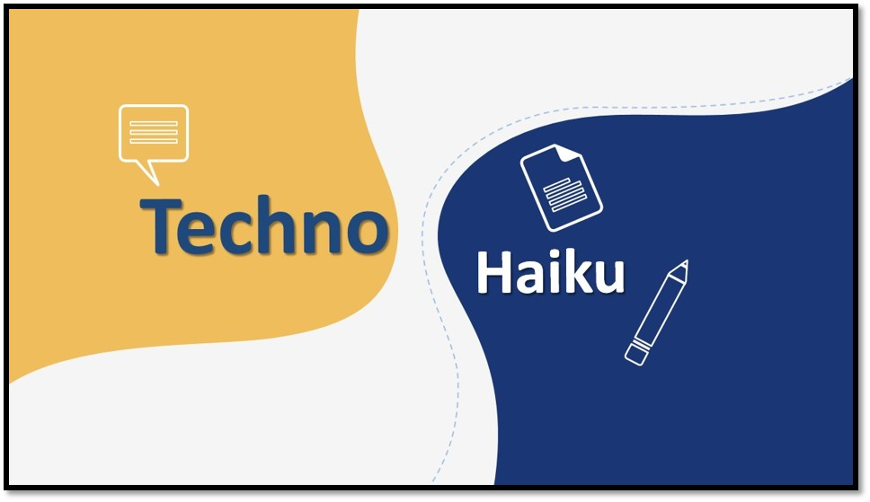
Image: “Techno-Haiku”.
Preamble
Working in a Digital Innovation team in a higher education setting in the capacity of a Learning Technologist and as an experimental performance poet, the combination of educational technology and poetry as a creative practice or techno-poetics emerged as a novel approach.
Haiku is a poetic form originating from Japan. It is created by using three lines with a total of seventeen syllables. Both the first and last lines have five syllables and the second line has seven syllables (Patt, Warkentyne & Till, 2010: p4).
An autoethnographic story can be defined as an “...artistic and analytic demonstrations of how we come to know, name and interpret personal and cultural experience” (Adams, Holman Jones & Ellis, 2015: p1). Drawing on a techno-auto-ethnographic approach, techno-haiku can provide an opportunity to share an “identity performance” in a poetic form (Clark, 2020). A techno-auto-ethnographic poem was published both in the Creative Academic Magazine and the #creativeHE Annual 2021 entitled ‘I’m a Learning Technologist. Get Me Out of Here’. A techno-autoethnographic poem. (McDonald, 2022). A Pecha Kucha presentation exploring the possibilities of techno-poetics was delivered at the Women in Academia Support Network (WIASN) Virtually Undisciplined: Diversifying Higher Education and Research Conference (McDonald, 2022). Pecha Kucha is a “presentation methodology” (Baker, 2014: p3). It was also created in Japan (PechaKucha, n.d.). Finally, a presentation at the Everyday Creativity conference at University of Brighton exploring the potential of techno-auto-ethnographic performance poetry as a creative approach to research methodology was also delivered (McDonald, 2022).
The author Stieg Larsson wrote the Millennium Trilogy which consisted of three books. The Girl With The Dragon Tattoo (2008), The Girl Who Played With Fire (2009) and The Girl Who Kicked the Hornets’ Nest (2009). The story was continued by David Lagercrantz in three other books The Girl in the Spider’s Web (2015), The Girl Who Lived Twice (2019) and The Girl who Takes an Eye for an Eye (2017).

Using the book titles as a prompt, the micro stories of a Learning Technologist in the form of techno-haiku were told.The extent to which the visual or graphic component in ethnographic approaches has been explored in a methodological capacity (Bonanno, 2022). For the techno-haiku story poems, a visual part has been included to “...put the graphic in the ethnographic…” (Bonanno, 2022).

Techo-Haiku Micro Stories

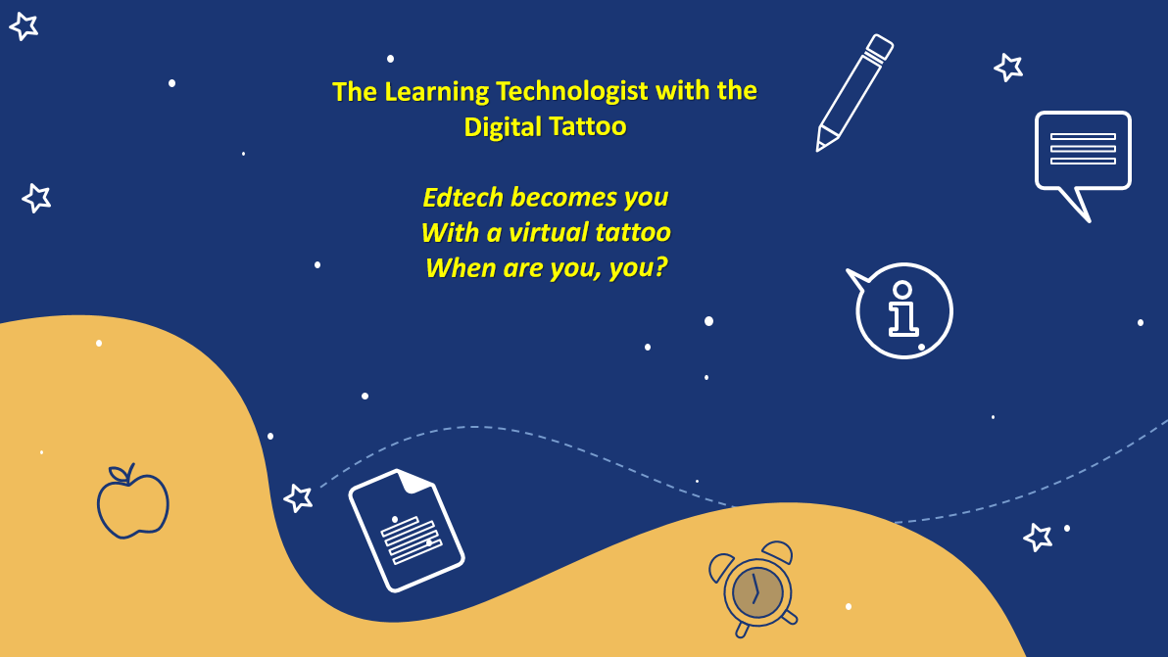
(Eclipse Digital Imaging Inc, 2021).
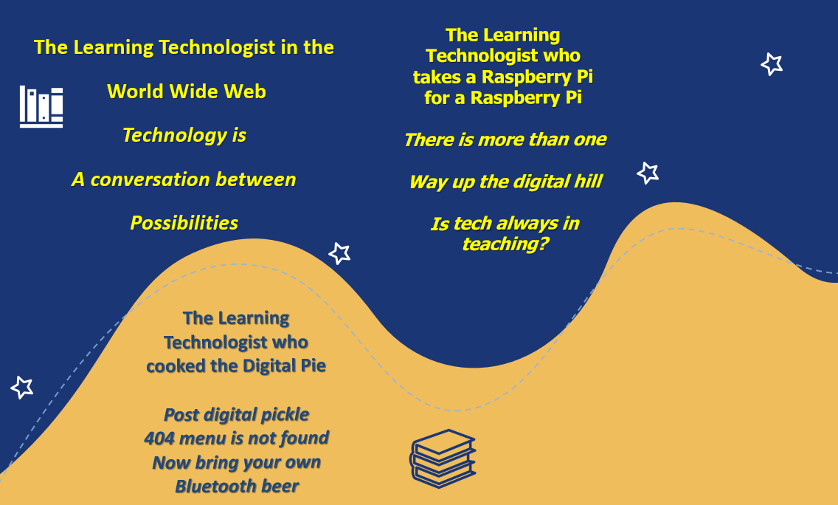
(Eclipse Digital Imaging Inc, 2021).

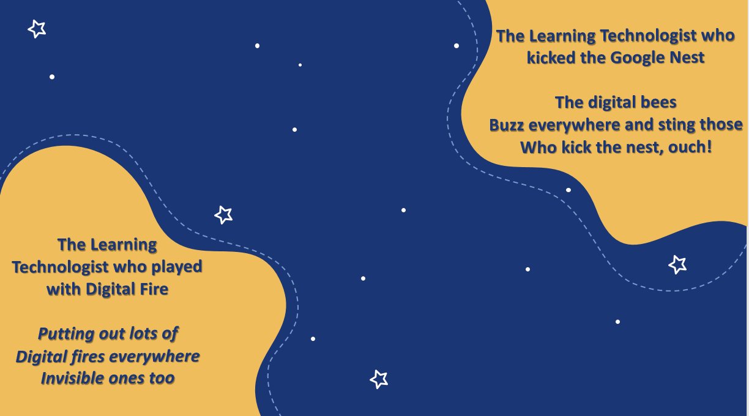
(Eclipse Digital Imaging Inc, 2021).

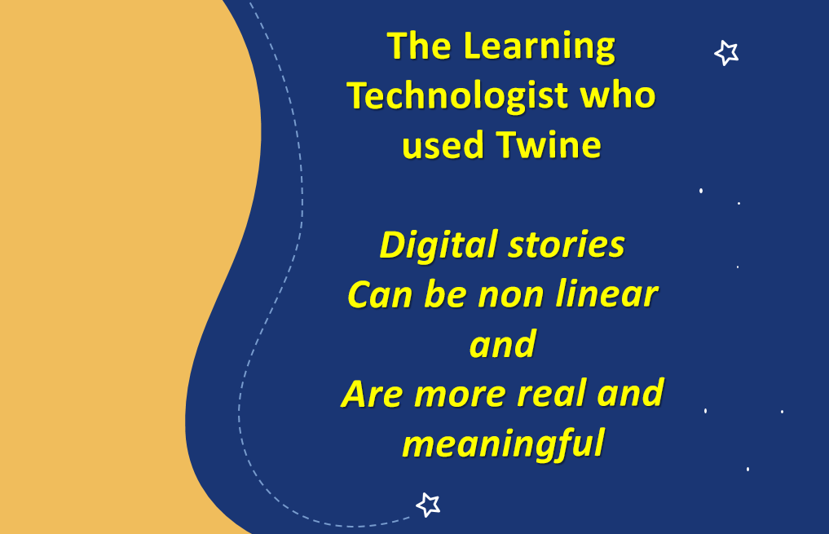
(Eclipse Digital Imaging Inc, 2021).

Bibliography

Baker, T. J. (2014) Pecha Kucha and English Language Teaching. 2nd ed. (s.l: CreateSpace Independent Publishing Platform)

Bonanno, L. (2022) The Graphic in the Ethnographic: A Serious Methodological Turn or Just Some Visual Fun? https://culanth.org/. Cultural & Anthropological Blog [blog]. 28 July, Available at: https://culanth.org/fieldsights/graphic-in-the-ethnographic [Accessed 8 August 2022]

Clark, D. (2020) “Tech and me: an autoethnographic account of digital literacy as an identity performance”, Research in Learning Technology, 280. doi: 10.25304/rlt.v28.2389 [Accessed 8 August 2022]

Eclipse Digital Imaging Inc. (2021) School Wave Theme (Online) Available at: https://www.presentermedia.com/powerpoint-template/school-theme-wave-pid-27036 [Accessed: 8 August 2022]

Larsson, S. (2008) The Girl With The Dragon Tattoo. Translated from Swedish by R Keeland (London: MacLehose Press)

Larsson, S. (2009) The Girl Who Played With Fire. Translated from Swedish by R Keeland (London: MacLehose Press)

Larsson, S. (2009) The Girl Who Kicked the Hornets’ Nest Translated from Swedish by R Keeland (London: MacLehose Press)

Lagerkrantz, D. (2015) The Girl in the Spider’s Web Translated from Swedish by G Goulding (London: MacLehose Press)

Lagerkrantz, D. (2017) The Girl who Takes an Eye for an Eye (London: MacLehose Press)

Lagerkrantz, D. (2019) The Girl Who Lived Twice.Translated from Swedish by G Goulding (London: MacLehose Press).
McDonald, P. (2022) The Possibilities of Techno-Poetics [PowerPoint presentation] Women in Academia Support Network (WIASN) Virtually Undisciplined: Diversifying Higher Education and Research Conference. April 2022. Online.
McDonald, P. (2022) Do-Techno-poets dream of electric sheep? Exploring the potential of techno-auto-ethnographic performance poetry as a creative approach to research methodology. [PowerPoint presentation] Everyday Creativity. Towards an International Research Network conference. University of Brighton. June 2022.
McDonald, P. (2022) One Small Step for Techno-Poetic Kind. Performing a Digitally Enhanced Techno-auto-ethnographic Poetry Comic. [PowerPoint presentation] Action, Creativity and Learning, for Healthy, Sustainable, Regenerative Futures Open Mic Conference. Online. July 2022.
McDonald, P. (2021) ‘I’m a Learning Technologist. Get Me Out of Here’. A techno-autoethnographic poem’ in Creative Academic Magazine. A Selection of Articles from the e-Book Being Creative in the Face of Adversity: Annual #creativeHE collection 2021 Creative Explorations & Practices Emerging from the Pandemic [pdf] pp36-40 (Online) Available at: https://www.creativeacademic.uk/uploads/1/3/5/4/13542890/cam20.pdf [Accessed 8 August 2022].
McDonald, P. (2021) ‘I’m a Learning Technologist. Get Me Out of Here’. A techno-autoethnographic poem in Tasler, N., O’Brien, R, E. & Spiers, A. (eds.) (2021) Being creative in the face of adversity. The #creativeHE Annual 2021. Creativity for Learning in Higher Education Community, #creativeHE. [e-book] pp37-44, DOI: https://doi.org/10.25416/NTR.17709860.v1 [Accessed 8 August 2022].
PechaKucha (n.d.) PechaKucha (Online) Available at: https://www.pechakucha.com/about [Accessed 10 August 2022]
Patt, J., Warkentyne, M., & Till, B. (2010) Japanese Art and Poetry (San Francisco: Pomegranate)

Story 13: A creative interpretation of 99 Online Education Buzz Words

The TALON team - Sandra, Fabian, Kylie and Krisha
sandra.abegglen@ucalgary.ca

Bio: TALON is…
- A Teaching and Learning Online Network
- An interactive lexicon of tools and resources for remote teaching and learning
- A hub for critical discussion of approaches to online design education
- A bulletin keeping the academic community informed about current developments in the virtual classroom
https://taloncloud.ca/
@talon_cloud

The human bios:
Abegglen, Sandra is a Researcher in the School of Architecture, Planning and Landscape at the University of Calgary where she explores online education and learning and teaching in the design studio. Sandra has extensive experience both as a social researcher and lecturer/program leader. She has published widely on collaboration and co-creation, emancipatory learning and teaching practice, creative and playful pedagogy, and remote education. She has been awarded for her interdisciplinary, multi-stakeholder education work with the University of Calgary Team Teaching Award 2020, and the ​​Collaborative Award for Teaching Excellence (CATE) 2022 by AdvanceHE.

Neuhaus, Fabian PhD, is an Associate Professor at the University of Calgary with the School of Architecture, Planning and Landscape in Canada. He is the research lead for the Richard Parker Initiative (RPI) and the principal investigator for TALON and NEXTCalgary. His research interests are the temporal aspects of the urban environment, focusing on the topics of habitus, type, and ornament in terms of activity, technology, and memory. He has worked with architecture and urban design practices in the UK and Switzerland as well as on research projects at universities in Switzerland, Germany, and the UK. He is passionate about learning and teaching, and design pedagogy.

Shah, Krisha is a Graduate Student in the Master of Planning program at the School of Architecture, Planning, and Landscape, University of Calgary. She was admitted to the program in the Fall of 2021 as an international student. With a background in Architecture and a passion for community driven projects, Krisha has joined the TALON team as Graduate Assistant Researcher in January 2022. She works actively on managing the social media for TALON, connecting with the community of educators and learners.

Wilson, Kylie is a Graduate Student in the Master of Architecture program at the School of Architecture, Planning, and Landscape, University of Calgary. In the 2020-2021 academic year, she was admitted to the program, being currently in her final year. Before pursuing architecture, she graduated with a Bachelor of Arts in Communications, Minoring in Political Science, also from the University of Calgary. She joined the TALON team as Graduate Assistant Researcher in May 2021 and works actively on the project's audio-visual content collection, newsletters and TALON publications. Kylie is passionate about storytelling and knowledge-sharing through media.

A creative interpretation of 99 Online Education Buzz Words.
We asked for 99 words about online education - and here they are. People registered on Minus (https://minus.social) - the finite social network where you get 100 posts, for life - can look up the accompanying keyword definitions by searching for: TALON_Cloud.

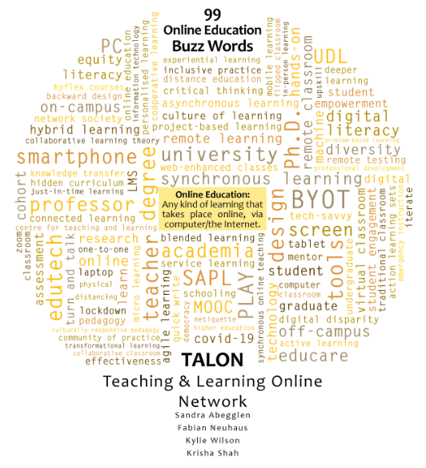
Image: TALON, the Teaching and Learning Network, provides 99 Online Education Buzz Words.

Bibliography

TALON (2022) TALON Manifesto & Glossary. (Online) Available at: https://taloncloud.ca/Manifesto-Glossary [Accessed 25 August 2022]

Story 14: Look Out

Charlotte Stevens
charlotte.h.stevens@open.ac.uk

Bio: Dr Charlotte Stevens joined The Open University in 2005. She has held a number of roles broadly based on the delivery of subject-based educational advice and guidance, quality assurance and enhancement, and management of systems. She is part of the Associate Lecturer Support and Professional Development team and is interested in using art and craft as a means of reflection.

Look Out

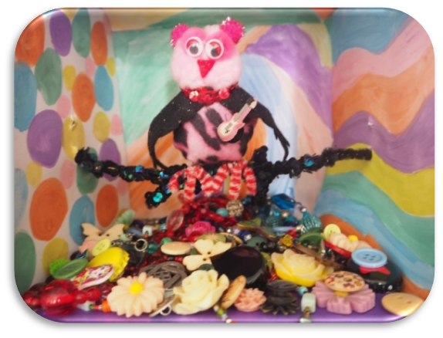
Image: home-made owl

T-wit…T-wit…T-wit…
I know what you’re thinking. Where’s my T-woo?
Well, you’ll be pleased to hear, there is a T-woo. And, now that I’ve found it, I must say it’s been life changing! Have I got your attention yet? I hope so.
You see, I was always a creative little owlet, never happier than when my feathers were covered in paint and glitter. When I entered the real world, I packed away that part of me in a box marked ‘weekend’. Sure, there were times when creativity crept through in the day job, when a presentation needed an imaginative twist, or when it was time to build a new future from Lego, but Creativity didn’t feature. Shame.
Then things changed. I stumbled upon #creativeHE.
T-woooo….
I met others like me, and we got together online and made things. Except. My new friends were braver and more daring than me. They brought Creativity into their practice. Could I do the same? Risky.
I took the plunge. I did shout Geronimooooo…but I was wearing water wings 😉
What I’ve learnt is that, if we were all perched on the same branch, looking down at Creativity Sea, we’d feel very differently about what lies beneath. For some of us, that sea would be full of fear; we’d get in a flap and want to fly the hell out of there. Others might feel a little excited by the danger, but hold back for fear of looking a bit of a…T-wit…But, for a few of us, that sea would be a landscape full of ideas, playfulness and magic. We wouldn’t want to calm the waves; we’d want them to come straight at us.
None of these responses is wrong, although sometimes it’s hard for the Creative to see that. We want to help others learn how to fly, just like us. We want them to open the door and let it all in.
T-wit…Twooooo…

Story 15: The Art of Collaboration: moving beyond your comfort zone

Anne Marie Morrin, Dr Anne Dolan and Dr Sandra Ryan
annemarie.morrin@mic.ul.ie

Bios:
Anne Marie Morrin is a lecturer Visual Art Education in the Dept. of Arts Education and Physical Education in Mary Immaculate College, Limerick. Anne Marie's particular interests include interdisciplinary approaches to visual art education; STEAM Education; educational environments as pedagogy; reflective journals as a tool in the classroom and art-based research.

Anne Dolan is a lecturer in primary geography in the Dept. of Learning, Society and Religious Education, Mary Immaculate College, Limerick. An enthusiastic educator Anne is particularly interested in creative approaches to geography, interdisciplinary collaboration, and the use of the arts in geographical explorations. Her current research focuses on approaches to teaching sustainability and climate literacy.

Sandra Ryan is a lecturer in sociology of education in the Dept. of Learning, Society and Religious Education, Mary Immaculate College, Limerick. Sandra’s current research focus is on parent engagement and teacher education needs in relation to working with parents. She is passionate about the central role of parents in their children’s learning, particularly as it relates to addressing educational inequalities, school improvement and social justice.

The Art of Collaboration: moving beyond your comfort zone

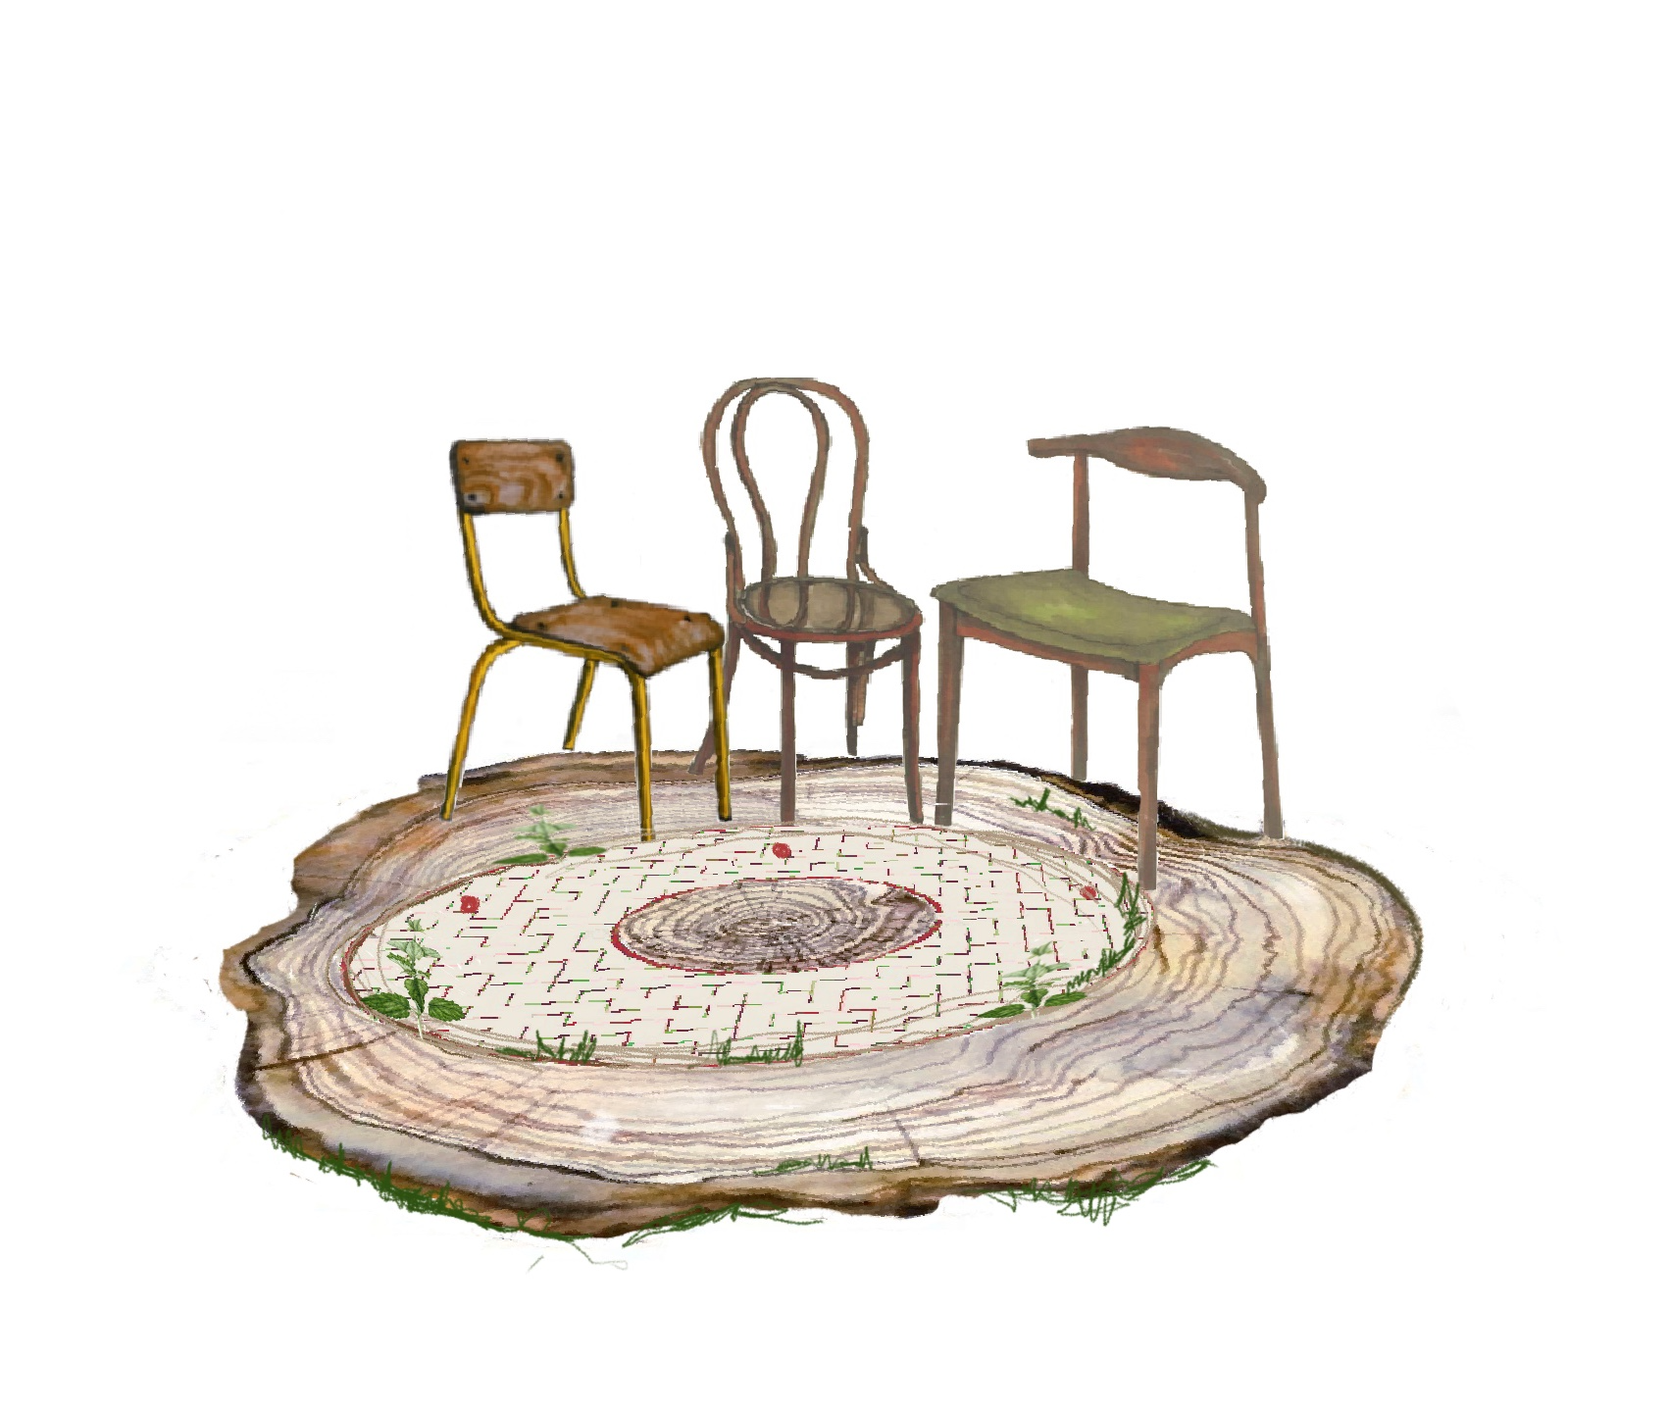Image: Our three chairs

The created image and poetry verse is a reflection on an initiative to promote innovative ways for collaborative partners (educators in Visual Art, Geography and Sociology) to engage and respond to innovative pedagogies and assessments. The project offered a professional development approach to use arts-based instructional strategies, offering an accessible gateway to understand and foster creative pedagogical approaches, promoting creativity, imagination and to generate critical thinking skills in a higher education setting.

The Art of Collaboration: moving beyond our comfort zone

Our chairs are hard to sit on
We need to move, swing, clap our hands
Splash, walk, study, talk
Can I try your chair? Can we swap, or have you a spare?
Let’s ground ourselves and try to settle
On each other’s grass and each other’s nettles
Let’s sit, let’s walk
Can we play? Can we talk?
We learn as we go
Our rings start to grow
The walls of our lives begin to blur
Yet our growth is defined, much more than we were

From three different worlds, a maze of unknown
I followed you and you weren’t alone
I learnt from you how you navigate
You learnt from me and now we create
Looking to the core of what we seek
Much more than before, we are complete
More comfortable now, I take my seat
We learn as much as we teach.

Story 16: Drawing on experience

Paul Kleiman
paulrk22@gmail.com

Bio: I am Senior Consultant (HE) at Ciel Associates and a Visiting Professor. My work and research focuses on creativity particularly in regard to assessment and curriculum design. My background is in the performing and visual arts and I was one of the founding tutors of the Liverpool Institute for Performing Arts. My work around creativity is cited widely in books and journals.

Drawing on experience

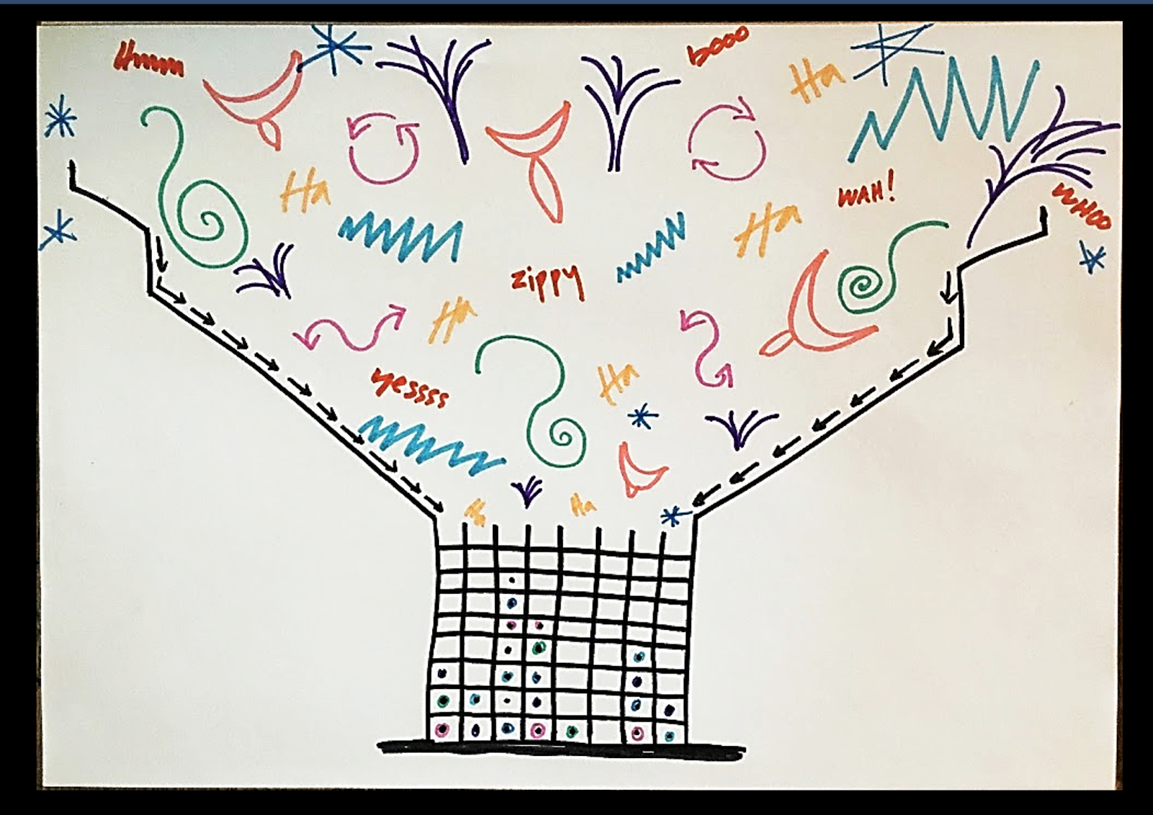
Image: Visualisation of assessment as attempting to funnel wonderful, creative, free-flowing ideas and outcomes into a very restricted container of rigid boxes.

After a number of years working professionally in the performing and visual arts I eventually stumbled into teaching in higher education. I was immediately struck by the fact that I had swapped a very physical, visual, and tactile world for the world of words and ideas…a very cerebral world.

Academics tend to live and work in their heads. In recent years, a significant part of my work has been spent working with academics on areas such as creative approaches to assessment and curriculum design. When I run a workshop, no matter what the disciplines are in the room, I usually start - as with an opener/icebreaker - by getting the participants to draw something related to the topic we are discussing. The word ‘draw’ often attracts some resistance of the ‘oh, I can’t draw’ variety. So I tend to use the phrase ‘make marks on paper’ to assuage the hesitant. There are big sheets of paper and lots of coloured pens. The participants have c. 10 minutes to create an image and then they each have 30 seconds max. to explain what they have drawn.

The Covid-19 pandemic meant that all workshops and seminars moved online. For the past three years I have led an annual online staff development sessions for a UK HE institution. The 21-22 session was on ‘Assessing Creativity/Creative Assessment’. Before the session I asked the participants to draw/make marks on paper about assessment and, in particular, how they felt about assessment and where they located themselves in relation to it. Rather than the ‘quick and dirty’ 10 minutes in the in-person workshops, the participants had as much time as they needed. The only constraints were that they had to submit a photo of what they had created by a deadline a few days before the session so that all the images could be collated and to provide a short written explanation that could be read out in 30 seconds.

A series of wonderful, imaginative, thought-provoking images arrived in my inbox accompanied by the explanations. One image, particularly, struck me as encapsulating a great deal about assessment.That is the image shown here. The explanation that accompanies it is as follows:

‘This is where I am regarding assessment. Student work is expansive, muti-dimensional and multi-coloured. This is how I feel when I come to quantify (assess) a student’s work - like I am funnelling a wild and wonderful rainbow into a grid better suited to a game of noughts and crosses.’

Other submissions reveal landscapes of mountains and various hazards; images of confusion and being lost, portraits of anxiety. These images and their explanations are not only powerful in themselves but they also act as catalysts for reflection and discussion. While the cerebral nature of academia is one of its core strengths, we ignore the potential for engaging with the visual/physical/tactile at our peril.

Story 17: Re-humanising Education, through Art

Melanie Foot
Melanie.foot@sunderland.ac.uk

Bio: A Senior Lecturer in TESOL at the University of Sunderland and previously a Head of Art at a secondary school, Melanie seeks to positively connect the processes and values of artists to the work of educators, particularly in the field of English Language Teaching.

Re-humanising Education, through Art

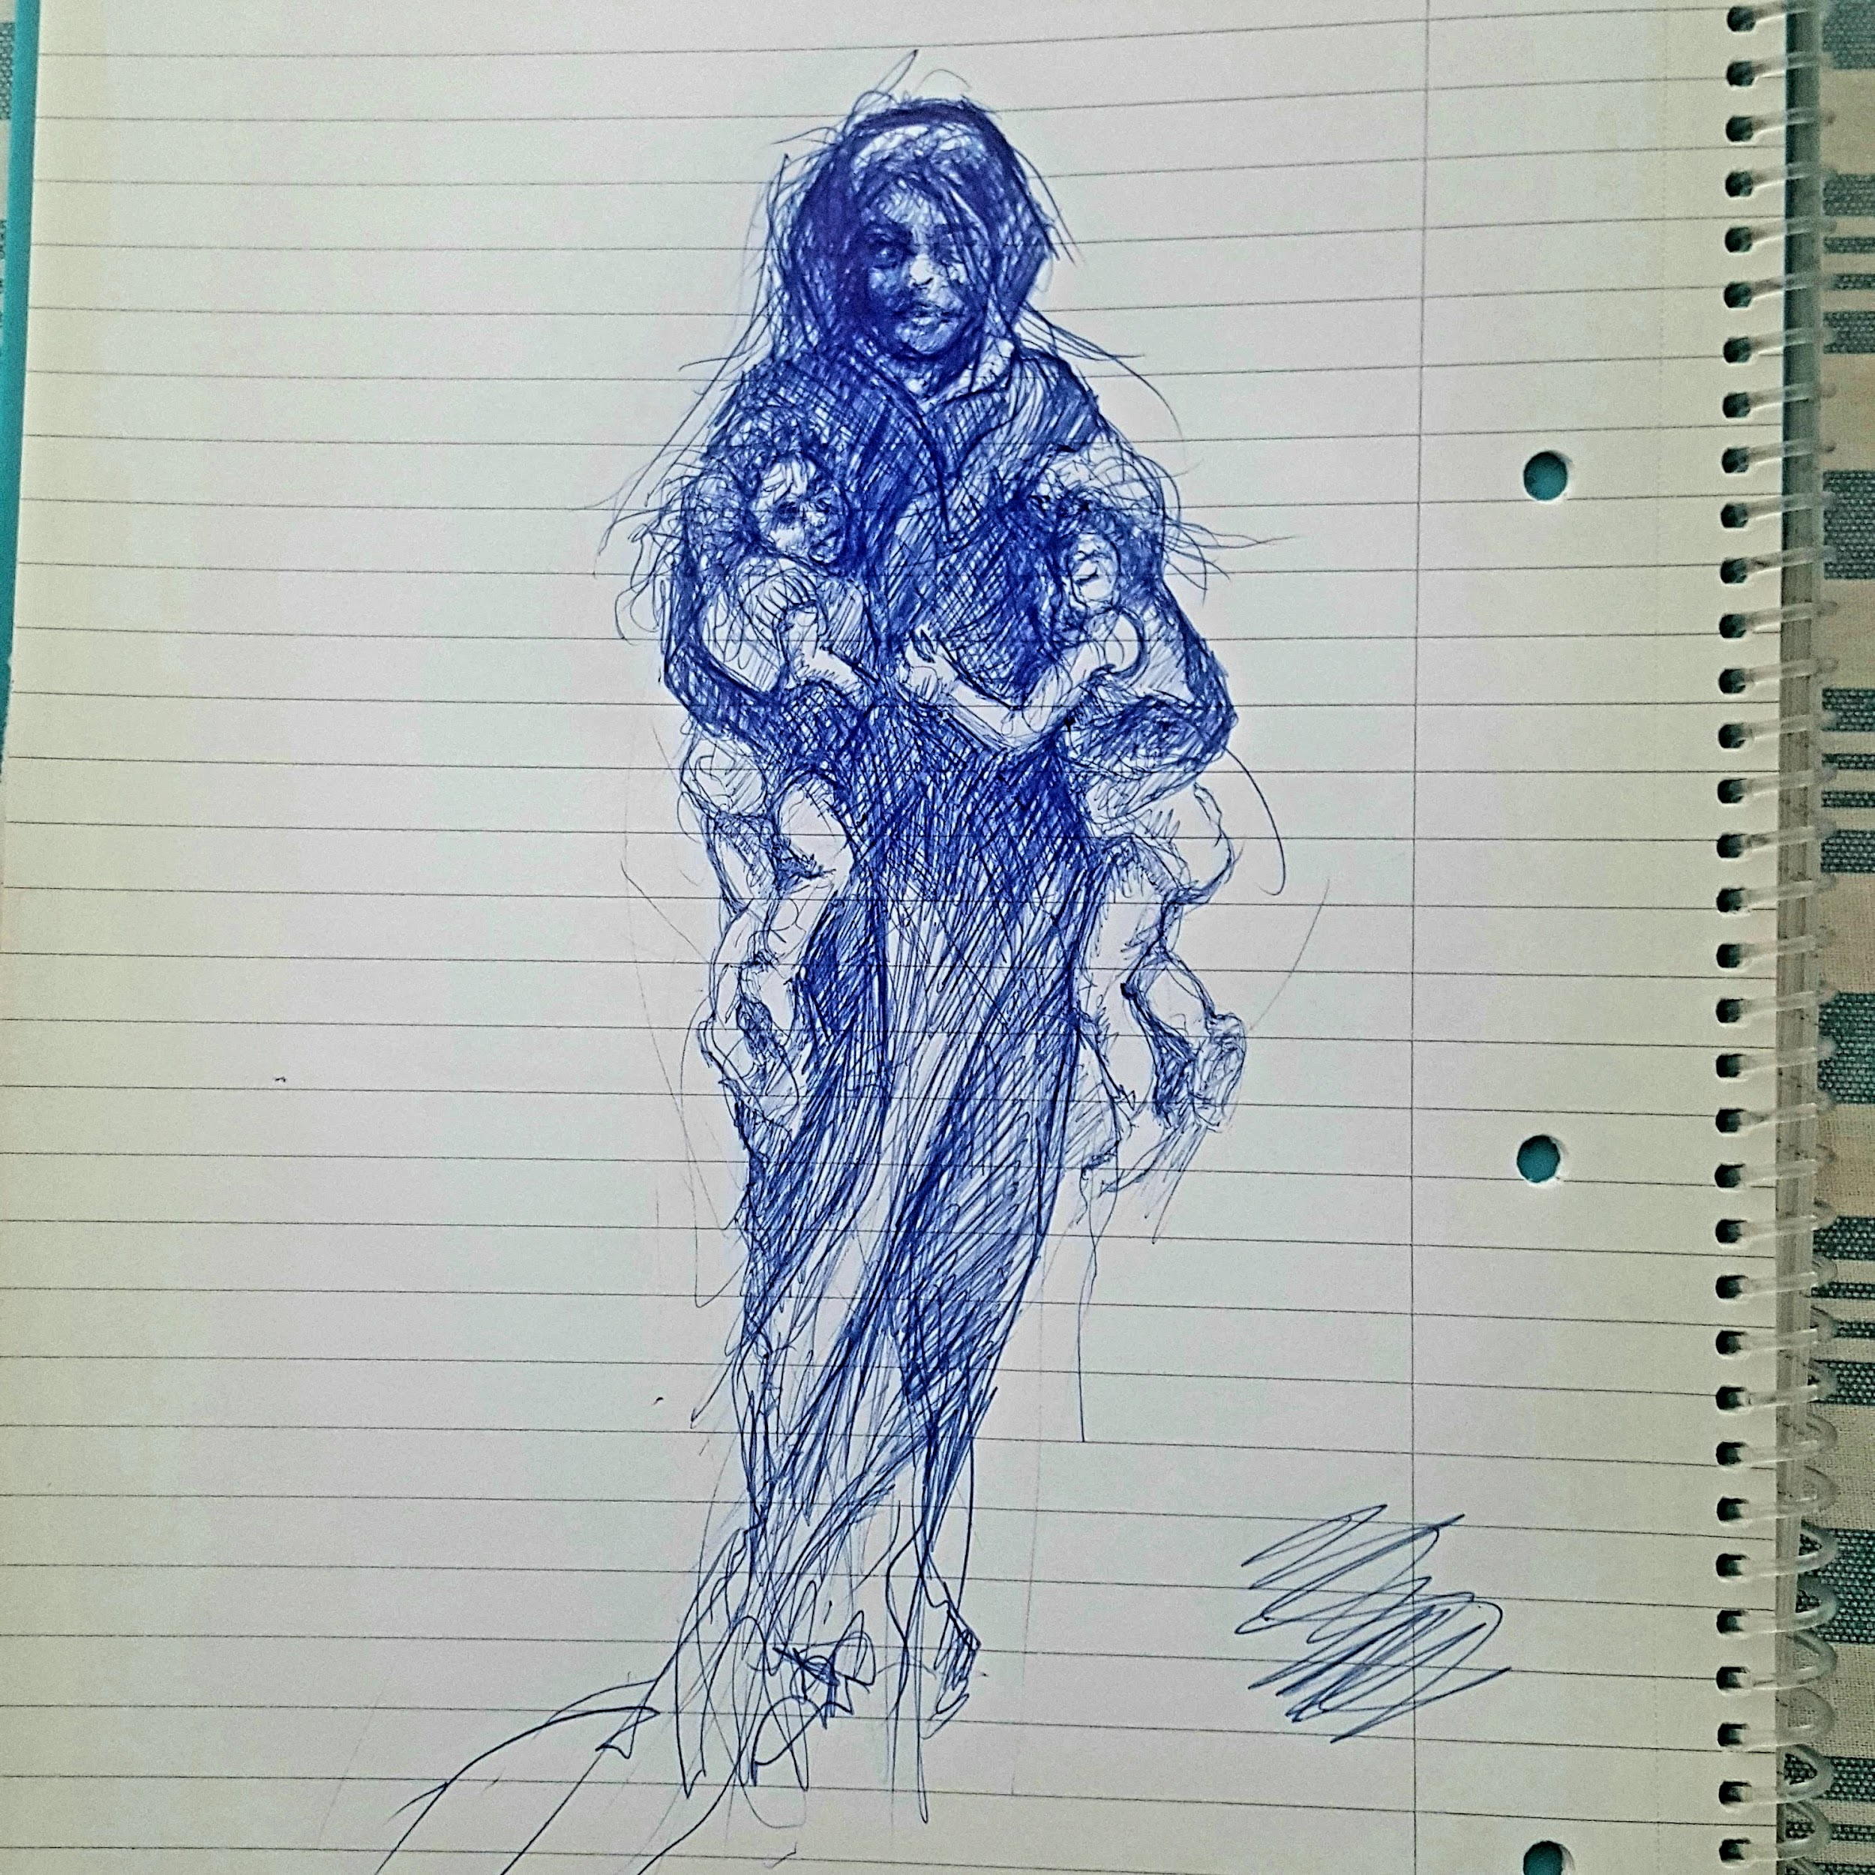
Image: Photo-journalism provides my inspiration for drawings as a personal reaction to our world. A rapid biro sketch of a woman fleeing with her children.
I've got my biro in my hand and I'm looking at the face of the woman in the photograph. Without knowing, I assume she's a mother, like me, and for a second I feel terror. Then I relax and I concentrate on drawing the children's legs because I remember how fortunate I am that I'm not running from my own life, like she is. And then I feel guilty and I try to make the drawing as powerful as I can as a tribute to her and all women like her, who are running and suffering. I'm making strong lines to represent her movements.

It's just a doodle, a little technical challenge for myself and maybe to release some pressure, but the process leads me to think deeply, feel strong emotions and make a physical connection to the image through my hand and heart.

At the same time, I was reflecting on teaching my university students online and felt a bit restless. They were TESOL students who should have been in a classroom practising peer teaching, taking risks and learning to trust each other as they critique each other's mini lessons. Instead, because of continuing Covid rates, they were doing a valiant job of teaching each other online. However, without the physical cues, eye contact and informal chatting that happens in a live classroom, the relationships weren't forming like in other years. It felt dehumanised.

My drawing was a response to this dehumanised teaching experience, an attempt to check in with my emotions and perhaps the reason I chose such an emotive photograph to copy. As I'm drawing, I'm becoming vaguely irritated that I didn't capture the woman's expression exactly, but quite pleased with the structure of the children's bodies and feet.

Now I'm critiquing my drawing using my harshest, internal criteria reserved only for my own art works, leading to more emotions. Opening up that portal to feelings allows my mind to fully engage with the reflective cycle I'm absorbed in and gives me a short time for a focused, deep analysis, to search for solutions and consider actions to re-humanise the peer teaching experience for my students.

In this instance, an auto-ethnographic narrative of a lived experience of a lecturer reflecting upon an unsatisfactory teaching episode, art is used as a tool for focus, to take time out to think and as a catalyst to emotions that stimulate productive problem solving for re-humanising an educational issue. This time, it's not art in the classroom for the students to participate in, but instead, it's art for the lecturer, with the aim of improving the student experience through reflection and exploration of solutions. The solutions themselves aren't necessary to explain here, just the journey to them.

Schön. D (1983) The Reflective Practitioner: How professionals think in action. New York: Basic Books

Story 18: Riding the great wave: sink or swim?

Anne-Marie Greenhill
a.m.greenhill@dundee.ac.uk

Bio: I work at the University of Dundee’s Academic Skills Centre as the Academic and Digital Literacies Officer. My role is varied and wide-ranging: I’m a module lead, collaborate with colleagues in Schools to develop and deliver content on their modules, have responsibility for the Centre’s web pages, create student resources and am also our team’s impressively-named Digital Champion. I enjoy learning and making learning fun for our students too. When I’m not involved in all things academic I can be found knitting everything from a Clanger (showing my age!) to baby cardigans, or running around after my youngest grandson.

Riding the great wave: sink or swim?
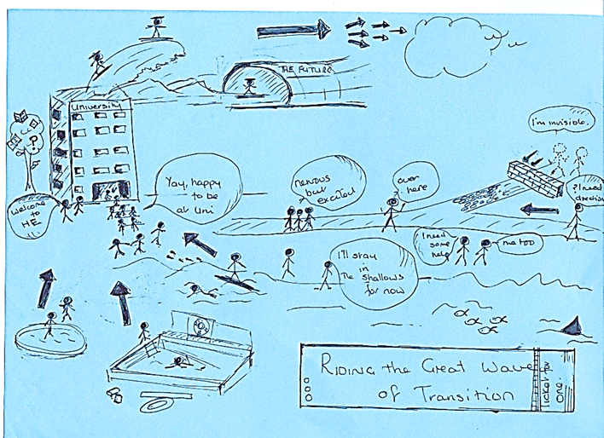Image: Students transitioning to university study through an access summer school online skills module

Many children are lucky enough to learn to swim in safety with encouragement and support from someone with experience. When they progress to deeper or more challenging waters, they will have developed the skills necessary for them to thrive, develop and survive in a variety of watery environments.
Some might start off needing flotation devices in the paddling pool, with these becoming superfluous to requirements as their abilities increase and they progress to the deep end. Some might develop skills enabling a transition to swimming in the ocean, entering competitions, joining others in synchronised swimming, or even surfing the great wave.
Others never learn to swim, perhaps they haven’t had opportunities or guidance, lack confidence, or even fear the thought of getting into the water. Some might have things that weigh them down. Some will not have their first encounter with swimming until adulthood. So, what do these adults do when they decide they want to take up swimming and join the many others who have already mastered that art?
Perhaps a few of my students might have felt transitioning into HE for the first time was a bit like learning to swim. Your first encounter with HE also depends on your background, existing skills, how you tackle new challenges and what support you are given, are prepared to accept, or reach out for. Are you prepared to embrace this new and sometimes scary environment? Do you have fears or other things that might hold you back? Do you tackle it as a solo experience, or will you share it with others, seek guidance from an expert or just go it alone and make it up as you go along? Once you’ve taken the plunge, do you know where to find out what you need to do, do you sink or swim, or reach out for the lifebelt that is thrown to you when you need it?
Some of my students on my transition module followed instructions and jumped straight in with no problems. They engaged with their peers, shared their reflections, and enjoyed their new learning environment. There were a few who needed their wings or rings a bit longer than others but mastered things in the end. Others just didn’t even know they had arrived at the water’s edge or had to be thrown a lifebelt. Happily, the vast majority, once what they had to do was explained and they started to immerse themselves in the module, had an enjoyable and rewarding experience which prepared them for the great wave of first year; as evidenced by the many positive and thoughtful reflections they shared with peers and tutors. However, a very small number just didn’t engage and there was no rescuing them despite best efforts. Why? What were the stumbling blocks for them? Encouraging these students to dip their toes in the water and take those first steps to riding the great wave to graduation is my focus for the next delivery of the module.

Story 19: The Great Confluence

Lovleen Kushwah and Geethanjali Selvaretnam
Lovleen.Kushwah@glasgow.ac.uk
Geethanjali.Selvaretnam@glasgow.ac.uk

Bios:
Dr Lovleen Kushwah is a Lecturer at the Adam Smith Business School, University of Glasgow. She has assumed roles of Honours Convenor, Senior Adviser of Studies, Complaint and Academic Integrity Officer, and Dissertation Convenor for the UG Economics degree. Her current research focuses on Macroeconomics, Sustainability, Supervision, Inner feedback, Assessment and feedback, Mental Wellbeing and Peer support. She holds a PhD in Economics from UC3M (Spain) and a fellow of RET. Prior to joining academia, Lovleen worked for HSBC and GE Money.

Dr Geethanjali Selvaretnam is a Senior Lecturer in Economics and is the Deputy Head (EDI & Sustainability) at the Adam Smith Business School, University of Glasgow. She has previously worked at the University of St Andrews, Royal Holloway and University of Essex, where she graduated with a PhD in Economics. Before academia, she worked as an accountant and at the Central Bank of Sri Lanka. In addition to her research interests in Development Economics, she researches on inner feedback generation, different assessment formats and multicultural interactions.

The Great Confluence
Image: “Two rivers meeting together preserved itself. Inseparable yet different. Varied shade of same hue, flows together, singing in same tune.” – (I. Ali)

We grew up in countries which are diverse in many aspects such as language and religion (India and Sri Lanka); currently live in the UK which is also seen as a multicultural country and work in the Higher Education sector with students coming from all over the world. Some of our observations of interaction across cultures have given rise to this piece of work.
We often see students, during class breaks, gather around and interact with those who speak the same language. Sometimes these circles are made up of those not only speaking the same language but also from the same area.
Here is one such occurrence, too important to be ignored. MA Economics is a popular degree programme. In the 2nd year, a large group of students from Glasgow International College (GIC) join another large group of students who are already at the University of Glasgow. These students, predominantly from China, make up about one-third of the total class size which is around 400 students. This phenomenon reminds us of a confluence, which the Oxford dictionary explains as “the place where two rivers flow together and become one”.
General observations suggest that the students from GIC tend to stick together, as do the other students to their own groups. This is not surprising given they join after a year of having already formed their own friendship groups. This situation is different to students who come on their own for a study-abroad year and make friends from different backgrounds.
Given these observations, we come to a valuable conclusion that students being willing to integrate into an existing body or welcoming someone from a different background does not depend on which diverse group they belong to. In fact, it depends on the size of the groups. Interactions across diverse groups are more likely when the size of the main groups are small.
In such situations where groups of students are not naturally interacting with each other, we as course leaders can intervene and design various group activities to facilitate interaction across these groups. An attempt was made in the 2nd year Microeconomics course where students were allocated into groups which enabled the students from GIC and those who were already here to interact with each other, which was presented at the UoG L&T Conference 2022. Different groups coming together is not necessarily a challenge to be dealt with but can be a beautiful confluence which starts an enriching journey leading to a promising future.

Story 20: Waves of Change: Decolonising a Reading List

Tanya Lubicz-Nawrocka
Tanya.Lubicz-Nawrocka@stir.ac.uk

Bio: Tanya Lubicz-Nawrocka is an Academic Development Partner at the University of Stirling (UK) where she leads the Postgraduate Certificate in Learning and Teaching in Higher Education. She completed her PhD research at the University of Edinburgh (UK), regularly publishing and presenting on curriculum co-creation and partnership. Her research interests include curriculum co-creation, inclusive curricula, student engagement, creativity, and pedagogies of play.

Waves of Change: Decolonising a Reading List

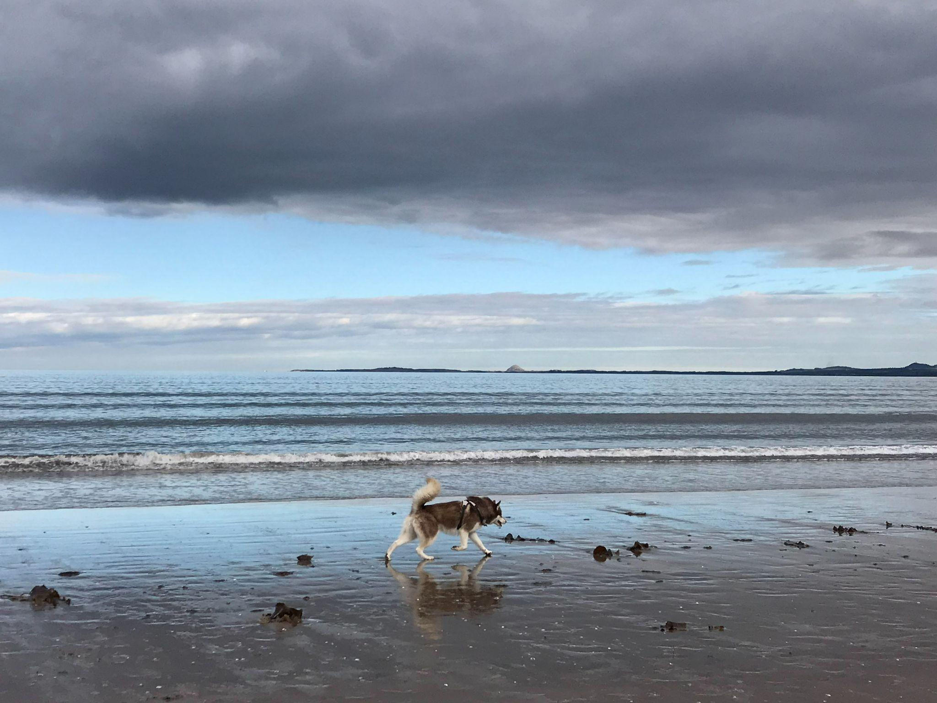

Image: Just like Islay the husky, I’m on a mission at the beach – I want to explore waves of change in decolonising the reading list for a module I lead

Just as each droplet of water comes together to form a wave and, collectively, waves can form a tide, I have been thinking of the many authors’ contributions that collectively form our reading lists. Inspired by social justice and recent discussions about decolonising the curriculum, in spring 2022 I became involved in the University of Stirling’s Inclusive Curriculum Working Group. I began to explore and share existing resources on decolonising the curriculum, including reading lists.
While I was inspired to effect changes to help make curricula more inclusive, it wasn’t until I attended the Glasgow School of Art’s Learning and Teaching Conference in June that I formed a plan to take forward work around decolonising reading lists. First, I invited colleagues from the Glasgow School of Art library and the University of Stirling library to discuss decolonisation projects and, as a result, we collaboratively ran an event at Stirling to help colleagues reflect on decolonising reading lists. This was positively received to advance conversations about what decolonisation means in our context and how we can take tangible steps forward in this area.
Drawing on a case study of work conducted at the Glasgow School of Art, I decided to audit the reading list for the module Designing and Facilitating Learning that I was preparing to teach in autumn 2022. Since I had inherited the module from others who had taught it during the pandemic, I was already planning to refresh the readings by making sure they were fit for our current context. The audit of the 2021-22 reading list included limited desk research with a two-click limit of looking into each author. This revealed that, of the 87 authors who contributed to 65 resources, 56% were presumed to be white, 39% were unknown (such as institutionally-published websites, videos or policies), and only 5% appeared to come from minority ethnic backgrounds. The audit also revealed that the vast majority of authors (79%) came from the UK or Ireland.
In my work to refresh the resources for the 2022-23 module reading list, I replaced roughly one quarter of the resources by identifying high-quality publications while also seeking to diversify the authors. Now, of the 80 authors who contributed to 66 resources, 55% were presumed to be white, 34% were unknown, and 11% (more than double the previous number) appeared to come from minority ethnic backgrounds. Furthermore, 38% of authors were of different nationalities outside of the UK and Ireland.
While I was pleased that the refreshed reading list is academically robust and also more diverse than previously, I recognise that this is only the start of the journey. I look forward to discussing this work with students on the module, critically analysing the perspectives presented by the authors and their contributions to the module. I hope that this will be the start of changing tides, attempting to make the reading list and, by extension, the module curriculum more inclusive as I work with the students to decolonise the curriculum further.

Story 21: Two Sides of One Coin – Hybrid Learning Edition

Nicole Cizauskas
nac6@st-andrews.ac.uk

Bio: Nicole has been a student intern with the University of St Andrews Enhancement Theme Team since 2021. During this time, she has focused on researching the impact of online/hybrid learning on student life, looking to identifying cohorts more affected than others by transitional periods. She has also delved into qualitative research methods, using creative storytelling and social media analysis to look at student feedback. Nicole graduated with a BSc Neuroscience, class of 2022. Currently, she is pursuing a MSc in Health Data Analytics with Machine Learning at Imperial College London, while maintaining her position on the St Andrews Enhancement Theme.

Hitanshi Badani
hb207@st-andrews.ac.uk

Bio: Hitanshi is a third-year student at the University of St Andrews studying International Relations and Psychology. She has been an intern with the St Andrews Enhancement Theme Team since 2021. Hitanshi researches the impact that online and hybrid learning has had on students’ academic and social experiences and their wellbeing. She also works on promoting student involvement with the Enhancement Theme Team via social media, using takeovers and advertising to communicate this. Hitanshi is the Deputy Student Lead of the Enhancement Themes within the wider QAA community and represents the student voice at various bodies of higher education enhancement.

Paula Miles
pjm11@st-andrews.ac.uk

Bio: Paula is a Senior Lecturer and the Director of Teaching for the School of Psychology & Neuroscience at the University of St Andrews. She is currently the St Andrews Lead for the QAA's Enhancement Theme and is a member of the University’s Mental Health Task Force, Mental Health Advisory Board and University's Student Experience Strategic Management Group. Paula's teaching includes topics on research methods, statistics and educational psychology and her current research focusses on factors that influence the student experience at university, particularly with respect to student wellbeing and resilience.
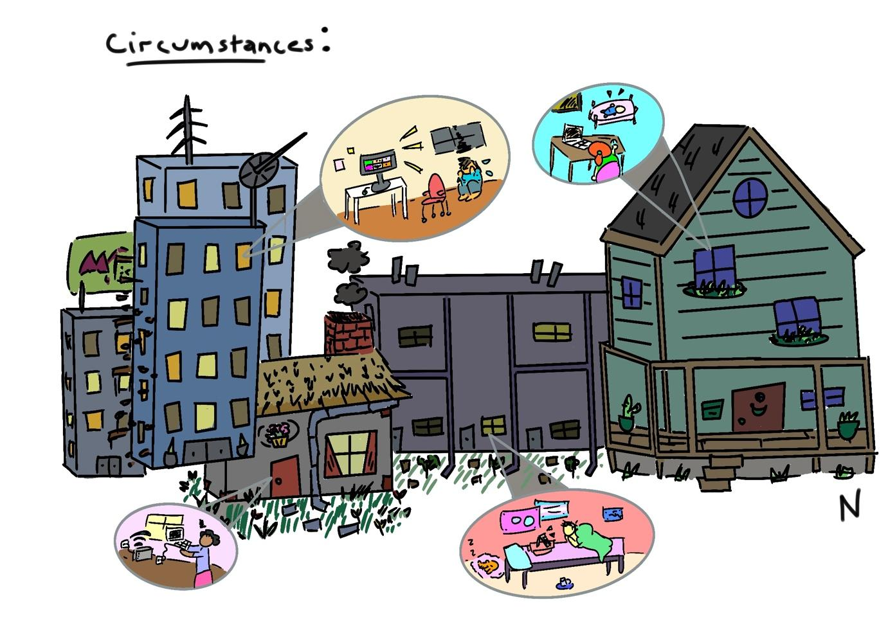

Image: Housing by Nicole Cizauskas, Digital Art.

Circumstances

This image highlights differences in student experiences of online/hybrid learning: a person living in a city is having a crisis while in a Zoom meeting; a woman in an American farmhouse is working flexibly while caring for a newborn; a woman in a cottage struggles with Wi-Fi connection; a man in a terraced house is learning from his comfy bed with his pet nearby.

Two Sides of One Coin – Hybrid Learning Edition
Words by Students; Composed by Nicole Cizauskas, Hitanshi Badani, and Paula Miles
This poem is composed entirely of student responses to questionnaires and an online forum, where students reported on their experiences of online and hybrid learning during the pandemic.
“Online socialising made me incredibly anxious.
As a one-year PGT student I felt left alone.
To this day I still don’t feel the same as I did before covid.
There is something I find awkward and scary about speaking in a large Teams call.
I was always afraid that someone would take a video, as I’m not a native English speaker.
I felt trapped and isolated staying in halls.
I was thousands of miles away from my friends and support networks.
Trying to study from home as a commuting student resulted in no place to go to study.
My home is only me and my mum who is a single parent.
I've had to contact a local therapist where I have to pay about 60 pounds per session.
Applying for university financial help is very time consuming for students who already work a lot.
I felt guilty for not doing more but I couldn’t physically make myself do more.
I do not want my Uni experience of classes to be defined by COVID.

“My social anxiety was lessened through online learning.
Being a fourth year, I already had my friends that I was very close with.
We were a small cohort and had a group chat, so I never had a sense that I didn’t belong.
I couldn’t always attend lectures in person due to certain health/mental health issues.
Having recorded lectures online allowed me more control over my schedule.
Many neurodiverse people, including myself, have found online lectures to be a lifesaver.
I didn’t need to attend a lecture when having a fatigue crash or flare-up of chronic pain.
It was a way for me to keep up with my studies even when I was physically unable to watch lectures live.
As a working student, recorded and online lectures were a huge help.
The intense stress of the exam hall was gone when I could sit the exam at my own home.
Recorded and captioned lectures must become a permanent aspect of learning.

I worked so hard to get here.
Does anyone else feel this way?”

Our research changed our understanding of students: instead of looking at students as a singular cohort with a singular opinion, we learned to see them as groups of cohorts with differing and sometimes conflicting ideas.

Story 22: I tried this Menti in class

Nilay Balkan
nilay.balkan@glasgow.ac.uk

Bio: Dr Nilay is a lecturer in Marketing and previously worked as a Business Advisor before joining the University of Glasgow in 2020. Her interests include entrepreneurship and SMEs, SME digital transformation, marketing strategy, marketing communications and scholarship in marketing and management subjects.

I tried this Menti in class

Image: The sun is rising over and reflecting on the Clyde on a clear day. In the background, the Glasgow Science Centre and BBC Scotland building are silhouetted against the sky.

I tried this Menti in class

“Cheers!” “Can we do that timed quiz thing again?” “That was fun!”

Woah, I thought as I smiled back at my students, the students liked - really liked - this Menti.

Menti is the nickname I gave this new tool I used, called Mentimeter. I thought I’d give it a try to see how the students would respond to it. And their response was… interested!

Why?

It dawned on me. Students are nervous about going back to campus.

“What if I say the wrong thing?”
“What if I’m bored?”
“What if I’m a fraud?”

What if…What if…What if…

Students like Mentimeter because:

Many voices are heard - chatty, shy, outgoing, unsure…everyone gets to have a say

Embarrassment, be gone - you can ask questions without feeling weird about it

No one needs to know your answers - there is relief in seeing others think like you or delight in being a rebel

Talking is easier - no more awkward silences to fill

It’s got variety - world clouds, competitive quizzes, open-ended texts and more

So, I say to you with a smile, give this Menti a try in your class. It might be fun!

Story 23: Connect online and everything will be okay

Dr Jane Hislop
Jane.hislop@ed.ac.uk

Bio: I work at the University of Edinburgh as a lecturer on an online postgraduate programme in Clinical Education. Our students are healthcare professionals and educators who come from a diverse range of geographical areas around the globe. As part of our courses we have weekly ‘live conversations’ where we encourage our students to discuss and share thoughts about the focused topic of the week. As well as being a lecturer I am also a clinician, cat lover and mother to two teenage children.

I wanted to write about my learning around accepting that life is busy for everyone and that working online means also accepting that technology may fail and that that is okay. In the last year I’ve learnt to not to set myself up for failure by trying to make a teaching session perfect. Being honest that things might not run smoothly and preparing for that means that I can forgive and be kind to myself, relax and enjoy the session. Taking this more humanistic approach also helps with building connections with students, and which in turn allows these sessions to be an opportunity to share understandings and experiences with each other in a safe space.

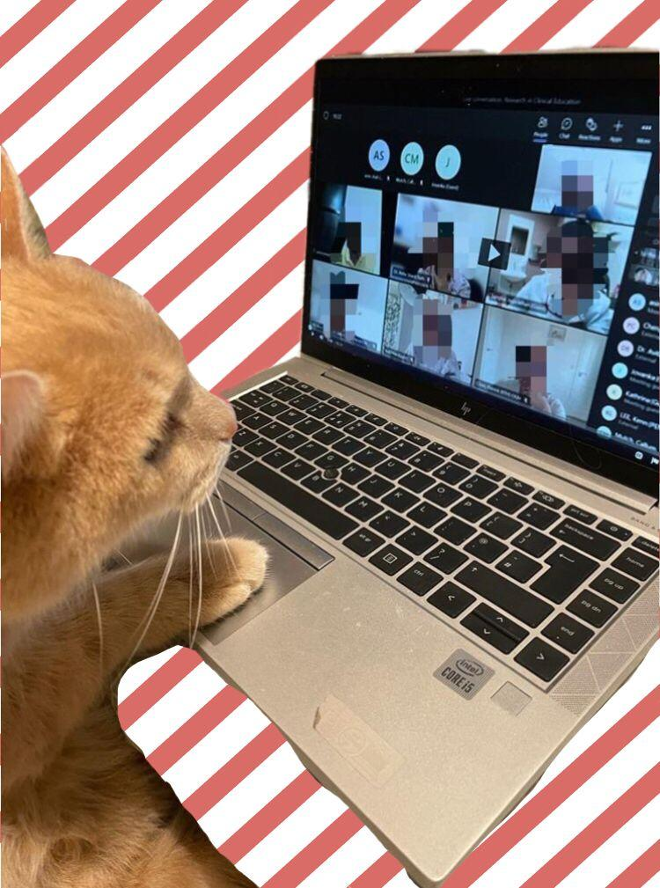

Image: Cat at computer
Connect online and everything will be okay

Logging on, feeling apprehensive
Positioning notes, notes ready on screen
Breathe in, breathe out, smile.

Clicking on the link to open the class
“Hello, hello, can you hear me?”
In my head: Where is everyone? Have I got the right link? Have the students’ got the right link? Is this the right day? The right time?
Then “hello I’m here!”
“Welcome – how are you?” “How is the weather where you are? It’s raining here again” “What time is it where you are?” “Is that your cat/dog/baby? So cute.” “I like your plants.” “Funky background, looks like you are on the moon!”
Click on record.
And we are off…

“Oh she’s gone… sorry we missed that….your connection is not working…”
Check connection, move closer to the router
“Mum, Mum, is tennis on? Mum, where are you?”
-Mute-
“I’m teaching! Yes, tennis is on!”
Breathe in, breathe out, smile.
-Unmute-
“Hi I’m back, can you hear me?”
“Hi you are back! Ha ha”
Off we go again….

“Oh dear she’s gone again”
Check connection, put laptop next to router.
Breathe in, breathe out, smile.
“Hi, hi can you hear me?”
“Yes we can!”
“Great! So where were we….”

[Ring! Ring!]
“Sorry that’s my door. I’ll be back in 2 minutes, can you carry on discussing why creating social connection online might be important for learning”
-Mute-

-Unmute-
“Sorry I’m two flights up, how did you get on?”
And we are off again…

“So that’s all for tonight, I’ll stop the recording now. Thanks for coming along, enjoy the rest of your morning, afternoon or evening!”
Stop recording
“That was great” “Thanks so much” “Really good session” “see you next week”
Breathe in, breathe out, smile.

Story 24: Joyful Connections

CLMOOC
Sarah.L.Honeychurch@Gmail.com

Bio: We are a group of educators who meet in the CLMOOC (Connected Learning Massively Open Online Collaboration) spaces. We enjoy joining together in creative challenges and collaborative remixes, which are open to anyone following the #CLMOOC tag and to a wider audience in social media spaces.

Joyful Connections

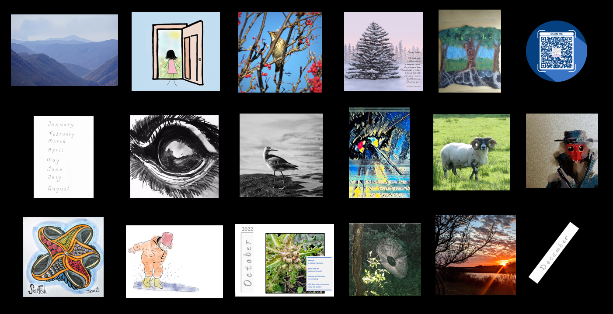

Image: A collage of the 15 images from our collaborative calendar and the QR code. Photos of scenery, animals and plants; drawings of a starfish, a child jumping into a puddle, poetry, some abstract art, and hand drawn lettering.

I awoke to hear a knock at the door. “The postman!” I thought. I jumped out of bed and ran down the stairs, shoving my arms into my dressing gown and tying it tightly around the waist. There on the doorstep was a big, fat envelope. At last - my printed copy of our creative collaborative calendar had arrived.

As the kettle boiled I tore open the envelope and put the calendar carefully on the breakfast table. As I turned the pages, I could hear the voices of my friends, reminding me that …

… the starfish were still falling and tumbling and that the night sky – where all of our stories were bound together as constellations – might never be the same without them. I placed my finger on the picture of the starfish, remembering how …

… the collaboration had helped us all to connect to each other, although we were dispersed across the globe. As I flicked through the pages I …

…saw within it the shapes of nature, noticing that each month’s story starred another shape from our beautiful earth…

… from an open door we are invited into a world of observations. Across the rolling hills of our varied landscapes we see as others see. These images and sounds conquer the need for a vast array of words, giving me….

…joy in connecting with other inspirational educators across the globe. The reminder that whatever skills we have, as long as we are willing to share, we can blend our contributions into wonderful artefacts like these.

Postscript: This collaborative project is serious fun. As educators we enjoy the freedom offered and a chance to showcase our creative skills. With the calendar format we have the opportunity to reconnect each month by sharing this open resource on social media platforms like Twitter, Facebook and Mastodon. The curator plays the bricoleur in assembling the contributions of images, poetry, music into a digital artefact also designed for printing. The importance of having a physical artefact, as well as all of the digital media, has helped us to feel closer to each other and to remind ourselves of the need for joy in educational contexts.

Projects like this help to connect participants from different places and time zones across the globe. We think they have potential for use in formal HE contexts.

Story 25 Pedagogy of Hope

Nathalie Tasler
drntasler@gmail.com

Bio: I am a senior lecturer in Academic and Digital Development (faculty development) and my foci are creative pedagogies for active learning as well as the scholarship of teaching and learning (SoTL). I am supporting colleagues in developing meaningful and student centred pedagogies and evidencing their impact. In my own scholarship I enjoy experimenting with different forms of text and knowledge creation.

Pedagogy of Hope

Image: Be the Light, @storyfae

Sometimes, there is nothing you can do but be there.
Sometimes, all the efforts are void.
Because sometimes, it’s really just not down to you.
Learners overwhelmed. Cognitive load bending under the weight like “insert cliché of soft squishy things here”.
Sadness creeps up on me as there is so much struggle all around.
Apologies unexpected in my course feedback; from students who would have wanted to engage but whose want and can did not meet.
A teary-eyed last session, on screen, in person, face to face synchrony.
All of us are tired.
Burn-out clings to the ether like dark fog reaching its tentacles across space.
Heavy. Everything seemed too heavy this year.
Laden with exhaustion, grief, good will, good intentions, ire, love, hope, and everything in between.
We muddled through. Togetherness becoming the prevalent pedagogy in a performative system.
Pushes for change from all directions and no capacity to implement.
No headspace to reflect.
And yet. And yet, you did well. The grades are good. The assignments interesting. Momentum moved forward despite everything.
And I will carry forward togetherness as a pedagogy of hope.

Story 26: Branches of Life

Norita Ahmad
nahmad@aus.edu

Bio: Norita Ahmad is a Director at Center for Innovation in Teaching and Learning, and a Professor of Information Systems and Business Analytics at American University of Sharjah, United Arab Emirates (UAE). Dr Ahmad taught at Penn State University, PA, USA, prior to coming to the UAE. She received her PhD in Decision Science Engineering Systems from Rensselaer Polytechnic Institute (RPI), an MSc. and a BSc. in Telecommunications and Network Management and Computer Sciences, respectively, from Syracuse University. She is currently the Associate Editor for Digital Transformation and Society, and a co-editor of Data Column for IEEE Computer Magazine.

Branches of Life

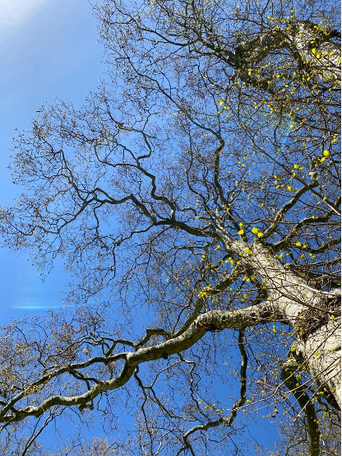

Image: Represents that the journey of teaching and learning is just like tree branches. Always growing and finding ways around any obstacles in their path.

This poem is inspired by the many stories that my students shared with me when we’re back on campus post Covid-19. Students felt lost, lonely, confused, yet hopeful for the future. I wrote this poem from the students’ perspective and I applaud all of them for being brave and motivated during this challenging time.

Awake eyes and fleeting fantasy
Stumble in laws of same routine
Future bestows opportunity to see
Present remains not too keen
The seed of my mind, budding to be

To the commute we go
A crowd like you and me
Sit to learn and come to know
Wisdom is power, knowledge is key
A sprout today with more to show

Will I be a doctor, saving lives?
Helping those in a time of need
Or a chef, with sharpened knives?
A custodian to cook and feed

I could be an astronaut in space
Making leaps for humanity
A lawyer working a case
Plead not guilty on insanity

What becomes of my classmates?
And will I make it out yonder?
Bound are we by degree and fates
Sitting outside to think and ponder
The sapling of mind, not eager to wait

Never a wish I found better than this
Composure to think and see possibility
The studies you take, the people you miss
Stay with you to grow, like branches on tree
Sturdy and strong, etched perpetual bliss.

Story 27: Come on feel the noise

Sean Morrissey
sean.morrissey@strath.ac.uk

Bio: I am an Academic Developer at the University of Strathclyde, Glasgow. My scholarship and practice interests centre around the enhancement of learning and teaching within a few particular areas of focus. These include inclusive approaches to curriculum design, peer support networks, student and staff well-being, critical pedagogy and anti-racist curricula

Come on feel the noise

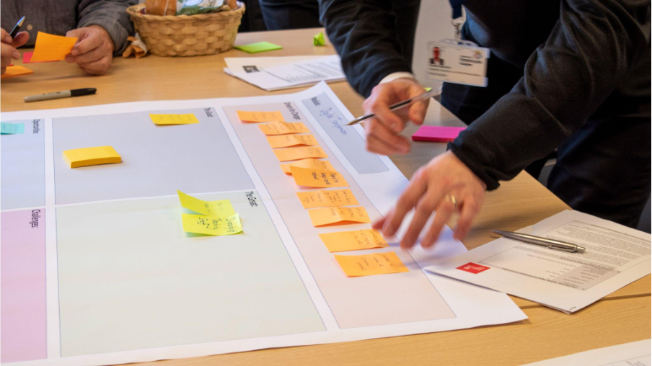

Image: A group of university lecturers writing and placing colourful notes on a very large poster

Suddenly and all at once, the room burst into life. A few minutes ago, you could have heard a pin drop. Now Kerry and I could scarcely hear ourselves think! My earliest experiences of education reinforced the rather unhelpful idea that a good student is a quiet student. These days, I am an academic developer in higher education. So, a noisy classroom is everything to me.

The participants were arranged in groups around four large tables. Each table had become an organised mess of A1 posters, colourful Post-it notes, coffee cups and Sharpie pens. Some participants stood while others sat. Some wrote while others talked. But everyone was leaning in, as if each table had a magnet quality that drew the bodies in the room inwards towards a point of focus. Kerry was beaming as she turned to me and exclaimed, ‘can you just feel the energy in this room? Gosh, I love our jobs!’

Later that day, the Principal of the university, who had been observing the workshops, pulled Kerry and me aside. “You know”, she said, “I have been thinking about the future of universities. Today’s students have access to the sum of all human knowledge at their fingertips. Some of them can even earn a degree without leaving their bedrooms. So, what is the future of our university? How does the campus add value? It’s complicated. But workshops like this, where our staff can actually experience active learning as they design learning opportunities for their students, they really must be part of the answer”.

In a pandemic-disrupted world, everyone involved in teaching and learning in higher education has had to navigate a number of existential challenges. An overwhelming concern, initially, was how to ensure continuity of teaching and assessment activities against the backdrop of so-called “lockdowns”, campus closures and restrictions on travel.
Questions then emerged around the student experience, issues around engagement and inclusion and how to adopt new digital technologies while maintaining professional standards. Solutions were found to challenges such as managing placements, conducting virtual laboratories and facilitating collaborative learning activities online.

Now that a ‘new normal’ is here, and campus-based learning has resumed, colleagues at our institution – and our academic partners around the world – are facing up to a new set of challenges. How to retain the best of over two years of digital innovation, while once more leveraging the opportunities of in-person learning?

If the past few years were all about pivoting online, this year I have (re)discovered the value of live, in-person, problem-based activities both for students, but also for our staff involved in our academic development programmes. As well as encouraging participants prepare for and extend through digital modalities at home, we strive to reflect this by offering interactive, peer-learning opportunities throughout our CPD and formal credit-bearing modules. The future of higher education is uncertain. But, for now, we’re taking every opportunity to make our classrooms noisy places once more!

Story 28: I Tried: Resistance and Recovery

Dr Katherine J. Haxton
k.j.haxton@keele.ac.uk

Bio: Katherine Haxton is a senior lecturer in Chemistry and Keele Institute for Innovation and Teaching Excellence Curriculum Fellow at Keele University. Katherine used to do experimental and laboratory work, sticking metals on polymers and studying their use for catalysis or drug delivery. Now her interests are in sustainability, decolonising the curriculum and academic peripheral – things related to study that impact students’ development. Currently she teaches a range of topics from industrial to polymer chemistry using various approaches including Blackout Poetry and mini-problem based learning and likes the term pedagogical alchemy to describe this approach but isn’t entirely sure yet.

Tried: Resistance and Recovery

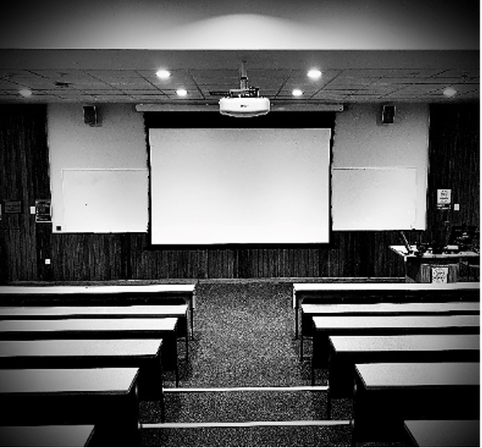

Image: An empty lecture theatre is viewed from the back, with rows of benches on the left and right of stairs leading to a view screen at the front and the lecturer’s podium. The image is black and white.

ENVIRONMENTAL & SUSTAINABLE CHEMISTRY Module Handbook Semester 2 2021-202 1. Description & Aims This module puts sustainable chemistry within a global context, looking at processes and technology that influence everyday life. The use of chemistry in human processes and the associated environmental implications will be analysed. Issues surrounding the sustainability of chemical processes form key aspects of the course content with students developing problem solving, information retrieval, team working and communication skills. Aims This module aims: To develop knowledge and understanding of issues in sustainable chemistry. To develop a range of problem solving, team working, and written communication skills. To discuss and critique key aspects of sustainability underpinning the role of chemistry in society. 2. Teaching Staff and Contact Details 3. Learning Outcomes Please refer to the Keele module catalogue for the definitive list of assessments, learning outcomes and module aims. 4. Teaching Methods, Session Titles and Deadlines Teaching Methods This module will be taught through a mixture of synchronous and asynchronous digital methods. Synchronous sessions will include: ‘Live’ Seminars (on campus or via Teams) Workshops Group activities Q&A sessions on assessments, and assessment briefings Asynchronous activities will include: Discussions on MS Teams Screencasts to watch Group activities to do in your own time Peer assessment activities We will try to record synchronous sessions such as lectures and assessment briefings to enable people who are unable to attend to review the content. Group activities will not be recorded. This module takes place Tuesday, 2 - 4pm. Teaching materials will be placed on the KLE in the area for the module you are studying, typically these will be available from 1pm Thursday before a class session on Tuesday. Some sessions will be Livestreamed via the Shared MS Team Space. Some sessions are scheduled to be run through MS Teams: Unless a session is designed to be run through MS Teams, we cannot guarantee that you will be able to participate fully in the session via the live stream Sessions designed for MS Teams make greater use of digital resources such as breakout rooms, websites, games and office 365 tools. Session Titles, Locations and Assessment Deadlines 5. Engagement, Extenuating Circumstances and Extensions You are expected to engage fully with all teaching sessions in this module.

Story 29: Better than you might think

Professor Sally Brown
s.brown@leedsbeckett.ac.uk

Bio: Professor Sally Brown is an Independent Consultant in Learning, Teaching and Assessment and Emerita Professor at Leeds Beckett University where she was, until 2010, Pro-Vice-Chancellor. She is also Visiting Professor at Edge Hill University

She holds Honorary Doctorates from the universities of Plymouth, Kingston, Bournemouth, Edinburgh Napier and Lincoln and is a Principal Fellow of the Higher Education Academy, a Staff and Educational Development Association (SEDA) Senior Fellow and a National Teaching Fellow.

Better than you might think

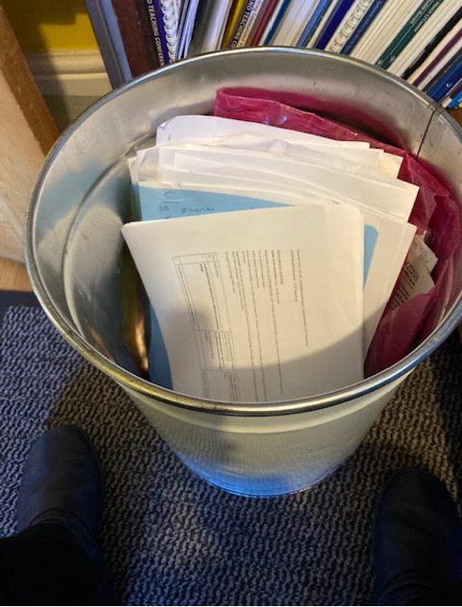
Image: Bin with papers

There was once an old woman who had achieved quite a bit in her life but still on occasions experienced self-doubt. One year she did some work with a university where she was trying to help them improve the student experience, and in particular, their student satisfaction survey rates in a way that she done several times before at other universities with great success. This project occurred during an appalling global pandemic, so she had to work remotely rather than face-to-face as before. When the results came out, it appeared that her impact had not been very great. The scores had stayed flat or only improved slightly and she felt awful. In fact, she felt as if the university that had employed her had wasted their money. Devastated, she apologised and vowed never to do this kind of project ever again.
Time passed. She threw all the associated paperwork away in disgust, feeling embarrassed to even see it on the shelves. Nearly two years later, she was contacted by the university again and asked to do some more work of the same kind again. She was astonished and reiterated to the person commissioning the work that she would be uncomfortable doing so because her impact had not been good enough last time. Gently but firmly, he told her she had been too harsh in her earlier self-judgment, confirming that he had said precisely this at the time, and that they could think of no one better to help again this year.
Tentatively she agreed to take on the project and he sent her all the data from the previous two years to review. Within the very systematic and thoughtful analysis was a section on the impact of the external consultant who had worked with them previously. This very clearly and irrefutably showed that the intervention had been very positive. The woman was thrilled with the affirmative evidence, to the extent that she read sections of it aloud to her husband, more than once.
The moral of the story is that it is all too easy to be very harsh in self-judgement, sometimes ignoring clear evidence to the contrary, and to only concentrate on the negative. And also, that it is never a good idea to throw away paperwork for quite a while in case it comes in handy at some time in the future! Fortunately, the old woman has quite a good memory still.

Story 30: Zoom Wars: Teaching and Learning Strikes Back

James Layton
james.layton@uws.ac.uk

Bio: James Layton is a Lecturer in Performance at the University of the West of Scotland. He has published on a range of topics including arts and health, digital pedagogy, and durational performance. His monograph Bergson and Durational Performance: (Re)Ma(r)king Time (2022) is published by Intellect Books.

Zoom Wars: Teaching and Learning Strikes Back

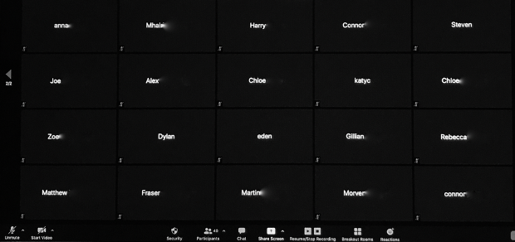

Image: Twenty black rectangles with names in them.

Not so long, long ago in a universe(ity), (not so) far, far away there was a classroom. It had chairs and tables and windows and doors. It was seen and heard, touched, smelled, and tasted. This classroom was occupied by humans of all shapes. Teaching shapes and learning shapes. The shapes interacted and, despite all being unique, they slotted together perfectly.

One day, a dark force arrived over the classroom and the shapes couldn’t be together any longer. They just couldn’t stay safe anymore and found themselves dispersed across the universe. Unwilling to surrender, they became rebel shapes.

The rebel shapes searched for a sign of hope and reached out to their screens:

‘Help us, technology. You’re our only hope’.

A message went out across the universe until the rebel shapes received a message that gave them courage:

‘New to Zoom? Sign up Free’

The rebel shapes were overjoyed by this sign of help. They duly signed up and fought back against the dark forces with their secret weapon in the form of a new shape: the rectangles of Zoom.

For a while, the rectangles of Zoom helped the rebel shapes be together. Often, the rebel shapes showed themselves to each other but then, one by one, they began to hide behind their screens. Some of the rebel teaching shapes became worried that their message to the rebel learning shapes was being lost. How could teaching and learning continue to thrive? Would the dark forces also threaten their rectangular communities?

Then one day, the teaching shapes decided that it didn’t matter all that much whether they could see the learning shapes. They knew that, despite the dark forces sometimes making the learning shapes hide behind rectangles, they were still learning.

We experience the world through our bodies, even when placing our bodies behind a screen or lens. The human shape will always win, whether we are physically together or coming together remotely. Embrace the blank screens – life is still out there!

Story 31: Into the Woods… A Tale of a Team

Victoria Barbé, Dr James Issitt, Beth Loughran, Tristan Poyser
beth.loughran@cumbria.ac.uk

Bios: Victoria Barbé, Dr James Issitt and Beth Loughran are performance academics at University of Cumbria, with expertise in acting, musical theatre, singing, dance and magic. With wider fellow team members, their current interests lie in arts and participation and its role in areas of health & wellbeing and creative economies development regarding local infrastructure and opportunities. Their close colleague Tristan Poyser with a background in ecology and biological photography, provides the woodland image as part of this story. It comes from a photography-based social prescribing programme and related exhibition called Bradley Brook (Poyser, 2022).

Into the Woods… A Tale of a Team

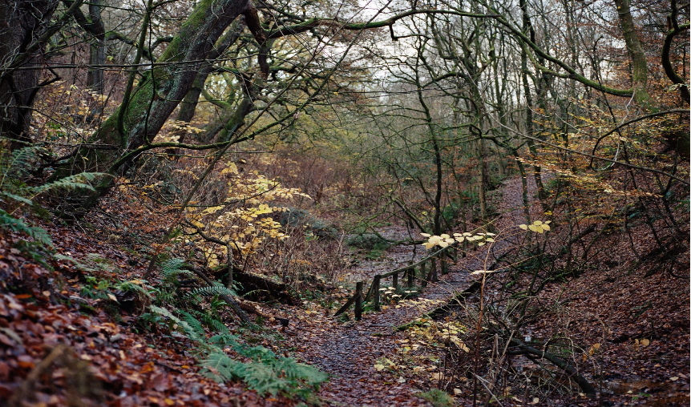

Image: A woodland with a low channel footpath and wooden bridge

Characters
Wise Owl
Agile Cat
Bumble bee
Rabbit
Hedgehog
Mouse
Earthworm

The calling
Wise Owl and Agile Cat journeyed to a magical wood they had heard about on the wind. It was far, far away in both time and space but they knew these factors should not cause separation of students and teachers. As teacher-beings, Wise Owl and Agile Cat’s purpose was to be kind to others.

The journey
Wise Owl and Agile Cat travelled in different ways, but they stuck together in team formation. They threaded, hopped, bounced, glided, jumped, flapped and fell making their way through the constantly changing landscape. The excursion was fun and challenging!

The context
The teacher beings entered the magical wood bringing all the ideas from their own space and time in the higher up mountains but remembering the presence of the unknown, as no time, place or animal ever stands still or stays the same.

The magical class
Bumble Bee felt confused and needed to understand how they felt.

Rabbit felt afraid and needed to come out of hiding.

Hedgehog felt strange and needed to understand more places.

Mouse felt energetic and needed to be able to stop and think.

Earthworm felt lost and needed to sharpen their senses.

Wise Owl and Agile Cat made very small and gentle sounds to let the animals know they were there. Would the animals in the magical wood also like to make a small and gentle sound, they wondered? In the noise of life, there were silent questions like;

Why is this owl and cat here?

I can’t see the owl and cat?

I have never seen an owl or cat before, what do they do?

The magical response
The questions were the magical unknown that students were primed for identifying and expressing in critical wonder.

The teacher beings continued and also, used lights and colours to connect the animals further to their own senses and experiences.

Earthworm was not aware of the visual displays, so Agile Cat moved across space to sense where Earthworm was in order to meet them. They conversed through movement, that for both were smooth and supple.

Meanwhile, Wise Owl had performed a magical display of tricks, to such surprise and excitement that Hedgehog and Mouse felt much more at ease. Earthworm’s earlier remembered self-acceptance and confidence helped them too, participate in the magic.

Bumble Bee and Rabbit also found ease in their lived experiences. Bumble Bee connected the black stripes of fur with Agile Cat’s black fur coat and took new appreciation of their own yellow fur stripes, which they were previously so unsure of. Rabbit had been in hiding for so long, but was able to emerge thanks simply to the arrival of much-needed help.

The new journey
On the journey back to the higher up mountains, Wise Owl and Agile Cat enjoyed the travel time together. Agile Cat said, “there were so many transformations”. “All by being ourselves together” Wise Owl added. The two started to think more about togetherness and being team-teacher beings more often.

Story 32: From engagement to empowerment - how a ‘souped-up” active learning can take student success further

Nicoletta Di Ciolla
nicoletta.diciolla@uniroma1.it

Bio: Nicoletta teaches in the department of Communication and Social Research (CoRiS) at Sapienza, University of Rome (Italy), after over 30 years of lecturing in Italian Studies in the UK. Her main research area is contemporary Italian crime literature, although in the past few years she has taken a stronger interest in pedagogical developments - as Education Lead for her Department in the UK, and as PI in an EU-funded Erasmus+ project that focussed on Digitally Enhanced Active Blended Learning (http://www.elseproject.eu/). She is a Senior Fellow of the HEA.

From engagement to empowerment - how a ‘souped-up” active learning can take student success further.

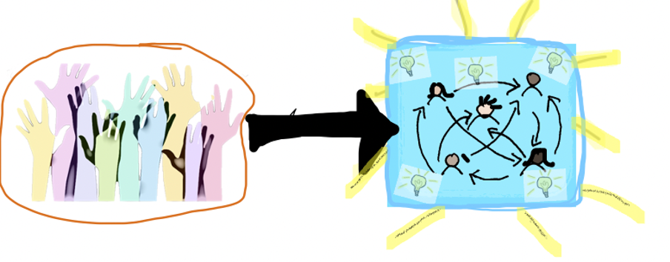
Image: From engagement (all hands raised) to empowerment (all students interconnected, but each with their lightbulb moment to share)

Once upon a time, there was the normal world of Higher Education.
In this world, every year and for a set number of weeks, normal teachers would preach and students would take notes; then the day of reckoning would come, and the knowledge acquired through those notes would be demonstrated, with a numerical value assigned to the performance. After a short intermission, the normal cycle would start over again.
Then something happened that threw into question the very concept of normalcy: it made the traditional order no longer feel ‘normal’, or desirable, even to those who had been its most stalwart advocates. And off academics went in search of alternative ways of doing Higher Education.
Beyond the essentially top-down operational changes introduced in response to the pandemic, significant pedagogical changes have come from academics realising that the exceptionality of the circumstances demanded new teaching and learning strategies to enable and sustain the students’ journey through their courses. I would argue, and hope, that the latter continue to evolve.
Few of us do not subscribe to the principles of active learning, or acknowledge that the essential conditions for students to remain engaged in their studies are that they are actively involved in their learning experience, that they are stimulated, challenged and rewarded, and that they are made to feel that they matter.
But the current challenge is not only to preserve and cultivate this productive L&T ethos, but also to find ways to compensate for the void left by a couple of years of COVID-induced ‘aloneness’, and generate a vibrancy that can rekindle students’ appetite for learning, fuel curiosity and enthusiasm. A souped-up form of active blended learning has been the answer for me.
While students are learning actively - that is they are “doing things and thinking about the things they are doing” - they should also be empowered to understand the relevance of what they are learning to their own personal lives. The most striking epiphany for me has been sparked by the concept of self-concordance. The more my teaching resonated with students’ developing interests and values, the more it sparked some recognition, disclosed its potential fit to their own experiences and ambitions for the future, the more students were keen to come on board and push the boundaries - of the unit content and assessment requirements -, and explore further beyond, in the direction they found meaningful. My role in making this happen is to keep the communication channels open, to signal my openness to shaping my lessons according to the individuals I am teaching, to accept their suggestions for materials to analyse.
The course I am currently teaching - I work on textual analysis with students on a Master’s programme in Journalism - has a growing resource bank co-created with students. Their analysis of narrative strategies is applied to texts that cover topics that interest them - our bank includes materials on topics that range from politics, to gender relations, to body shaming - and sometimes takes directions I had not anticipated, and that usually generate inspiring discussions in the group.
Thus configured, learning is becoming a proactive experience: students are keen to acquire knowledge and understanding, to explore and experiment, to share their findings; and the unit becomes fluid and dynamic.
Students thrive in this sense of empowerment, which contributes to their autonomy, agency and awareness of individual accountability - skills that support the development of their intellectual as well as personal (in the sense of human) skills, while at the same time meeting and anticipating the expectations of the 21st century workplace.

Story 33: Eyes on the : Writing about the 2022 World Cup in Qatar

Jana Fedtke
jana.fedtke@northwestern.edu

Bio: Dr. Jana Fedtke is an Assistant Professor in Residence in the Liberal Arts Program at Northwestern University in Qatar (NU-Q). Her research and teaching interests include data justice, science and technology in fiction, gender studies, and transnational literatures with a focus on South Asia and Africa. Dr. Fedtke’s work has been published in, for example, Online Information Review, Asian Studies, Journalism Practice, South Asian Review, and Asexualities: Feminist and Queer Perspectives (Routledge).

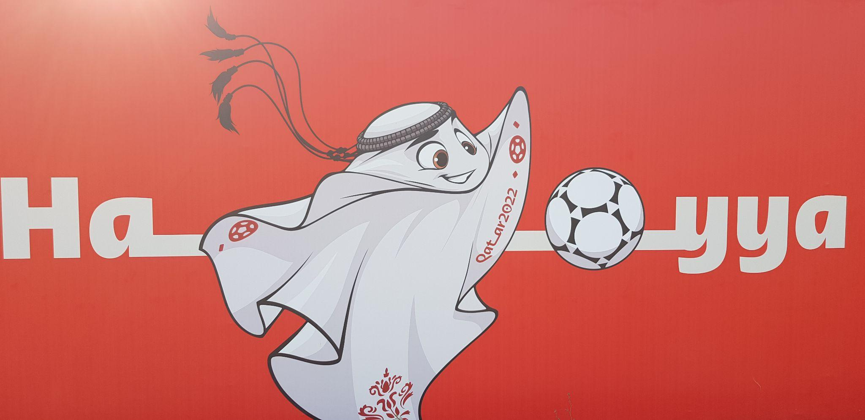

Image:
لعيب / La’eeb, the mascot of the 2022 FIFA World Cup in Qatar, as represented on a poster advertising the event; photo taken by the author on the Doha Corniche in August 2022
Eyes on the : Writing about the 2022 World Cup in Qatar

In our writing class at Northwestern Qatar
We discussed many texts from near and afar
We focused on the FIFA World Cup as a mega event
And in that process made many a friend

Writing has helped us argue with conviction
Even though – or maybe because – there’s been so much friction

Workers sweat and toil
Qatar has been called unfit
Some don’t care a bit
As temperatures boil

Exploring the topic, we nudge and judge, but we do not budge

Eyes on the
And as the slogan reminds us, “now is all”

Most of our sources were not in Arabic
But many of them included a pic

We watched the official soundtrack for what seems forever
Chiming in when they sing, “Hayya, هيا, we’re better together”
“The time is now or never”

Accommodation, transportation, situation, citation
MLA, APA, Chicago
Won’t interrupt my flow

As I am citing
I am also nail-biting
Writing and fighting
What is the best argument?
How can I convince my friend?

Plagiarism is not my thing
I also don’t need much bling
As I try to avoid bias
I don’t want to sound too pious

Sustainability, equality, and gender
Challenging, but I will not surrender
I think about writing and its power
No time to cower
My sources I need to devour

I’ve written my intro
Do I feel like a pro?
I’m proud of my thesis
It’s not just in pieces
My paragraph
Nothing to laugh
What a conclusion
There’s no confusion

Before this semester
Who would have thought we’d write about soccer
Qatar and the Cup
What a whopper

Doha has become a hub
When I’m done with my writing I’ll show you around
If you’re Qatar-bound
I’ll read you my paper before the World Cup

We belong to the desert
Yet our projects are not haphazard
2022
Whether you cheer or boo
All are welcome to Q.

Story 34: Cradling Post pandemic Architecture Education

Dr Najah Md Alwi
najah.ma@umk.edu.my

Bio: Dr Najah Md Alwi is a Senior Lecturer and Researcher in Architecture at the Universiti Malaysia Kelantan, Malaysia. She holds a PhD in Architecture from the University of Nottingham, UK and a Master of Architecture in Sustainable Design from the University of Auckland, New Zealand. Her research interest is sustainability approaches to the built environment through design and urban planning but her mission is also to find ways to advocate equality for gender, diversity and inclusion in architectural education. In 2021, Dr Najah was also the first elected Graduate Architect Representative Council Member in the Malaysian Institute of Architects (PAM). She is an active member of several other committees in the institute.

Cradling Post pandemic Architecture Education
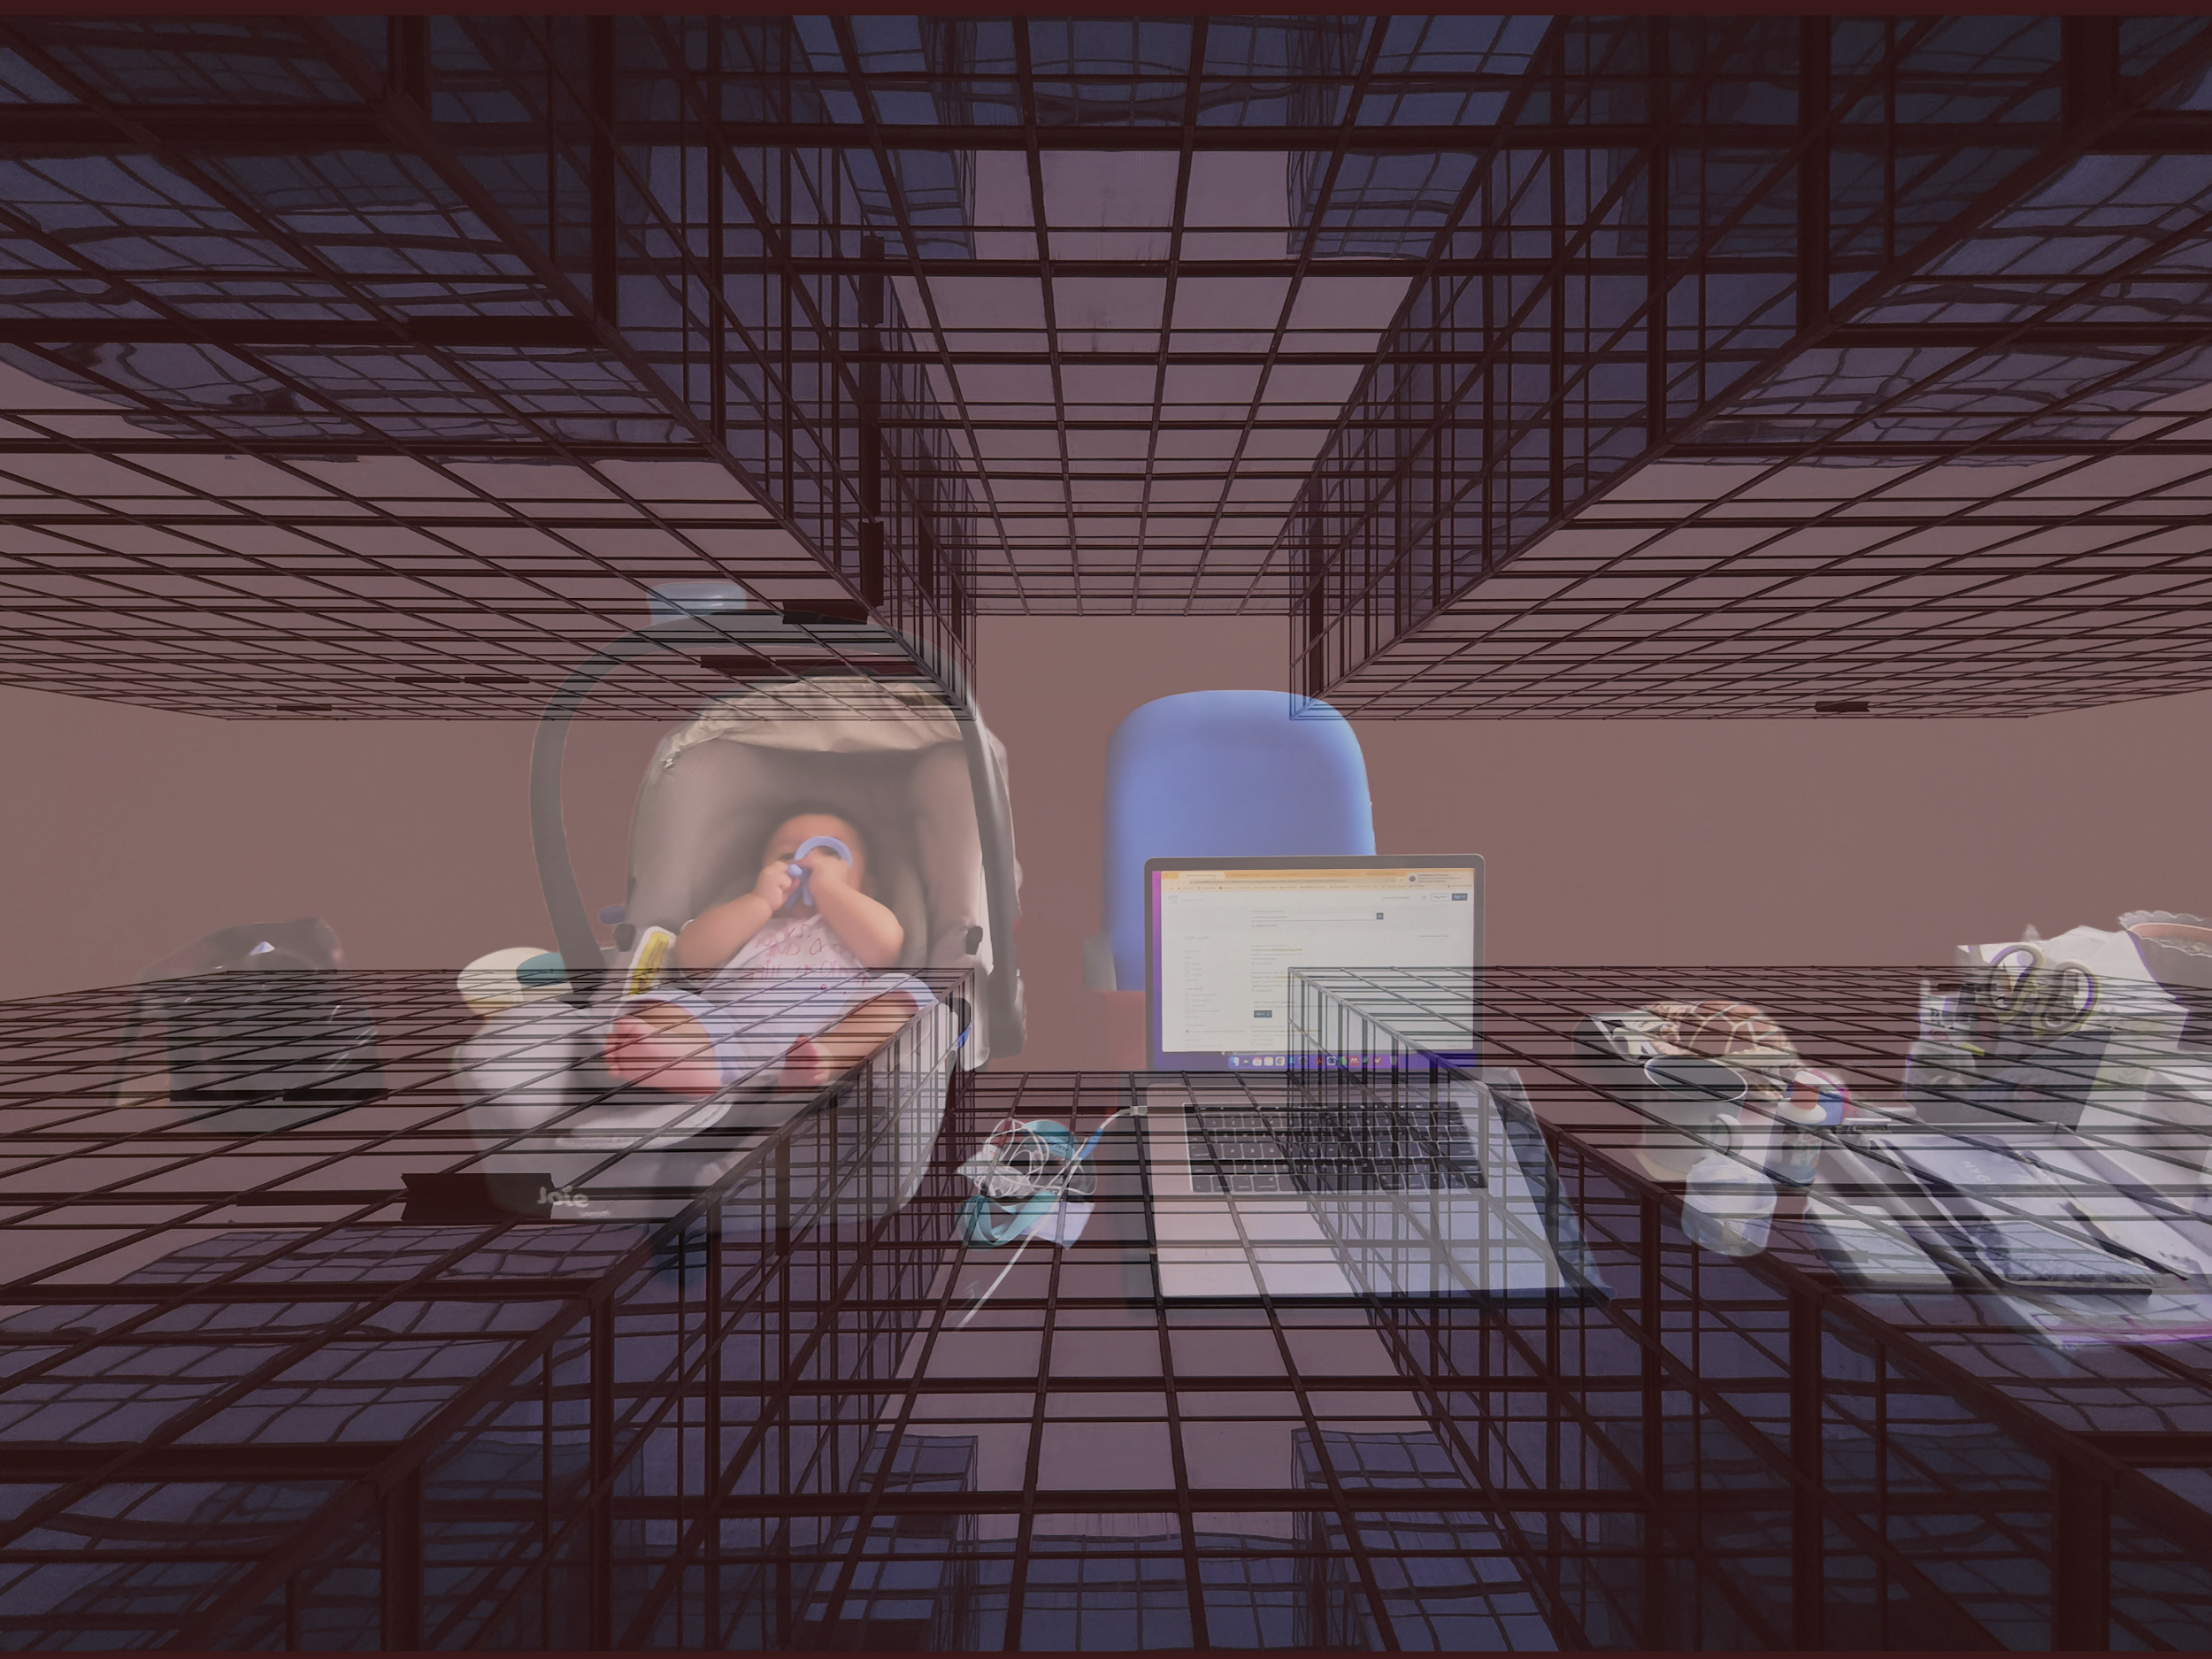
Image: My handbag, my infant son in his car seat, and my laptop next to him on my desk while I conduct virtual/hybrid classrooms

The year is 2022, and most definitely, the ways of "traditional" in-class teaching and learning art and sciences have changed in line with technology, evolving times of social media, and to cater for the needs of the future generation. Even the pandemic has helped catapult the internet to reach rural and underdeveloped areas where it was absent before, to allow communications and a sense of connectivity to daily activities such as ongoing education. Nevertheless, it is a continuing debate whether just the presence and availability of the internet is enough to ensure “learning” happens.

As someone just starting a career transition from the construction industry into academia, observing how architectural education developed and finding my role in the institute has been both curious and exciting. The architectural studio, particularly, where students of architecture worldwide spend most of their time, has always been reserved for different aspects of creative exploration. While it is important to note that online classes for architectural studios served their purpose as much as possible during the pandemic, the traditional use of studios is still not ready to be fully virtual. I cannot speak for other institutes or places in the world, but in Malaysia, where students and staff, mostly each coming from high-status cultural backgrounds, virtual studios don’t always assist the student or instructors in an exchange of a learning process. Where communication languages for expression and meaning are not only verbal but small physical gestures and facial cues, much of the interactive communications of showing and demonstrating comprehension or grasp of creativity are limited only to what the screen can capture. Also, this depended on the stability of the internet connection to convey the needed message back and forth from the student to the instructor or vice versa. It was interesting for me to chart and see different outcomes when idea-generation sessions with students were pre-arranged in different size groups or with individuals of a different gender. My observations also included noting interactions that occurred between instructors of different gender, age and professional experiences in the built industry and how this affected students.

Globally, this year was a new start for the post pandemic recovery. After two years, most of us in HE are now back to hybrid or face-to-face classrooms again. In Malaysia, while strict legal measures in protecting health and safety by means of observing social distances between people and wearing masks while being indoors are still in place, the distribution of Covid-19 vaccines to the public meant staff members and students were safe enough to be able to start physical classes again. By March, physical classes were allowed again, allowing for almost back to normal studio classrooms. However, the return of face-to-face classrooms were also found to pose challenges to both students and instructors as this new transitional period became a start of multiple adjustments to the processes of teaching and learning in this post pandemic phase. For example, now that we are gathering back in the same place, there is much confusion in the expectations for students whether to reuse the “pencil to paper” sketch for studio discussion, or hands-on physical modelling or straight away utilising design software or web application on the laptop as done during virtual studios? Also, there is no mute button or off-video for students who may have difficulty participating in study sessions.

Coming back from maternity leave for the first time ever for me also meant negotiating ways of teaching in the studio. I somehow managed to be given some leeway with my little infant either carried in a sling on me or in his carseat to ease my own transition. I was determined to continue and participate once again in the “traditional” face-to-face studio despite it seemingly being a strange choice of action to some students and other staff members. My infant was very cooperative, mostly spending time asleep or wide-eyed on my chest as I sat across from students inspecting their paper-made models and sketches. Having an infant on me does limit my capabilities to get involved physically with practices relating with sharp or electrical tools for model making or areas of work where on-site studies are concerned, but it was also important to me to show to students, generation of ideas and participation in this course should not have a gender role exclusion. I do wish there were ways to have more support for working professionals but that is also yet to arrive. Admittedly of course, teaching online and working from home has its benefits for a new mum, and there were instances such as lectures and small exercises which I was able to just monitor students to do remotely.

My story on hybrid and traditional studio teaching in person is still in its early days. My son is now almost a year old and in daycare to allow for my full participation in the studios I teach. There is a lot more to overcome and consider when teaching a professional course in a high status cultural background, other than virtual or physical presence. There are also perceptions that need to be addressed. Regardless, this story continues to find out how to support student learning and advocate equality which I hope to be able to contribute to.

Story 35: Once upon a musical journey to Drill

Gail Frampton
gailframpton@googlemail.com

Bio: Gail Frampton, known to her family and friends on Twitter and Instagram as Gigi.
My current role is Faculty Lead at University Campus Oldham, previously course leader for Early Years Prep Year and Education Early Years BA (Hons). In the past I have established community groups such as Chorlton Parents Support Group, Parents of Black Children and Chorlton Telling Tales. I developed a Kitcha Group in Oldham called Sew and Tell and I have a passion for storytelling. My exciting news is that in January 2023 I will take up a new position as Lecturer in Children, Schools and Families and will be joining the UCLan community in the school of Social Work, Care and Community.

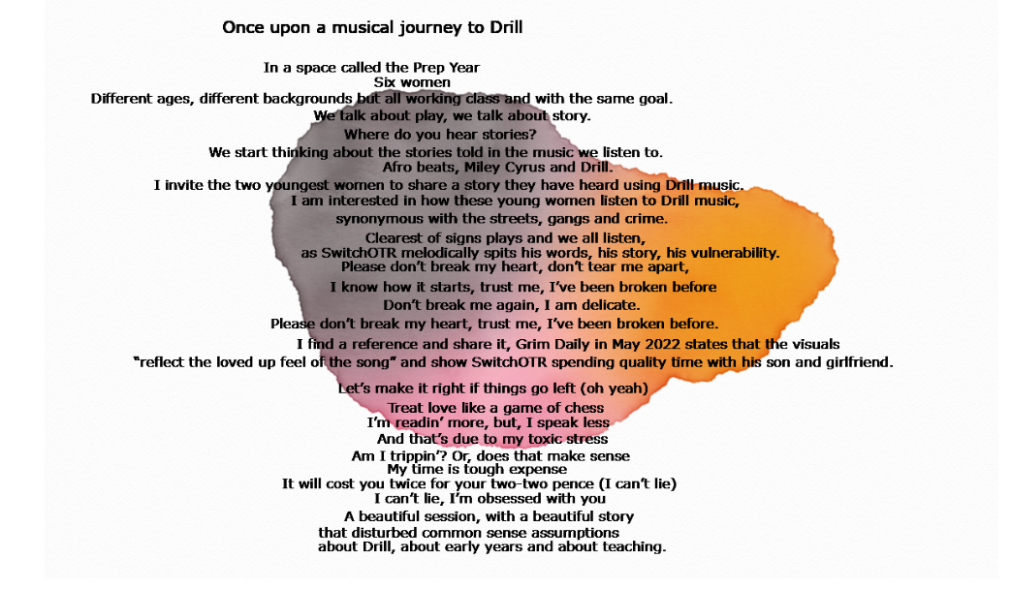

Image: a creative story using the words of SwitchOTR and depicting a journey to Drill music in the classroom, Doodlefan tool used

Story: The story is in the image

The context to the story: A session held on a Friday afternoon in academic week four, semester one. It is a HE Group Tutorial 1p.m. to 4p.m. with the Prep Year often known as Entry Level or Foundation Year. There are six women in the group. C is new, she has two children and it is her time now to do something else with her life, her words, not mine. J has worked with children for 12 years, she still needs to work, she is a single parent, her mum helps her and the hours of the Prep year suit her. She is hoping to be able to give up some days next year when she passes the Prep Year. She also needs to get her GCSE English. T has joined the group this week for the first time, she had a critical mental health situation just as the course started and has a history of trauma and crisis. T is from Nigeria. S, F and I are all young women of South Asian descent. None of them have passed their final L3 exam in Health and Social Care so they will be resitting in the new year.

The aim of the session is to engage the group in some HE academic writing, I hope to use their writing to develop some I poems. We begin with some icebreaker discussion provoking thought around the role of play and what the value of play is. The group offers answers such as it is fun for children, too, children learn through play.

We move on to discuss ‘story’. The aim was to provoke some discussion that would then lead to the group writing their own story, but we didn't get that far. I ask about the role of story and how do children hear stories? The answers are about imagination, but also they mainly focus on reading stories.

I ask the group how do you hear stories? They look confused. I suggest that they might hear stories through music. The group are encouraged by this idea and offer genres they listen to. The two youngest students mention that they listen to Drill. I am now surprised! Drill is a subgenre of Hip Hop, it is commonly thought of as violent street music associated with gangs, provocative lyrics and crime.

As a creative rebel and risk taker, I invite the young women dressed in modest clothing, heads covered with scarves to introduce a story using the genre of Drill. We are introduced to SwitchOTR and the sound of Clearest of Signs. The irony of the title should not be lost on anyone as there was nothing clear about the session so far and all the signs I had thought I knew about Drill were disturbed.

Story 36: A Leap of Faith

Dr Lovleen Kushwah
Lovleen.kushwah@glasgow.ac.uk

Bio: Dr Lovleen Kushwah is a Lecturer at the Adam Smith Business School, University of Glasgow. She has assumed roles of Honours Convenor, Senior Adviser of Studies, Complaint and Academic Integrity Officer, and Dissertation Convenor for the UG Economics degree. Her current research focuses on Macroeconomics, Sustainability, Supervision, Inner feedback, Assessment and feedback, Mental Wellbeing and Peer support. She holds a PhD in Economics from UC3M (Spain) and is a fellow of RET. Prior to joining academia, Lovleen worked for HSBC and GE Money.

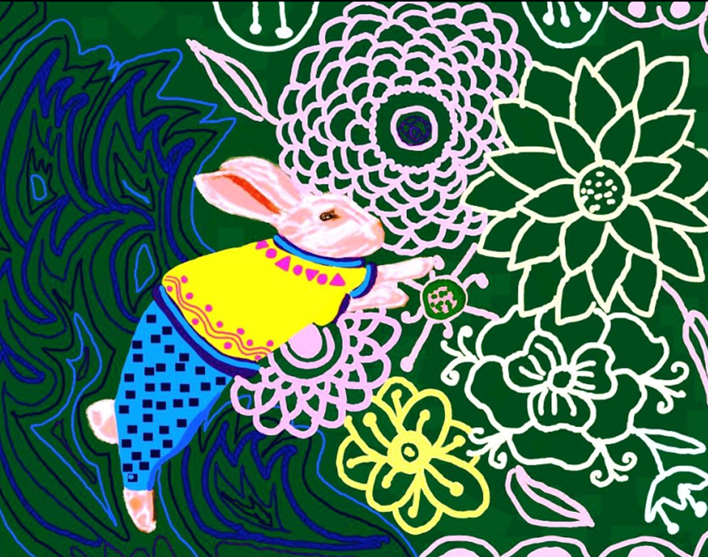

Image: ‘When I took the leap, I had faith I would find a net; Instead, I learned I could fly.’ – John Calvin

A Leap of Faith
“I am far away from home, and here I am alone, my best friend is my pillow. It has seen my tears every night.”.
Lillie, my postgraduate student said those words as we held tall champagne glasses celebrating a successful Business School event. A while ago we were talking about her excitement of living in Glasgow, she said the weather was dreich, but this was her first taste of champagne. She was smiling and as she said those lines there was sadness in her eyes. I knew what she felt.
It took me back to the days when I was a student who looked to the future and was in a new city. I learnt so much during that time that I would relive it if I could. Moving away from home was a big shock in every sense, far away from loved ones, I plunged into the uncertainty of fears. While I knew how to be a good student, there was more to me and that was the part which struggled the most. My experience was limited as for the first time I saw different faces of society and weathered harsh realities alone. At that time, simple words like ‘anxiety’ did not exist in my vocabulary, and yet it was ever present.
Speaking to Lillie, and looking back at my own experience, I wondered, how our students’ lives would change if they were told openly that anxiety is part of everyone’s life rather than a weakness; instead of feeling shame for struggling to cope, if they are shown stress is part of growing up rather than a hurdle. So, in that brightly lit room of the business centre, in an impersonal setting, I told her something personal, “the depths of mind are made of bittersweet emotions and the meaning we attach to them. Through our life journeys, it is only natural to feel wounded and scarred, but this helps us to grow. While maturing, I realised that life is not only about struggles but also precious lessons. Like a masterpiece painting, life is made with dark and light strokes; without one the other cannot exist. Just as I managed, you will too.”
I stood with Lillie and made an agreement that we will not give up. Her as a student and I as an educator. We decided to hang in there, with our frustration, anxiety, pent-up anger or whatever that is there that we couldn’t name or speak freely of yet. And that we shall take a leap of faith and march ahead to know unknown territories within. As a result, I decided to be more honest and authentic with my students, engaging in professional self-disclosure and reflection, which helped them see me as a whole person. And somehow, they felt like doing the same. Bringing more of my current and past self in the classroom to meet where my students were was transformative, and all it took was to cross that threshold which I thought kept me safe.

Some academic research (not part of the story):
Eckersley, R. (2008), Values and Vision: Youth and the failure of modern western culture. Youth Studies Australia, 27, 10-19.
Marginson, S., Nyland, C., Sawir, E., & Forbes-Mewett, H. (2010) International Student security. Cambridge: Cambridge University Press
Sawyer, A., & Forbes-Mewett, H. (2016) International Students and mental health, Journal of International Students, 2016 Vol. 6 (3) pp 661-677.

Story 37: The Kids Are Alright

Alexandra Winder
ed21aw@leeds.ac.uk

Bio: Alexandra is a Digital Learning Coordinator and Teacher at a British primary school in the United Arab Emirates. She has interests in developing student leadership and creating student led learning opportunities. She is also a 2nd year Digital Education Master’s student at the University of Leeds with a particular interest in digital citizenship and online safety. When not teaching or studying, she tidies up after six year old twins and also works as a semi-professional cat wrangler.

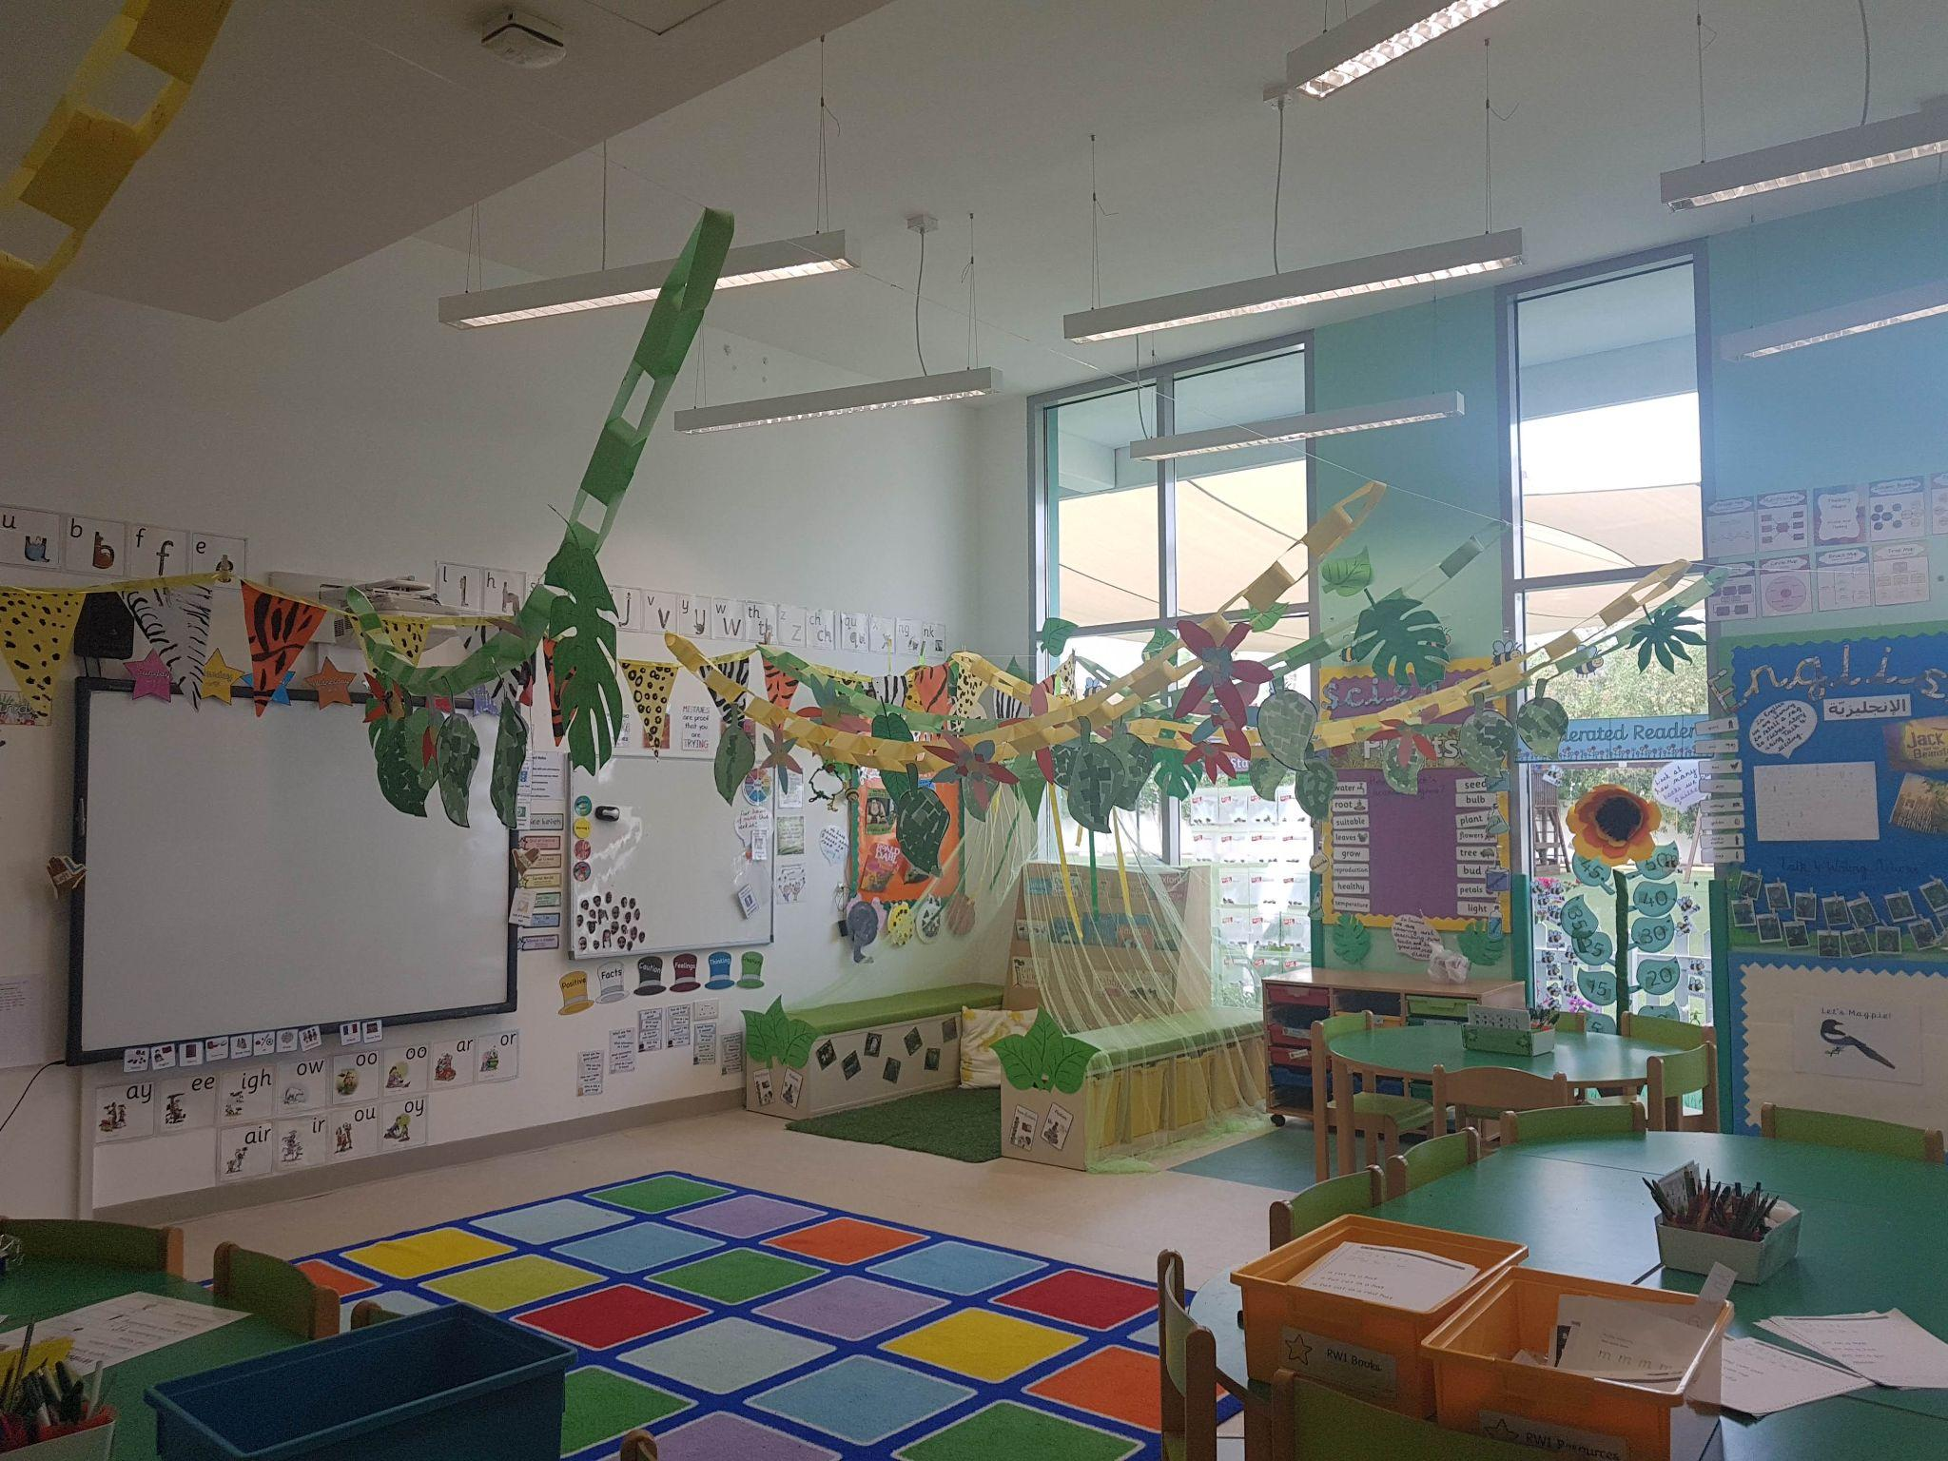

Image: A brightly decorated, empty, primary school classroom

The Kids Are Alright

Twenty-two little faces peered out at me from their boxes on my computer screen. “This is my dog!” exclaimed one, her box blurring in and out of focus as she chased her pet around the living room. “AM I ON MUTE?” shouted another. Favourite toys appeared on screen, older siblings mooched around in the background and somewhere, never far away, teachers and parents quietly worried about the long term effect ‘all this’ would have on these children.

Fast forward to today, those same 22 faces are noisily barging around the classroom, tripping over their shoe laces and trying to hide the toys they’ve snuck into their school bags. They’re bigger now. Not just physically. They’re bigger emotionally too. In 2020, we were concerned that the transition to online education would leave younger learners with huge knowledge gaps and set back decades of educational progress. We also fretted over the impact a lack of socialisation would have on their behaviour and mental health. As a consequence of this, I made the decision to gain a deeper understanding of how the digital world affects students and subsequently enrolled in a Master’s course on Digital Education at the University of Leeds.

Now we are all back in the physical classroom, over the past year, I have had the opportunity to reflect on the effect of digital learning on my students and on my practice. Through conversations generated in digital citizenship lessons, it became clear to me that putting the student voice at the heart of my teaching not only improved engagement, but also improved the content. The 22 students in front of me today are happy, intelligent, polite, digitally savvy 10-year-olds who have just written a ‘Digital Charter’ for their school. What I have learned from them is that, when given the opportunity to challenge their own, and their teachers’, assumptions, they can be trusted to make emotionally sensible decisions and set reasonable boundaries for their online lives.

The theme for Safer Internet Day 2023 is ‘Want to talk about it? Making space for conversations about life online’. In light of this, it feels as though I’m not alone in learning that those students we were so concerned about during lockdown, are actually more effective at conducting their online lives than we have previously given them credit for. We are doing them a huge disservice by not listening to their experiences when creating digital education and policy. By creating a space in my teaching where their voices are heard and asking them to write their own rules, they made themselves safer online and also educated me.

Back then, I would never have imagined that those 22 little faces would effectively be doing my job for me in 2022. But here we are. And I couldn’t be more proud of them.

Story 38: Once upon a time

Tom Burns and Sandra Sinfield
t.burns@londonmet.ac.uk
s.sinfield@londonmet.ac.uk

Bios: Tom Burns and Sandra Sinfield are co-authors of Teaching, Learning and Study Skills: a guide for tutors and Essential Study Skills: the complete guide to success at university. Together Tom and Sandra have taken a production of Godber’s Bouncers on a tour of Crete music venues, written and made a feature film (Eight Days from Yesterday) and produced teaching and learning courses and materials in a range of settings. Their Take Control video won the IVCA gold award for education. Tom and Sandra are members of #creativeHE aspiring to develop creative pedagogic and curriculum innovations with a special focus on igniting student curiosity, power and voice.

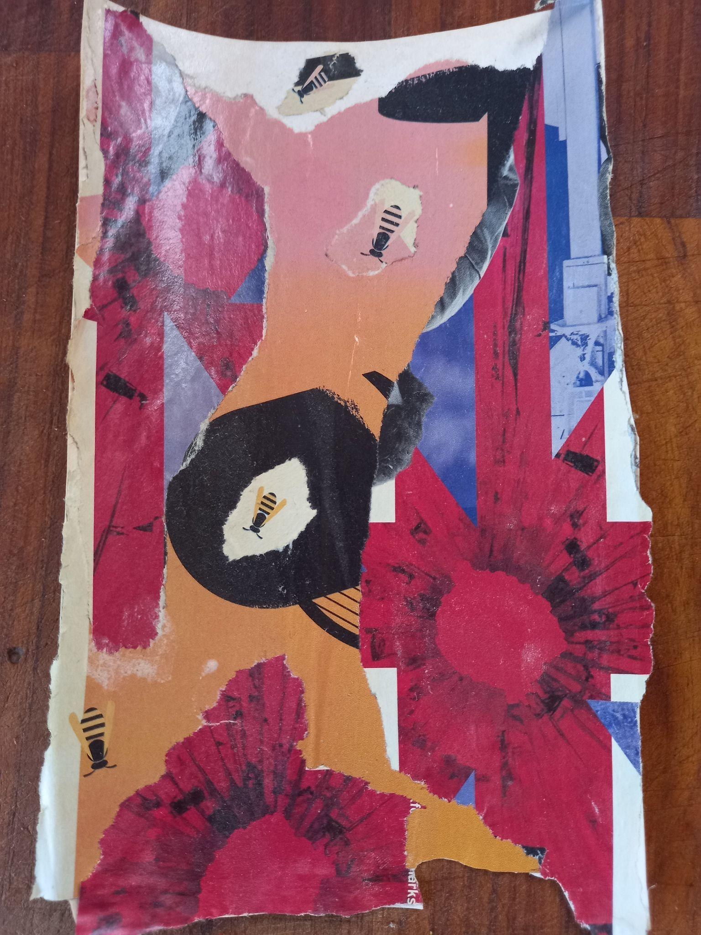

Image: A collage we made: All the bees and all the flowers

Once upon a time

Once upon a time
There were
There are
Many bears
Many big bears
And many more little bears
Living in the woods
They all like honey-
playing -
and sleeping in the sun

were plentiful
And things appeared to just be getting better
When a little bear named Karl said to a big bear named Hegel
This is solidarity
But Hegel said more like teleology to me.

Winds started to blow and
The sun stopped coming out
and bees stopped visiting
The honey was running out and it seemed to just keep and blowing

Chrissi a little bear who read a lot said we need to think and act.
Maha, another little bear, said yes but it must be joyous.
Creativity and collaboration - that is the only way to bring the sun back and stop the rainand save the honey.
How do you know, said Chrissi?
Maha said because I have been playing and talking with them all.

Hegel and Karl made a note here while looking suspiciously at Bakhtin - a very chatty bear
Chrissi and Maha hatched a plan - a very cunning plan
They drew everyone together
not just bears,
But all the others who lived in the woods
and the sun, the moon, the stars
and even the rain

The sun, the moon, the rain and all the inhabitants from the woods turned up
This looked like a party
not a meeting.

Are we playing said a - I like the rain
and the said are you sure the sun is coming
and all the said there will be honey - in a hopeful way
Chrissi and Maha reassured everyone that there is something for everyone
But this was not just play
As the ology had been stolen from the end of tele -
From the end of time -
It was all their jobs to find and mend the future
It was play upward and beyond

The sun and moon - all the small and all the large things played and played
And little and big were sharing this time - and all the little and big thoughts
And together they had many, many plans of how to make the future together and save tomorrow
Some even said we can have a better future than we thought before

And they ate the Honey and slept in the sun
- except for the who loved the rain
- and Bakhtin who never stopped talking

(and they all played happily ever after)

Story 39: Drawing the Dialogic Growth: Mapping the Supervisory Relationship

Oliver Delgaram-Nejad
Dr Gerasimos Chatzidamianos
olinejad@protonmail.com
g.chatzidamianos@mmu.ac.uk

Bios:
Oli Delgaram-Nejad is an experimental and corpus linguist. His research interests include mixed-methods, language testing, and naturalistic speech. He also has micro communications experience. His PhD is about developing diagnostic criteria for disorganised speech/formal thought disorder in schizophrenia that also account for linguistic creativity/language play. His earlier degrees (BA and MA) were in creative and professional writing, and he also enjoys cooking and gardening.

Dr Gerasimos Chatzidamianos is an Experimental Psycholinguist who completed his M.Phil. and Ph.D. research at the Department of Experimental Psychology, University of Cambridge, U.K. He is also qualified to practise Psychology in Greece (Department of Psychology, University of Athens, Greece), and a Qualified Teacher in Special Education. He is currently a Senior Lecturer in Psychology at MMU. A passionate researcher on mental health and deafness, psycholinguistics, schizophrenia, bipolar disorder, and clinical communication, Gerasimos has extensive expertise on HRA research ethics and the use of social media in health research.

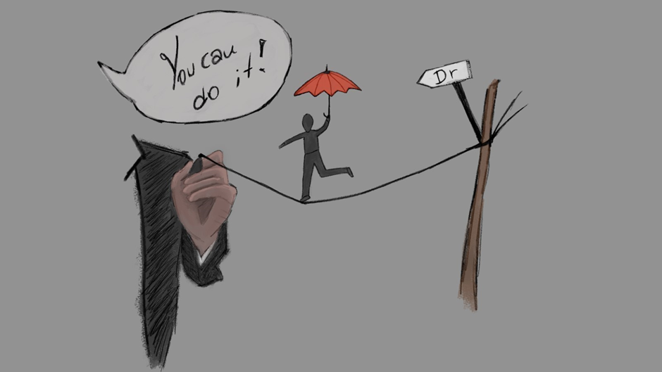
Figure 1: Gerasimos’ picture

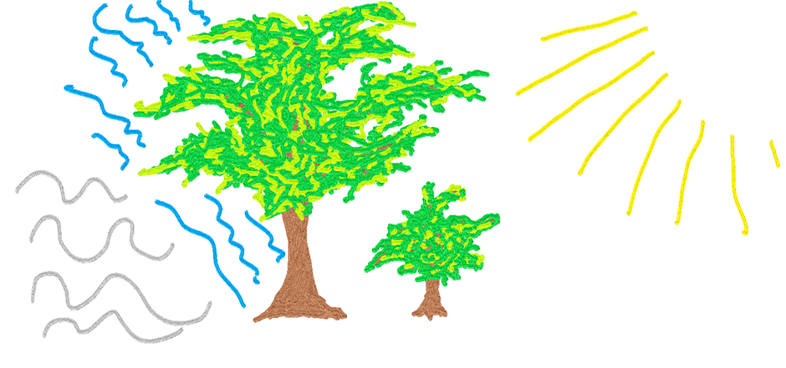
Figure 2: Oli’s picture

Drawing the Dialogic Growth: Mapping the Supervisory Relationship

Oli is a PhD student. Gerasimos is his supervisor. They wrote something (with Dr Chrissi Nerantzi) on dialogic feedback last year (Chatzidamianos et al. 2022), and this expands that. Each represented their view of supervisory relationships pictorially, reflected on their own work, and reflected on the other’s work. The results follow.

Gerasimos’ reflection on Figure 1:
The dynamic of the PhD supervisee-supervisor is a priori skewed. One wants to become what the other one is… providing the latter with power. Dear supervisor, use this power constructively and lets yourself grow from the process too. You might be drawing their path, but be by their side, not ahead, not behind… listen to their needs… not simply their academic conundrums.

For the road to doctorness, is not merely about “contribution to knowledge”, “metrics” and “intellectualism”… it involves re(connecting) with ourselves and others, communicating experiences, and ideas and above all… emotions…

Dear supervisor colleague, harness this opportunity, trust the process… and your supervisee will become!

Oli’s Reflection on Figure 1:
PhD supervision is a balancing act, one co-created by the supervisor and supervisee. Both need to adjust according to each other’s approach. Like relationships in general, success depends on how commonality and difference are worked into a constructive interplay. The danger of failing (or falling) is real, and not everyone will see the appeal of walking the tightrope to begin with. Support from someone who understands that drive and has obliged it for themselves is essential, irreplaceable. Supervisors are more than just academic mentors. The best ones model how to live well, not just learn well.

Gerasimos’ reflection on Figure 2:
There will be unsettled and inhospitable seas with hostile tribes inhabiting their shores… stay on route… it will be OK…

There will be times when you realise that your roots are not deep enough to hold you against the strong winds, and some of your twigs might break… remember… you are growing new branches and our roots are connected underground… it will be OK…
Your path is lit by vast knowledge out there… follow it and I will be there by your side.

Oli’s reflection on Figure 2:
Supervision seems to be about facilitating growth, and in good supervisors I see mature trees. They shelter against wind and rain (read project setbacks and reviewer two) while making light accessible (presenting work, accepting credit where due). Both are part of the supervisory ecosystem that requires and rewards hard work by all involved. Mature trees improve young trees’ chances, and this has been my experience of supervision. I’m very fortunate to have support of this kind and owe my progression to how we operate as a team. So, my two cents are that good supervisors embody and promote natural growth.

~~~

Over to you...

How will you ensure that you grow together?

References
Chatzidamianos, G., Nerantzi, C. & Delgaram-Nejad, O. (2022) The power of dialogic feedback: Research reflections. In: Irons, A. and Elkington, S. (2022) Enhancing Learning through Formative Assessment and Feedback, Oxon: Routledge, pp. 128-133.

Story 40: Building bridges; primary masters

Alison McCandlish
alison.mccandlish@glasgow.ac.uk

Bio: Alison is a lecturer in city planning and award winning freelance heritage and community engagement practitioner. She loves all things creative, and helping people have a say in place based issues which matter to them. She has many hats, teacher, practitioner-researcher, illustrator and writer.

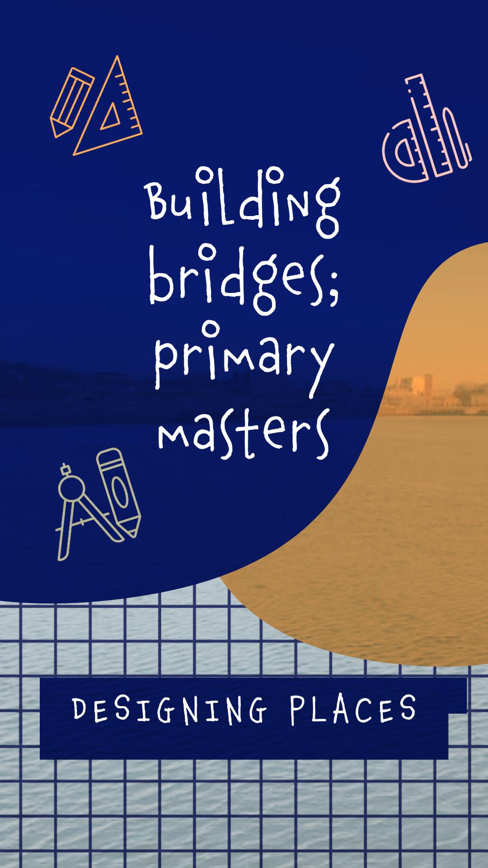

Image: Building bridges

When I saw an article in a newsletter about Widening Participation activities at my University, I knew straight away I would love to get involved in this. IntoUniversity gives pupils a chance to experience university subjects and explore school topics in a different way. I teach City Planning and am based in Urban Studies; as someone who is passionate about teaching and using active learning it was great fun to try and “translate” Masters level content into primary school lessons.

Two very enthusiastic groups of pupils discussed what they liked and didn’t like about their walk, lift or cycle to school, suggested what could change in their area and created amazing structures with paper and pen for all forms of sustainable transport to get across the river (a new bridge was in the news; planning on their doorstep).

I so enjoyed hearing what they thought about the area where they lived, and I’ve been invited back to do another session so I can tell it went well! It made me reflect on my own journey into learning and skills for exploring different subjects I teach. My primary school version of “designing places” uses a lot of the same observation and critical thinking skills as the postgraduate one, being able to draw, plan and design something which solves a real life problem links closely to the school Curriculum for Excellence (responsible citizens, confident individuals). Here is a short list of active and creative words which I hope give a little insight into the flow of the day:

Meet
Greet
Play
Stay
Move
Groove
Group
Loop
Look
Book
Think
Link
Draw
Build
Show
Grow
Explore
More!

References and links to related materials:
Education Scotland “What is Curriculum for Excellence”
IntoUniversity
Royal Town Planning Institute “What a town planner does”
University of Glasgow “Designing Places”
University of Glasgow “Widening Participation”

Story 41: Tree trunks and grass roots

Simon Abbott
simon.abbott@city.ac.uk

Bio: Simon is dedicated to fostering creativity across all areas of Higher Education, and learning about the ways in which creativity can be used to benefit HE institutions and their people. Over the past few years Simon has delivered creative workshops, helped visualise ‘utopian learning spaces’, worked with PhD students to illustrate their research and initiated a virtual ‘lockdown art school’ with colleagues in his office.

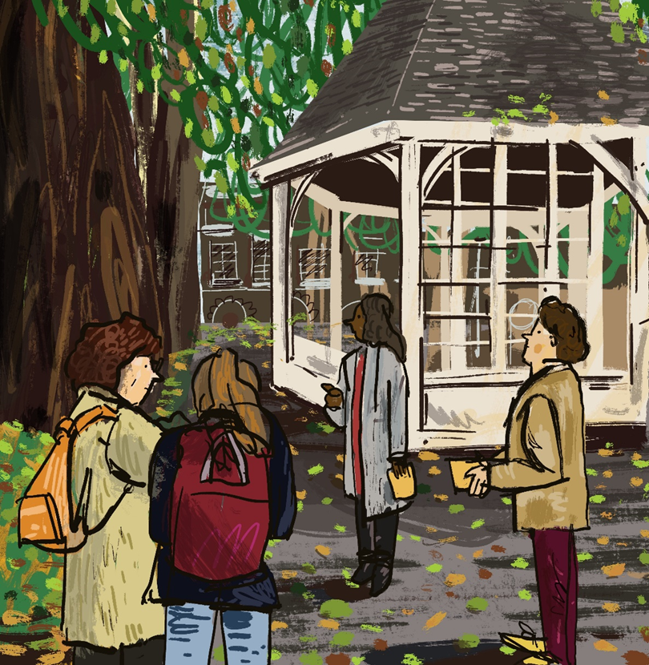

Image: People in a small park sketching the trees

Tree trunks and grass roots
As I walk up to Northampton Square, I’m pleased to see a few members of the group are staring up at the trees. Others are drawing in their sketchbooks, and a couple are chatting. I’d given the group instructions for the activity before going back to pick up a latecomer, who mentions as we approach that he’s already feeling grateful to have something to take his mind off work, as he starts drawing in the sketchbook I’ve given him. I open my own, and scratch black marks onto the page with charcoal, testing out my instructions to sketch the silhouettes of the trees. I could stand here in the dappled autumn sun all afternoon, but we’re 45 mins into an hour-long workshop and we’ve still got a few activities left on the schedule.
The workshop I was leading was part of a new ‘Detachment from Work’ series that had been organised by the university’s Organisational Development team. When they had asked if I might contribute a couple of creative sessions I couldn’t contain my excitement - ‘we’ll draw patterns in nature! We’ll do printmaking!’ I went out for lunch that day with a brain brimming with ideas, and then a bird shat on my head. Was my luck changing?
I had reason to be excited; as an artist that had been working in lower level admin roles in HE over the past eight years, It’d been tough to find ways in which to be creative and foster creativity within the different institutions I’d worked in, and even harder to be taken seriously once I had the ideas. I’d taken the opportunity whenever I could to learn about creativity in HE and boost my credentials as a ‘serious’ creative instigator; undertaking an MA in Arts Policy in the evenings, and later a postgraduate certificate in Higher Education, choosing modules where I could focus on creativity (the Open Education one was a revelation). These courses strengthened my belief that creativity in HE is a value that needs to be embedded across the whole institution and I needed to be involved. But it would be a few more years of trying to squeeze in the odd bit of learning, workshop delivery or networking around the ‘day job’ before I felt like I was anywhere near achieving this.
Standing here in the square with colleagues, some of whom I’d never met, that were taking time out from their busy roles in the library, marketing, admin and data analysis to walk around campus getting stuck into these drawing exercises (and having fun with it) felt very special. Perhaps it was possible to make a difference to the way that universities think about creativity, and who is creative within them. But for now, my hour was up and I had to rush back to the office.

Story 42: The Not-Dead Tree: Tales of creativity in dark times

Anna Hunter
anna.hunter@law.ac.uk

Bio: Anna is an academic developer and creative researcher, with a love of metaphor and visual imagery. She is currently the Programme and Student Lead for the Postgraduate Diploma in Higher Education at the University of Law. Anna has a research background in English Literature, which inspires her use of metaphor to explore experience, whether that is through her teaching or through research. This has also inspired her continuing love affair with writing and creative expression through language. She is an organising member of the #creativeHE community and regularly contributes to community events.

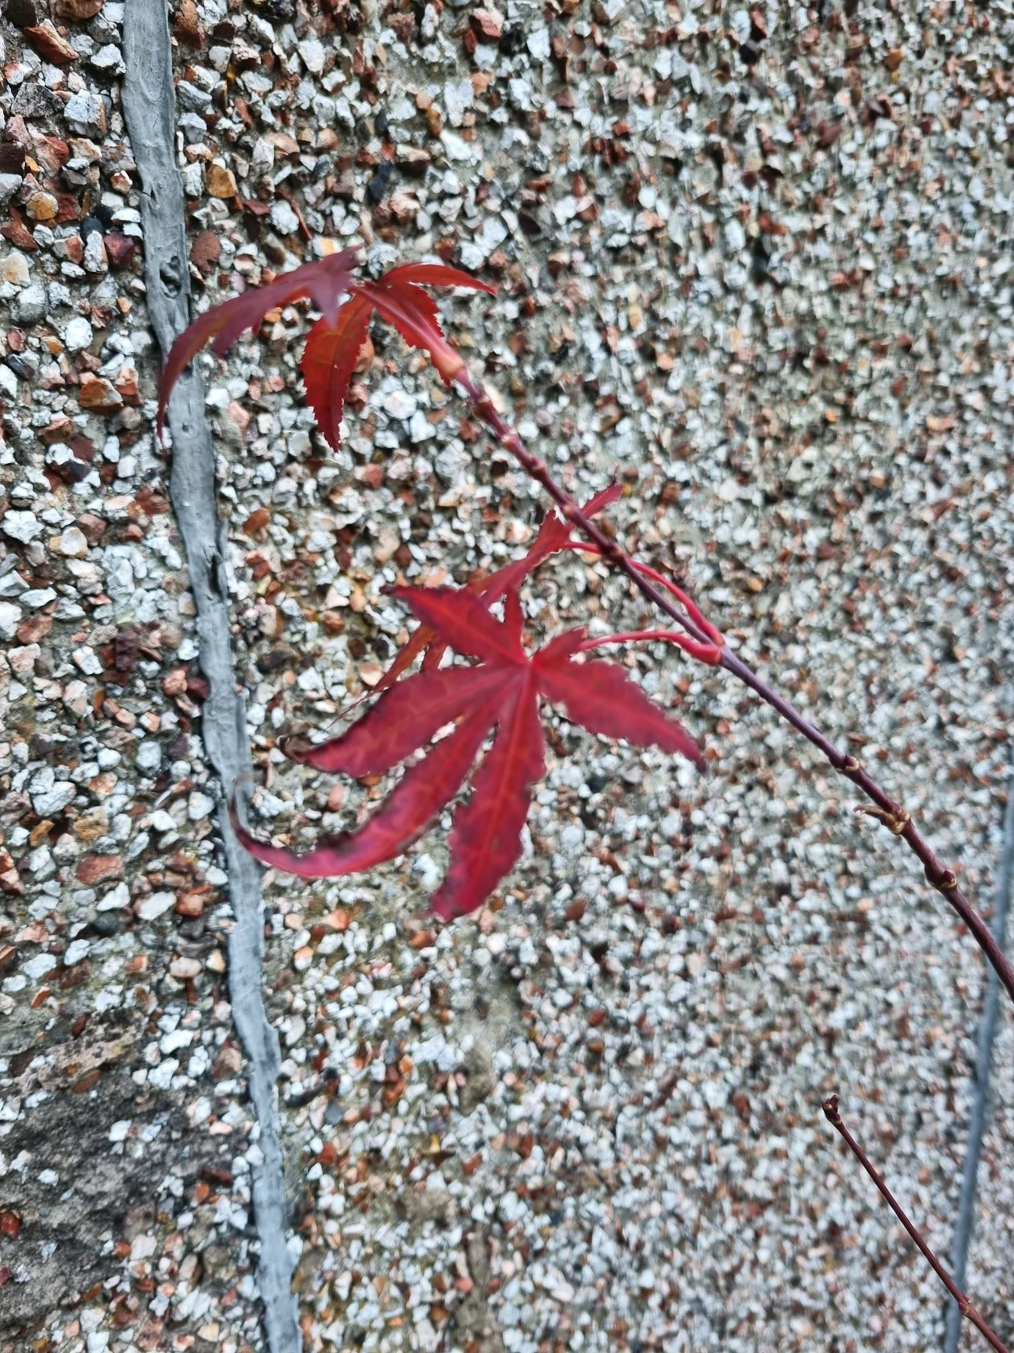

Image: A picture of a young maple tree, it has started to shed its leaves in the Autumn, but a few vibrant red leaves remain.
The Not-Dead Tree: Tales of creativity in dark times

Nature is a harsh critic, she stunts many gardeners’ aspirations. Nature doesn’t care for good intentions, or whether you are having a bad time at work. Likewise nature has the capacity to restore and revive, but until you get stuck in, you never know which face she will show to you.

For as long as I have lived in my house, I have wanted to grow lavender in my garden. When we moved in, it was late April and the garden was just beginning to show itself to us; one at a time the flowering plants revealed themselves, like much loved guests at a surprise party. I am not a natural gardener, however, and these annual remnants of the previous homeowner’s time and passion owe nothing to my own care. My next door neighbour has a magnificent lavender bush, every summer it teems with bumble bees. I wanted to grow lavender too, but despite my best efforts, every bush I planted eventually died. Sometimes they lasted a summer, sometimes a year or two - but inevitability seems to strip the leaves and leave nothing but sticks. I have no luck with lavender.

Late last summer, as I browsed yet again the pots of maturing lavender on my way out of the supermarket, contemplating what might have been (and what might be), I came across a tiny maple tree. Little more than twigs, with a few dried leaves, the poor soul bore the supermarket mark of shame - a reduced sticker. £2.99. I had no intention to buy a tree, let alone one that looked like it would not survive for much longer. “Why not try?” the tree whispered. “What have you got to lose?”

I took it home, gave it a pot and a place in the sun. Within a month the leaves were gone completely - it was now the end of September and the last of the Autumn sun slipped away to be replaced by rain, and gloom. From my workstation I saw the twigs of the maple tree every day, mocking (or so I thought) my terrible gardening skills. And yet. As the warm weather tiptoed back from its hiatus, a bud - then two - then bright scarlet curls emerged to greet the new spring. The tree was still there - not magnificent by any stretch of the imagination, but definitely Not-Dead.

The Not-Dead tree taught me an important lesson. Does it matter if the tree is small, as long as it is still there? As long as there is something, surely that is something worth cultivating? Creativity is much like the Not-Dead tree. In dark times, times of anxiety, pressure, overwork, stress, it is easy to feel that our creativity has abandoned us. But creativity is always Not-Dead. What we cultivate doesn’t have to be perfect, but it is always there, as long as we remain willing to try. Theodore Roosevelt famously said “comparison is the thief of joy”. I can’t grow lavender, but the Not-Dead tree doesn’t care about that.
Postscript

Thank you for reading through the #creativeHE Annual. We hope that you have enjoyed engaging with the stories as much as we have. A big shoutout to all the contributors, their students - and the stories they’ve told. We can see the collegiality that runs through the stories themselves - and through the whole #creativeHE community that sustains us.

As we enter another year, we hope that you are thinking about writing a story of your own for the next Annual - and that you are exploring ways to increase storytelling within your own teaching practice. It is ‘story’ and our stories that sustain and nourish us through these uncertain times. It is the certain uncertainty of #creativeHE and the support it offers us all that helps us fulfil our and our students’ potential.
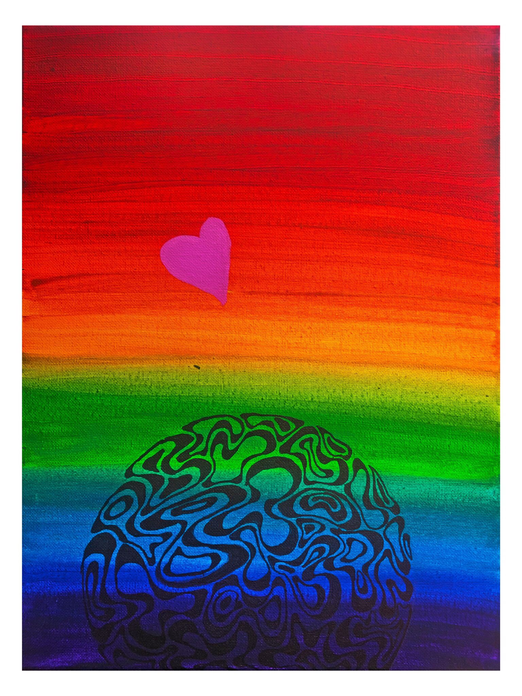
Image used with permission of the artist Malika Winfield

